Vortex Micropump for Integrated Optically Transparent Microfluidic Chips

Kin Fong Lei and Wen J. Li*
Centre for Micro and Nano Systems, The Chinese University of Hong Kong,
Shatin, Hong Kong SAR
*Contact Author: wen@acae.cuhk.edu.hk

Abstract – A polymer based vortex micropump fabricated by micro molding replication technique is described in this paper. The optically transparent and biocompatible material used to fabricate the micropump will enable the pump to be applied on many biomedical and chemical analyses applications. Fluid transmission of the vortex micropump is driven by the circumrotating motion of an impeller inside the micropump. The pump rate can reach 2.5ml/min at a low operating voltage of 3V with a power consumption of 345mW from the experimental results. Moreover, micropumps, microvalves and microchannels were successfully fabricated on a single chip. This is the initial result towards to the large-scale integrated microfluidic system. Since the microfluidic components described in this paper are made entirely of PMMA, which is an optically transparent material, the integrated chips will eventually allow vision-based investigation of micro-flow phenomena.

Keywords – microfluidic devices; microfluidic systems; micropump; micro molding replication technique; vortex micropump.

I. INTRODUCTION

In the past decade, microfluidic devices have emerged as an attractive area of the research in micro-electromechanical systems (MEMS). Various microfluidic devices have been developed including microvalve [1], micropump [2], micromixer [3], microchannel network [4], microfluidic flow sensor [5], etc. A microfluidic system, which consists of several microfluidic devices, is designed to sense, regenerate, and deliver fluid in the order of micro-liter. The large-scale integration [6] of microfluidic devices is a trend of advancement in the microfluidic technology.
Because of the nature of microfluidic systems, they usually have chip sizes in the order of 1 cm² and are made of several wafers bonded together, which makes the mass-production of microfluidic components non-trivial. In addition, the fluidic connection with the external world is also complicated. Moreover, for the applications of bio-optical detection and chemistry, optically transparent materials are required in building microfluidic systems. Therefore, Micro molding replication technique is one possible method to achieve cost effective fabrication, ease of packaging, and optical transparency of microfluidic devices. Micro molding replication technique includes mastering and replication processes. In the mastering process, the replication master is fabricated by high aspect ratio photolithography, electroplating and resist stripping. In the replication process, by using the replication master, microstructures can be transferred to polymer substrates by a hot embossing machine. After obtaining the embossed polymer substrates, they can be bonded to other flat PMMA substrates by spun-on UV-curing epoxy resin, or PDMS. Thus, a closed volume microfluidic system can be fabricated. Details of the basic polymer-base microfluidic devices fabrication processes developed by our group are discussed in [7] and [8].
Micropump is one of the most important devices in microfluidic systems. Various micropumps have been proposed recently. For those employing mechanical check valves for flow rectification [9], the small and fragile silicon parts are critical problems to overcome and complicated fabrication processes are involved. Hence, “valve-less pumps” became attractive due to their extremely simple structures. For those pumps, flow rectification is achieved using special channels to generate different flow resistance [10]. From the view point of miniaturization and integration of complex microfluidic systems, simple structures would be valuable in making the whole system more simple and compact. Comparisons of different micropumps are shown in Table 1. In this paper, a novel micropump based on vortex flow generation is discussed. The fluid enters the pump near the center of an impeller and is moved toward to the outer diameter by the rotational motion of the impeller. This motion converts the liquid velocity gradient to pressure gradient such that the vortex micropump produces a continuous flow in a microchannel linked to it. Due to its planar and simple structure, micro molding replication technique is suitable for fabricating such kind of micropump. From our experimental results, the pump rate of the vortex micropump can reach 2.5ml/min at a low operating voltage of 3V with power consumption of 345mW. The pump actual design, fabrication processes, implementation and experimental results will be described in the following sections.

II. MICROPUMP DESIGN AND FABRICATION

A. Design
The vortex micropump uses kinetic energy to move fluid through the use of an impeller and a circular pump chamber. The fundamental design concept is illustrated in Figure 1. The fluid enters the pump near the center of the impeller and is moved toward to the

Table 1. Comparison of different micropumps
 | K. S. Yun [11] | S. Bohm [12] | R. Linnemann [9] | J. H. Tsai [13] | A. Olsson [10] | Our vortex pump
Valve type | Check valve | Check valve | Check valve | Valve-less | Valve-less | Valve-less
Material | Glass, Si | Plastic | Glass, Si | Glass, Si | Plastic | Plastic
Actuation method | Electrowetting | Electromagnet | PZT | Thermal-Bubble | PZT | Motor
Pump Rate  (maximum) | 0.07ml/min | 2.1ml/min | 1.2ml/min | 0.005ml/min | 1ml/min | 2.5ml/min
Back pressure  (maximum) | 0.8kPa | 10kPa | 100kPa | 0.377kPa | 5.9kPa | 7kPa
Applied voltage | 2.3V | 5V | 120V | - | - | 3V
Power consumption | 0.17mW | 500mW | - | 1W | - | 345mW

outer diameter of the pump chamber by the rotating motion of the impeller. Because of the boundary of the pump chamber, the fluid is guided to enter the microchannel and the pumping flow is created. Since the generation of pumping flow is due to the rotating motion of the impeller, by changing the rotational speed of the impeller, the pumping flow rate can be controlled smoothly.
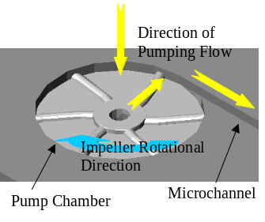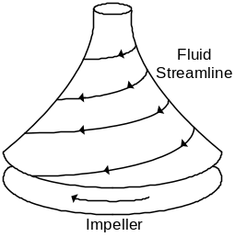
(a) (b)
Figure 1. (a) Illustration of the vortex pumping principle. (b) Fluid streamline inside the pump chamber.

The expressions of the theoretical head H_{th} (pressure difference generated by a rotating fluid) and flow rate Q_{th} [14] are shown in Eq. (1) and (2).

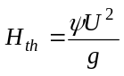 (1)
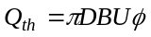 (2)

which U is tip speed of the impeller, g is gravitational constant, D is diameter of the impeller, B is the exit width of the pump, ψ is head coefficient, and φ is flow coefficient. The above equations give estimates on the pressure gradient and flow rate generated by an impeller. Typical values for head coefficient are ψ = 0.4 to 0.7, and for the flow coefficient are φ = 0.05 to 0.2. However, due to the rudimentary design of our vortex micropump, a ψ of ~0.4 and φ of ~0.0026 are obtained for the current device.
As mentioned earlier, microfluidic devices are required to be optically transparent and bio-compatible for bio-optical detection and chemical applications. For our vortex micropump, we choose polymethyl methacrylate (PMMA) to be the structural material. The micro impeller is placed inside the pump chamber. When the fluid enters the micropump from the center of impeller, the rotational motion of impeller, driven by a DC motor, can induce a fluid pressure gradient and thus create a continuous flow. In our vortex pump design, two structural layers are needed. The lower layer includes pump chamber and microchannel, while the upper layer is a cover layer providing fluidic connection.

B. Micro Molding Replication Technique
Micro molding replication technique is a low cost and flexible microfabrication method for polymer based microfluidic systems. It includes two processes: mastering and replication, as illustrated in Figure 2. In the mastering process, the metal mold is fabricated by high aspect ratio lithography, electroplating and photoresist stripping as explained earlier. Since the required aspect ratio of the microstructures in the vortex pump is relatively high, we chose MicroChemTM SU-8 photoresist as the mold for electroplating, i.e., the metal is electroplated on the photoresist-patterned substrates. After the SU-8 photoresist is striped, the metal mold is fabricated. In the replication process, the closed volume of the microfluidic devices are fabricated by the hot embossing process and bonding process. That is, the microstructures on the metal mold is transferred to the PMMA substrates by the hot embossing process. Then, flat PMMA substrates can be bonded to the embossed PMMA substrates to achieve a closed volume microfluidic devices by using spun-on interfacial layers such as UV-epoxy or PDMS.
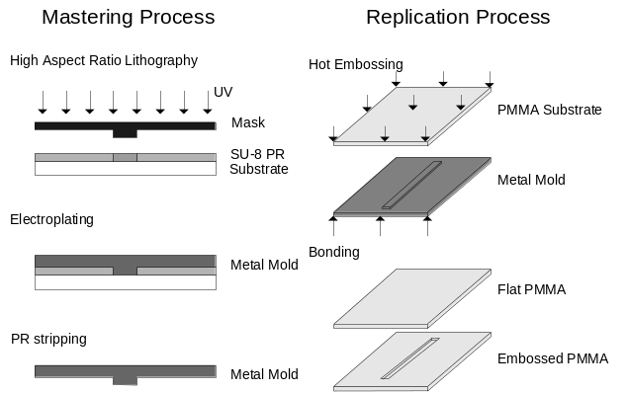
Figure 2. Illustration of the micro mold replication technique

C. Fabrication of Vortex Micropump
An example of using micro molding replication technique to fabricate microfluidic device is vortex micropump. In this section, the fabrication of micro impeller and micro mold, replication of pump chamber and microchannel, and assembly process of vortex micropump are presented.

1) Impeller fabrication process
The fabrication process of impeller is illustrated in Figure 3. On the PMMA substrate, 500 Cr as adhesive layer and 3000 Au as conductive layer are first sputtered. MicroChemTM SU-8 2075 photoresist is then spun on the substrate at 3000rpm. Soft bake is processed at 65°C for 5mins and then at 90°C for 20mins. Then, SU-8 is exposed under the photoresist mask with the pattern of the impeller circular base. Post- expose bake is processed at 65°C for 5mins and then at 90°C for 20mins. After this, SU-8 photoresist is developed in SU-8 developer for about 10mins at room temperature with mild agitation and then rinsed with isopropyl alcohol (IPA) and DI water. After the above lithography process, the 100μm thick SU-8 impeller circular base mold is fabricated. Then, the mold is electroplated with Cu using a current density of 40mA/cm² for 1.5 hours, which gives a 100μm thick Cu impeller circular base. Afterwards, the second layer of SU-8 photoresist is spun on the first layer at 3000rpm. Then, it is soft baked and exposed under the photoresist mask with the pattern of the impeller blade with the proper alignment to the impeller circular base. Post-bake and resist development then followed. After this second lithography step, the 100μm thick SU-8 impeller blade mold is fabricated on the Cu impeller circular base. Then, the mold is electroplated again with Cu using a current density of 40mA/cm² for 1.5 hours. The Cu impeller blade is thus fabricated on the Cu impeller base. Finally, the SU-8 photoresist and PMMA substrate are removed by MicroChemTM Remover PG, leaving stand-alone Cu impellers. To more easily remove the impeller from the substrate in the final process, we found that using PMMA substrate is better than silicon substrate. An SEM image of a prototype micro impeller is shown in Figure 4.

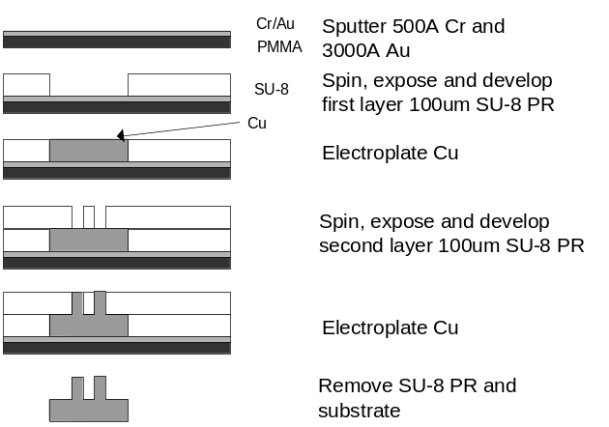
Figure 3. Fabrication process of copper impeller.

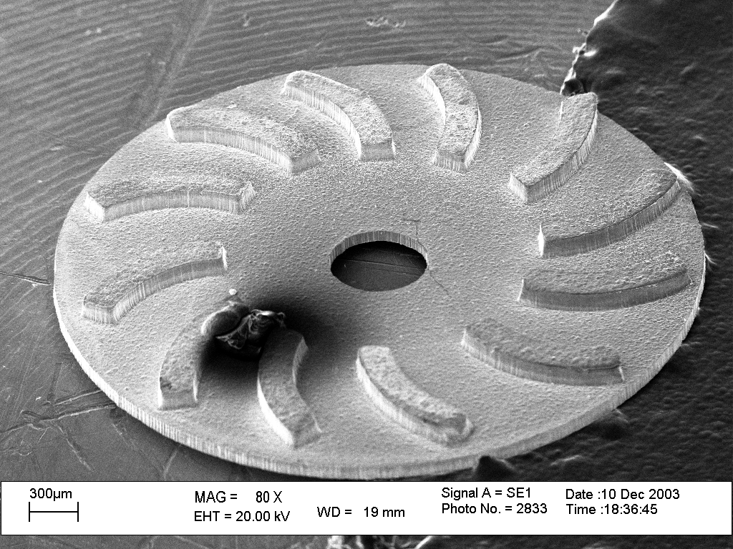

Figure 4. SEM image of a copper micro impeller. The diameter of the impeller is 4mm; length of each blade is 1mm; width of each blade is 150μm.

2) Micro mold of vortex micropump fabrication process
Micro mold functioned as a replication master. It includes the pattern of pump chamber and microchannel. The fabrication process of micro mold of vortex micropump is illustrated in Figure 5. On the PMMA substrate, MicroChemTM SU-8 2075 photoresist is spun at 2000rpm. Soft bake is processed at 65°C for 5mins then at 90°C for 30mins. Then, SU-8 is exposed under the photoresist mask with the pattern of the pump chamber and microchannel. Post-expose bake is processed at 65°C for 5mins then at 90°C for 30mins. After that, SU-8 photoresist is developed in SU-8 developer for about 15mins at room temperature with mild agitation and then rinsed with IPA and DI water. After the high aspect ratio lithography process, the 200μm thick SU-8 mold of pump chamber and microchannel is fabricated. Because of the insulating property of SU-8 photoresist and PMMA substrate, 300 Au layer is sputtered on the surface for the preparation of electroplating process. In order to make the micro mold to be hard and rigid, ultra thick Ni electroplating is necessary. Then, the SU-8 mold is electroplated with Ni using a current density of 40mA/cm² for 15 hours. After removing of SU-8 photoresist and PMMA substrate by MicroChemTM Remover PG, 1mm thick micro mold of vortex micropump is fabricated. The photo of the micro mold is shown in Figure 6.

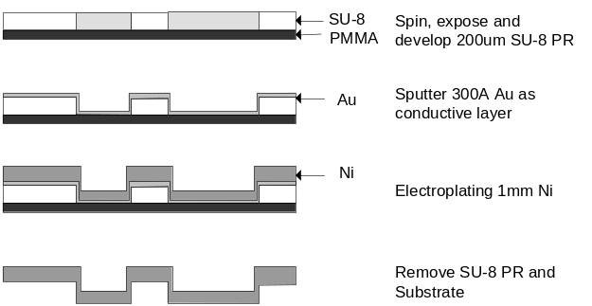

Figure 5. Fabrication process of micro mold of vortex micropump.

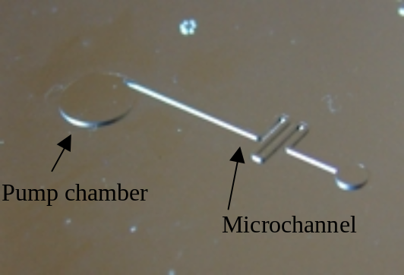

Figure 6. Photo of nickel micro mold of vortex micropump chamber and microchannel.

3) Vortex micropump replication and assembly process
The micropump replication and assembly processes are shown in Figure 7. To replicate the pump chamber and microchannel from the micro mold, a PMMA substrate is heated to 120°C, which is slightly above its glass transition temperature (T_{g} = 105°C). Then, a pressure of 7MPa is applied by a hydraulic press to compress the micro mold towards the PMMA substrate. This causes the microstructures on micro mold to transform to the PMMA substrate negatively. After the substrate and the micro mold cooled down, the embossed PMMA substrate is released from the micro mold. To increase the pump chamber volume, machining tools is used to deepen the chamber. An impeller and a DC motor are assembled on the top and bottom of the chamber, respectively. The inlet and outlet of the micropump is produced by drilling holes through another flat PMMA substrate. Finally, a polyester film is coated with spun-on UV-curing epoxy resin on both sides. The embossed PMMA and the flat PMMA are bonded together by the polyester film and form a closed pump chamber and microchannel between two substrates eventually. A completed vortex micropump with microchannel is shown in Figure 8. The diameter of pump chamber is 5mm. The fluid is pumped through a microchannel of 300μm in width and 200μm in depth.

1. Replicate the pump chamber and microchannel.

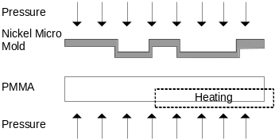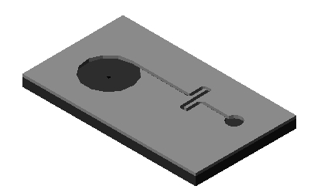

2. Modify the pump chamber by machining tools.

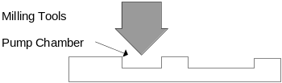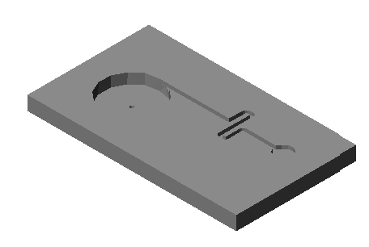

3. Assemble the impeller and DC motor.
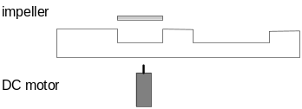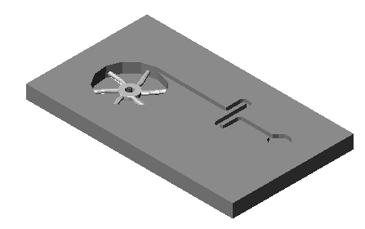
4. Bond two substrates by UV-curing epoxy resin coated polyester film.
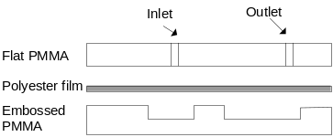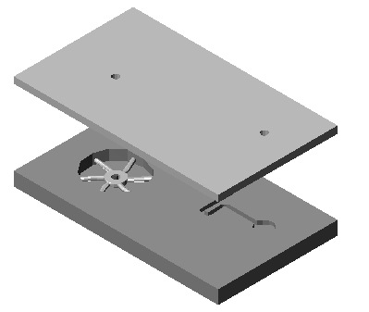

Figure 7. Replication and assembly processes of the vortex micropump.

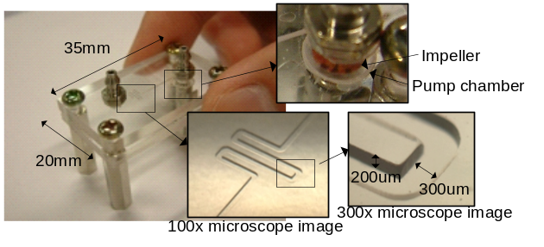
Figure 8. Photo of a vortex micropump with microchannel. The chip size is 20mm × 35mm. The diameter of pump chamber is 5mm. The microchannel is 300μm in width, 200μm in depth.

III. EXPERIMENTAL SETUP AND RESULTS

The experimental setup for both volume flow rate and pumping pressure measurements are illustrated in Figure 9. In both experiments, the far ends of the polyurethane tubes from the micropump are connected to the large opening beakers filled with water as liquid reservoirs. In the volume flow rate measurement as shown in Figure 9(a), the two beakers are set at the same liquid level for equilibrium pressure. The pumping flow rate is approximated from the increased water weight measured by a digital balance over a certain time interval. Because the density of water is 1kg/m³, volume flow rate (ml/min) can be calculated from the change of water weight (g) over time (min) directly. Because of the large opening of beakers, the liquid level change in the beakers during the pumping process is negligible and the measured volume flow rate is assumed to be under zero back pressure. In the pumping pressure measurement as shown in Figure 9(b), the setup is similar to the one for measuring volume flow rate except that the outlet polyurethane tube is put vertically. Liquid level of the outlet polyurethane tube in equilibrium is recorded before the pump is turned on. The pumping pressure is measured from the liquid level change in the outlet polyurethane tube when the maximum height is reached. The measured pumping pressure is assumed to be under zero flow rate.

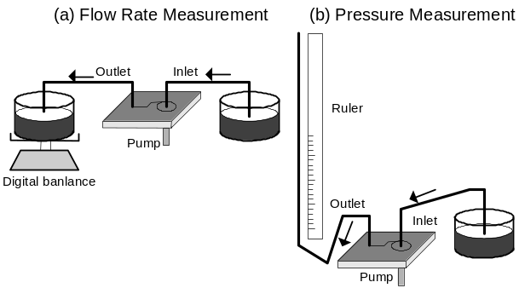
Figure 9. Schematic drawing of the experimental setup. (a) Flow rate measurement under zero back pressure. (b) Pumping pressure measurement under zero flow rate.

The pump rate and pumping pressure as a function of the applied voltage are shown in Figure 10 and Figure 11, respectively. Due to the operating principle of the vortex micropump, the produced fluid pressure is proportional to the impeller rotational speed. The pump rate and pumping pressure increase linearly with the applied voltage to the DC motor. The minimum pump rate and pumping pressure are 0.02ml/min and 117Pa at the startup voltage (0.5V) of the DC motor, respectively. In our experiments, we measured the pump rate and pumping pressure from startup voltage to 3V and 2V of the DC motor, respectively. The measured pump rate is up to 2.45ml/min at 3V, and the measured pumping pressure is up to 7105Pa at 2V.

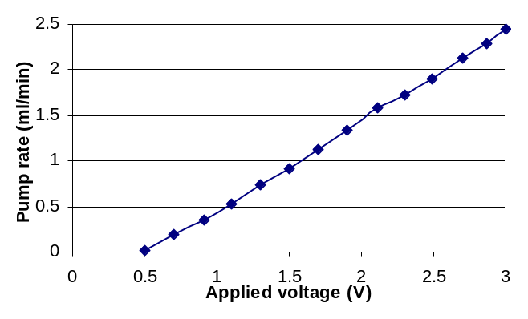Figure 10. Pump rate (water as pump medium) as a function of the applied voltage at zero back pressure.
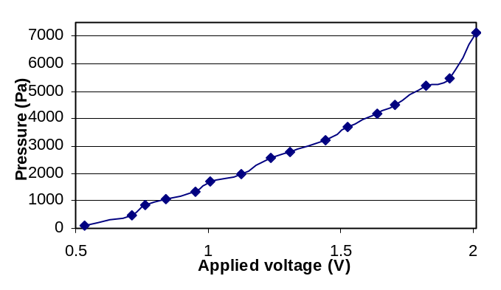Figure 11. Pumping pressure (water as pump medium) as a function of the applied voltage at zero flow rate.

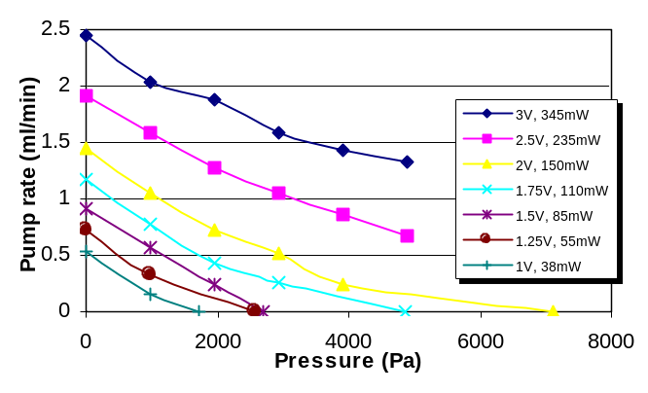Figure 12. Pump rate (water as pump medium) as a function applied back pressure on the outlet port at different applied voltages.

Further investigations were performed to characterize the pump rate applied back pressure. As shown in Figure 12, the pump rate was measured under different back pressures and input voltages of the DC motor. It is observed that the pump rate is linearly decreased when the back pressure is increased. Furthermore, as indicated by the experimental results, the pump rate and back pressure are proportional to the applied voltage. That is, by increasing the applied voltage, the slope of each curve is nearly the same. This will allow for potentially manipulate fluids through computer interface software.

IV. DIGITALLY CONTROLLABLE INTEGRATED MICROFLUIDICS

This initial integrated microfluidic system includes two vortex micropumps, two tesla valves [15] and a “Y” shaped microchannel connected to each component. These devices were constructed together as shown in Figure 13 such that no extra manufacturing step is required. Two inlets of the integrated chip were connected to the beakers as liquid reservoirs. For easier observation of the fluid flow, two inlets were connected to two liquid reservoirs filled with different colored water. One of the reservoirs was filled with water, another was filled with red ink. Liquids were supplied and pumped from two inlet ports by turning on the vortex micropumps controlled by computer. In order to prevent backward fluid flow, tesla valves were integrated in the outlet of each pump and also both pumps always had to keep low pumping force to generate forward pressure. These mechanisms can eliminate the backward fluid flow. Because of the fast response of the vortex micropump, by controlling the applied voltage sequence of pumps shown in Figure 14(a), liquids can be swapped in the microchannel shown in Figure 14(b) and also prevent backward flow in both pumps. Changing the duty cycle (t₁ : t₂) of the applied voltage of the pumps, the liquid portion can be changed in the output liquid. An experiment was conducted to show the controlling of fluid flow. By controlling the higher pumping pressure of the water, water will be pumped into the outlet channel and the red ink is stopped at the joint, as shown in Figure 15(a). The same phenomenon appears with the red ink, as shown in Figure 15(b). Using this mechanism, fluid flow can be manipulated.

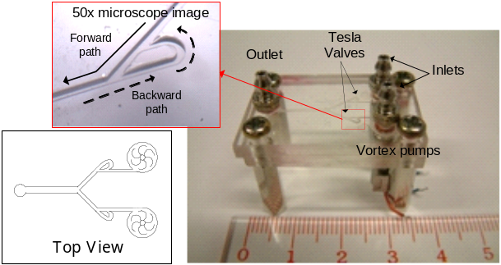

Figure 13. The integrated microfluidic system. It includes two vortex micropumps, two tesla valves and a “Y” shaped microchannel.
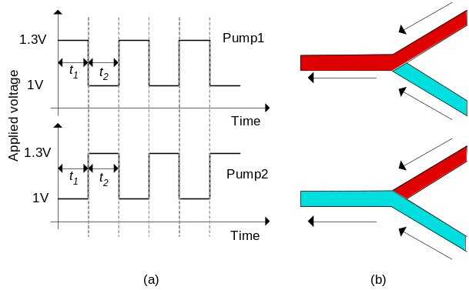
Figure 14. (a) Time sequence of applied voltage of two pumps. (b) Illustration of liquids swapping in the microchannel.

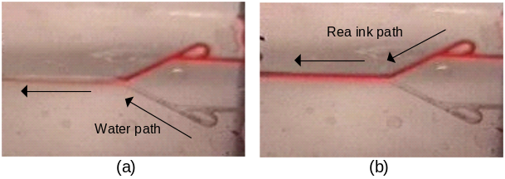

Figure 15. Experiment of controlling fluid flow. (a) Water was pumped into the outlet channel and the red ink is stopped at the joint. (b) Red ink was pumped into the outlet channel and the water is stopped at the joint.

V. CONCLUSION

In this paper, a novel polymer-based vortex micropump was demonstrated. Detailed fabrication process and performance characteristics of micropump were provided. The measured pump rate can reach 2.45ml/min at 3V, and the measured pumping pressure is 7105Pa at 2V. An advantage of the vortex micropump is that the pump rate and pumping pressure increase linearly with the applied voltage of a DC motor. By using this advantage, a digitally controllable integrated microfluidic system was also presented. Fluid flow can be manipulated in the chip. This will allow eventually a computer controllable micro fluidic delivery and transport system using the vortex pump discuss in this paper.

REFERENCES

[1] M. Kohl, D. Dittmann, E. Quandt and B. Winzek, “Thin film shape memory microvalves with adjustable operation temperature”, Sensors and Actuators, vol. 83, pp. 214-219, 2000.
[2] S. Li and S. Chen, “Analytical analysis of a circular PZT actuator for valveless micropumps”, Sensors and Actuators, vol. 104, pp. 151-161, 2003.
[3] Z. Yang, M. Matsumoto and H. Goto and R. Maeda, “Ultrasonic micromixer for microfluidic systems”, Sensors and Actuators, vol. 93, pp. 266-272, 2001.
[4] D. Baechi, R. Buser and J. Dual, “A high density microchannel network with integrated valves and photodiodes”, Sensors and Actuators, vol. 95, pp. 77-83, 2002.
[5] G. Bedo, H. Fannasch and R. Muller, “A silicon flow sensor for gases and liquids using AC measurements”, Sensors and Actuators, vol. 85, pp. 124-132, 2000.
[6] T. Thorsen, S. J. Maerkl and S. R. Quake, “Microfluidic large-scale integration”, Science, vol. 298, pp. 580-584, 2002.
[7] K. F. Lei, S. Ahsan, N. Budraa, W. J. Li and J. D. Mai, “Microwave bonding of polymer-based substrates for potential encapsulated micro/nano fluidic device fabrication”, to be published in Sensors and Actuators.
[8] W. W. Y. Chow, K. F. Lei, G. Shi, W. J. Li and Q. Huang, “Micro fluidic channel fabrication by PDMS-interface bonding", Conference on BioMEMS and Nanotechnology, SPIE International Symposium on Microelectronics, MEMS, and Nanotechnology, December 10-12, 2003, Perth, Australia.
[9] R. Linnemann, P. Woias, C. D. Senfft and J. A. Ditterich, “A self-priming and bubble-tolerant piezoelectric silicon micropump for liquids and gases”, IEEE MEMS 1998, pp. 532-537, 1998.
[10] A. Olsson, O. Larsson, J. Holm, L. Lundbladh, O. Ohman and G. Stemme, “Valve-less diffuser micropumps fabricated using thermoplastic replication”, IEEE MEMS 1997, pp. 305-310, 1997.
[11] K. S. Yun, I. J. Cho, J. U. Bu, C. J. Kim and E. Yoon, “A suface-tension driven micropump for low-voltage and low-power operations”, Journal of Microelectromechanical Systems, vol. 11, no. 5, pp. 454-461, 2002.
[12] S. Bohm, W. Olthuis and P. Bergveld, “A plastic micropump constructed with conventional techniques and materials”, Sensors and Actuators, vol. 77, pp. 223-228, 1999.
[13] J. H. Tsai and L. Lin, “A thermal-bubble-actuated micronozzle-diffuser pump”, Journal of Microelectromechanical Systems, vol. 11, no. 6, pp. 665-671, 2002.
[14] J. Tuzson, Centrifugal pump design, Wiley, 2000.
[15] S. Bendib and O. Francais, “Analytical study of microchannel and passive microvalve, application to micropump simulator”, Design, characterization and packaging for MEMS and microelectronics II, Proceedings of SPIE, 17-19 December 2001, Adelaide, Australia, 2001.

