Microwave Bonding of Polymer-Based Substrates for
Micro/Nano Fluidic Applications

Kin Fong Lei ¹, Wen J. Li ^{1,*}, Nasser Budraa ², and John D. Mai ²

¹ Centre for Micro and Nano Systems, The Chinese University of Hong Kong, HKSAR
* MMW413, Dept. of ACAE, The Chinese University of Hong Kong, Shatin, HKSAR
Phone: +852 26098475 Fax: +852 26036002 E-mail: wen@acae.cuhk.edu.hk

² Microwave Bonding Instruments, Inc., USA

ABSTRACT

Microwave-based bonding of polymer substrates is presented in this paper to illustrate a promising technique for achieving precise, well-controlled, low temperature bonding. Microwave power is absorbed by a very thin film metal layer already deposited on the polymer (PMMA) substrate surface. The intense thin-film volumetric heating promotes localized melting of refractory metals such as gold. One of the advantages of the process is that PMMA is relatively transparent to microwave energy in the 2.4 GHz regime. This makes it an excellent substrate material for microwave bonding. Selective heating and melting of the thin layers of metal also causes localized melting of the PMMA substrates and improves adhesion at the interface. We have shown that ~1μm of interfacial layer can be generated which composed of the melted gold and PMMA, and which can hold the substrates together under applied tension greater than 100lb/in². We also used lithographically patterned metal lines on the PMMA substrate to demonstrate that the PMMA remains optically transparent after microwave processing.

INTRODUCTION
Since the publication of results from silicon die microwave bonding experiments at the Jet Propulsion Laboratory (JPL) [1] in 1999, there has been interest in selective heating for MEMS applications using electromagnetic energies at frequencies from radio frequency (RF) up to microwaves. A group from the University of Wisconsin [2] showed that direct silicon wafer bonding, which usually requires temperatures greater than 1000°C, was possible using a 2.45GHz microwave source with a power output of 1500 W. Complete, void free bonding was achieved using this process in less than 5 minutes. Similarly, a group from the University of Minnesota [3] used RF heating to bond silicon wafers together via a dielectric insulator interface. This group applied 500W of power from a 14MHz source for 7 minutes to bond silicon wafers via a 2 to 20μm thick polyimide dielectric layer. Other groups have attempted hermetic sealing using compression waves at ultrasonic frequencies to get hermetic sealing, similar to that achieved by the JPL group using electromagnetism. One group from UC Berkeley [4] used ultrasonic frequencies at up to 25 W for almost 2 seconds to bond approximately 2mm² of In/Au and up to 50W for 5 seconds to bond approximately 2mm² of Al/Al. However, until now, there has not been much focused attention on using selective microwave heating to join thin film metal layers between polymer substrates.
In recent years, polymer-based micro fluidic devices have become increasingly important in biological applications [5]. However, polymer substrates must be bonded to make functional micro channels, and adhesion between the substrates is a problem of great practical concern. Existing polymer-to-polymer substrate bonding methods includes thermal-compression, ultrasonic, or gluing by application of either epoxy or methanol. Unfortunately, these techniques are not precise when compared to standard IC/MEMS bonding processes, i.e., they may induce global and localized geometric deformation of the substrates or leave an interfacial layer with significant thickness variation. For channels in the millimeter to a few hundred microns range, these drawbacks are tolerable. However, it is implausible to construct micron and nanometer sized channels using these techniques since significant global and local material deformations may distort the micro/nano channel geometries. In this paper we will present our ongoing work to use localized microwave heating to bond polymer (PMMA) substrates without causing any global deformation to the substrates and resulting in a precise and well-controlled interfacial layer thickness of 1μm. Thus far, we have shown that microwave energy can be used to selectively melt a film as thin as 50nm of gold deposited on each side of the two PMMA substrates to be bonded. Melting of these thin layers of gold caused localized melting of the PMMA substrates and allowed them to bond. The 1μm interconnect layer is composed of the melted gold and PMMA and has been shown to hold the substrates together under applied pressure greater than 100lb/in².

MICROWAVE BONDING
The central idea behind microwave bonding is to use the nature of the interaction of high frequency energies with thin film metals that are used as bonding interfacial layers in a single mode cavity (SMC). In such a cavity the power delivered to metal contact is proportional to the conductivity and the electric field (E²), as shown in Equation (1) [6]. In Equation (1), ω_{o} is the fundamental frequency, ε_{o} is the permittivity of free space and tanδ is the loss tangent of the material.

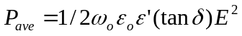 (1)
In microwave bonding, most of the power is delivered through a microwave transparent substrate and is absorbed by a very thin-film metal of less than one micron thick (skin depth). This power induces heating that leads to high temperature melting of refractory metals such as gold. The low electrical conductivity of a polymer or semiconductor substrate, relative to a metal, allows the substrate to essentially remain unaffected by the energy deposited in the SMC. The high intensity fields found in a SMC is unique to these types of cavities and allows the melting of high-melting-temperature thin films or contact points as found in this application. The thinness of the metal (skin depth), the high intensity, and the short application time contribute to the following critical advantages:

1. Localized power concentration allows for strong hermetically bonded areas between the substrates. High bond strength results from the utilization of high melting temperature metals at the interface. This means higher device reliability.
2. Selective heating of the thin metal means the bonding process is a globally low-temperature process; this means a polymer with a low-melting temperature could be used as a substrate. Also, since the substrate temperatures remains low, adverse thermal coefficient of expansion mismatches are minimized.
3. Unlike some laser welding and ultrasonic bonding techniques, our process is low cost because the bonding occurs simultaneously and quickly.

MICROWAVE BONDING TO POLYMER
In general, we succeeded in bonding PMMA to silicon and PMMA to PMMA substrates together using selected microwave frequencies to locally melt the interface metallic thin films between the substrates. As shown in Figure 1, the prototype of equipment is capable of handling test dies up to 45mm in diameter.

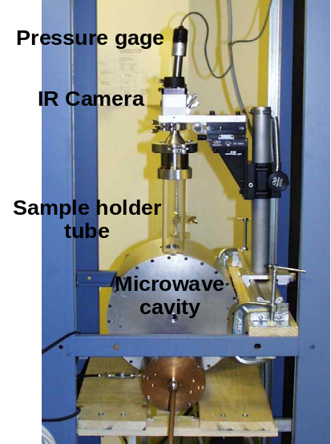
Figure 1. The prototype of the microwave bonding equipment. The current design allows up to 45mm in diameter sample to be fitted in to the sample holder.
Our bonding experiments showed that PMMA is relatively transparent to microwave energy near the 2.4GHz frequency band. This makes PMMA an excellent material for microwave bonding. Most of the microwave energy is absorbed by the thin film metals at the interface, thus minimizing heating in the bulk PMMA substrate. An oscilloscope was attached to a diode antenna that measures the amplitude of the resonance peak in the microwave processing chamber as the frequency was swept from 2.3 to 2.5GHz. Data captured from an oscilloscope is shown in Figure 2. The resonant peak of the empty chamber is shown in Figure 2a. The resonant peak of the chamber loaded with 2 sample blocks of PMMA is shown in Figure 2b. The y-axis is the measured output voltage in milli-volts. We found a maximum reduction in the value of the resonant peak between the loaded and empty chamber configurations of less than 1%. This shows PMMA essentially transparent to microwave energy.

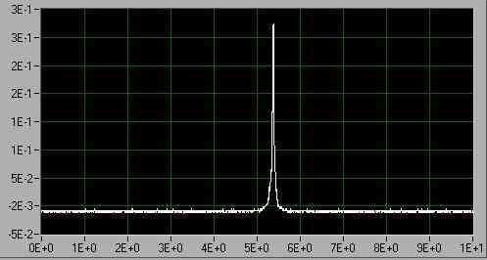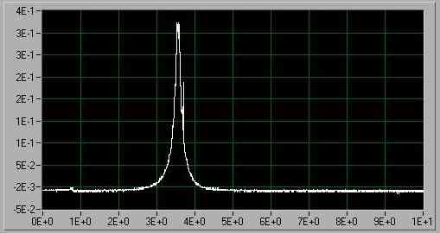
(a)
(b)
Figure 2. Resonant peak in the microwave-processing chamber as the frequency is swept from 2.3 to 2.5GHz (a) Empty chamber. (b) PMMA loaded chamber. The x-axis presents time-sequenced data. The y-axis is the measured output voltage in milli-volts.

EXPERIMENTAL RESULT

A. Silicon to PMMA Bonding

Silicon to PMMA bonding was achieved by using thin film 63% Sn and 37% Pb solder pre-forms to address the problem of PMMA substrate flatness, as shown in Figure 3. The thickness of silicon and PMMA is 1mm and 3mm, respectively. 50nm Cr adhesion layer and 50nm Au bonding layer were e-beam deposited onto both surfaces. The pre-form is 50μm thick and melts at 183°C. Microwave bonding of PMMA to a silicon die is shown in Figure 4. This was done at approximately 30W of applied power for 180 seconds. Note the critical fact that the Au surface of the PMMA was unaffected (by visually examination) after processing and the bulk PMMA was still transparent. It was possible to look through the backside of the PMMA to see the unaffected Au top layer.

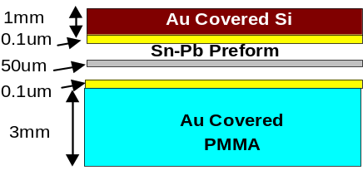
Figure 3. Illustration of die stack for Au covered silicon and Au covered PMMA bonding experiment. Solder pre-form films of 63% Sn and 37% Pb were used to enhance PMMA-Si bonding.

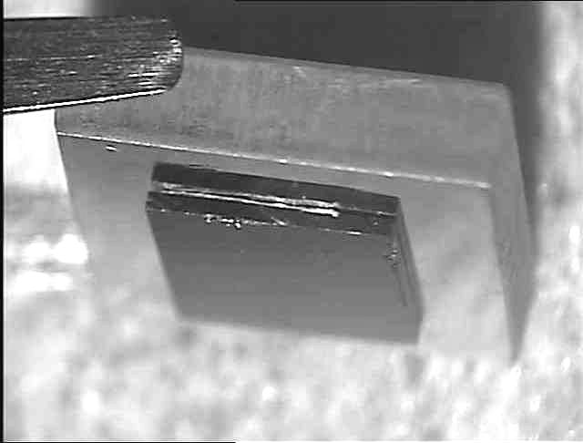
Figure 4. PMMA to silicon bond. Note, the apparent bottom Si substrate is a reflection of the top Si substrate off the Au film on PMMA substrate.

B. PMMA to PMMA Bonding

Embossed PMMA and PMMA bonding is possible via thin film Au already deposited on the surface, as shown in Figure 5. Using hot embossing technique [5], microchannel can be created on the PMMA. 50nm Cr adhesion layer and 50nm Au bonding layer were e-beam deposited onto both embossed PMMA and bare PMMA surface. An example of two PMMA substrates successfully bonded together is shown in Figure 6. Two substrates were bonded at 10W for approximately 120 seconds. Again, the substrates were not affected based on visual examination after the microwave bonding processing.

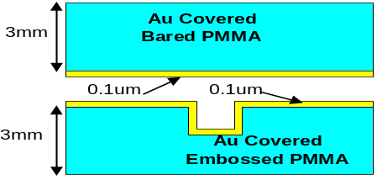
Figure 5. Illustration of showing the dimensions of the PMMA substrates and Au thin film layers used in the PMMA-PMMA bonding experiment.

An SEM image of the cross section of the PMMA-PMMA substrates is shown in Figure 7. In this figure we found the thickness of interfacial layer is approximately 1μm and results in a precise and well-controlled layer. From the EDX spectra, as shown in Figure 7b, the interfacial layer composes of the mixture of Au and carbon, which indicates that the microwave energy melted the Au layer causing localized melting of the PMMA substrates to be bonded. This bond was shown to hold the substrates together under applied pressure greater than 100lb/in².
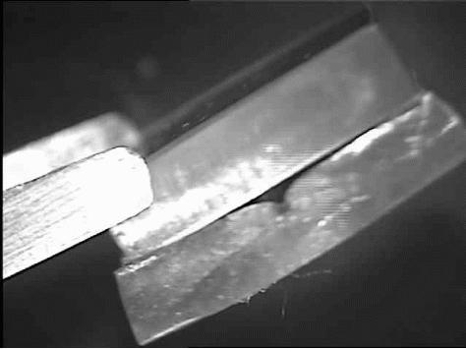
Hot embossed micro channel
Figure 6. Embossed PMMA to bare PMMA bond.

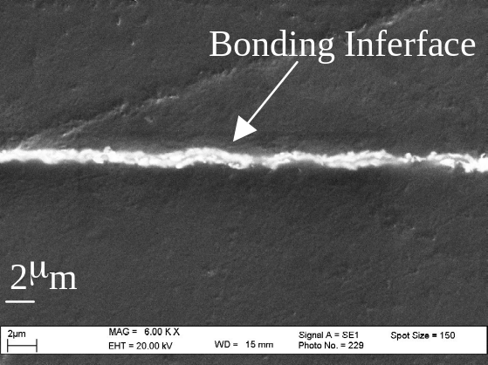
(a)
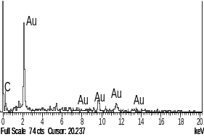
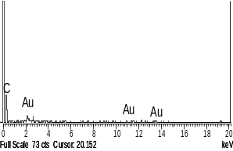
Figure 7. (a) SEM image of PMMA to PMMA bonding interface. (b) EDX spectra of interface region showing that it mainly composes of Au. (c) EDX spectra of PMMA, showing that it is most carbon.
(b)
(c)

C. Si-In to Au-PMMA Bonding
We have also successfully bonded PMMA substrates with patterned Au layers to Si substrates with patterned In layers. The Si substrates are 1cm x 1cm x 400μm thick, lightly doped silicon covered with patterned thin film layers of 30nm Cr, 100nm Au and 2μm In. The PMMA substrates are 2mm thick with patterned thin film layers of 50nm Au and 50nm Cr. Samples were bonded using less than 5W of power in less than 60 seconds. An example of bonded substrates is shown in Figure 8.
IR measurements, as shown in Figure 9, were carried out in real-time during the some of the bonding process to study the temperature distribution on the bonding substrates (in all of the bonding combinations described in this section). In general, we found that some parts of the bonding substrates reached 70°C, which is below the melting temperature of PMMA, but the bulk of the bonding substrates remained near room temperature. After the microwave bonding process, the transparency of bulk PMMA was not changed and there was no global deformation to the substrates.
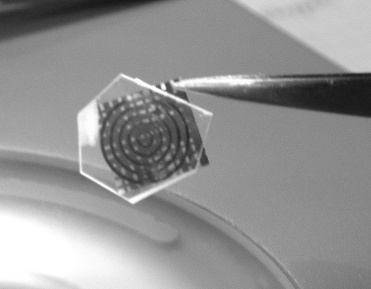
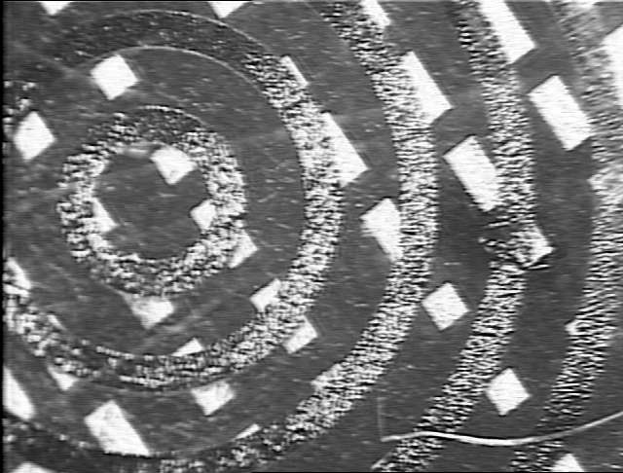
PMMA substrate with patterned Au “rings”
Si substrate with patterned In “grids”
Figure 8. An example if Si-In to Au-PMMA bond. Note that the PMMA is still transparent after the bond and the Au “rings” are still clearly defined. This proves that microwave bonding affects only the interfacial metal layer and will not globally heat the PMMA substrate.
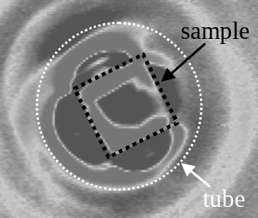
Figure 9. IR image of PMMA stack in the microwave chamber after 20W of power is applied for 5 seconds. Note that edges are heated (darker shade), possibly caused by IR emission from gold visible on the sides of the sample due to misalignment; IR reflection from the sides of the sample holder tube is also visible. Clearly, the center body of the PMMA stack is near room temperature (stripes).
70ºC
23ºC
FUTURE WORK
We have already demonstrated that it is possible to produce micro/nano structure using a standard hot embossing technique [7], as shown in Figure 10; however, none of the existing bonding techniques, such as thermal-compression, ultrasonic, or gluing, would allows us to seal them. From the above initial microwave bonding results, we have proved that microwave bonding can be used to bond polymer substrates to Si or other polymer substrates. So, our ongoing work is to use microwave bonding technique to seal the micro cavities by lithographically patterned metal lines around the cavities and bond them with a flat substrate. The fabrication process is shown in Figure 11. The micro cavities are first formed by hot embossing process. Next, 50nm Cr adhesion layer and 50nm Au bonding layer are e-beam deposited on the substrate surface. Following lithography, substrate is patterned with AZ-5214 photoresist. Then, Au etch, plasma etch (to remove photoresist) and Cr etch are utilized to produce metal lines on the substrate surface. Finally, microwave bonding is performed for sealing the micro structure. We will report our experimental results shortly on this process.
CONCLUSIONS
A low temperature bonding technique for polymer-based substrates to achieve a precise and well-controlled bonding interfacial layer has been described. These initial results indicated that microwave bonding has great advantages over thermal-compression and other conventional polymer to polymer bonding techniques, especially when micro/nano structure is to be encapsulated. For micro/nano fluidic applications, microwave bonding will give much advantage for bonding polymer substrates to make functional devices.
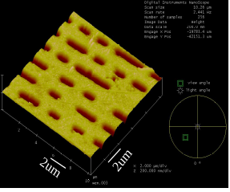 | 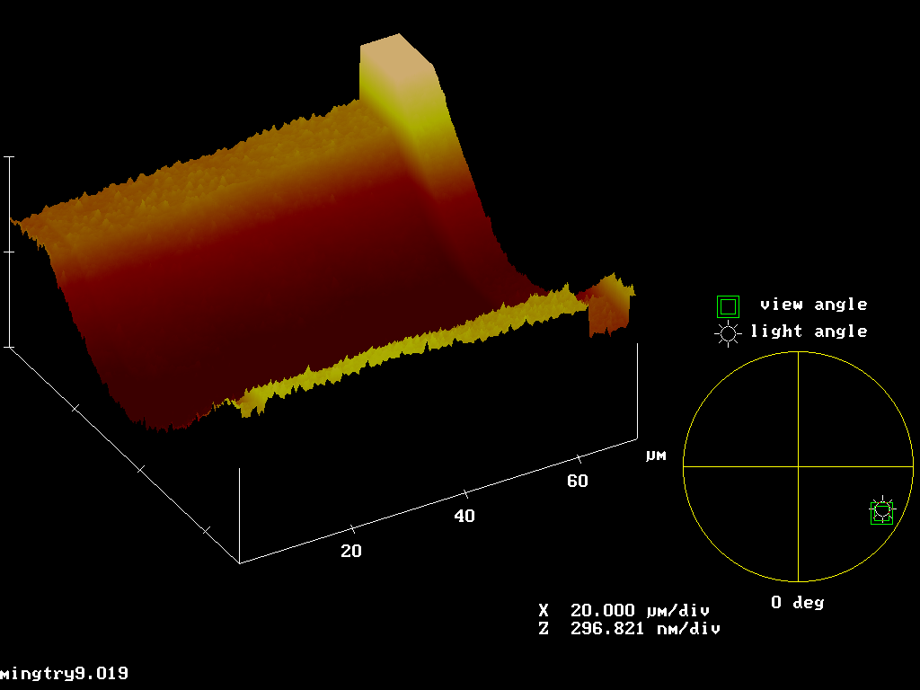
Figure 10. (Left) SPM image of a molded PMMA substrate with nano-cavities. The cavities have dimensions of width ~680nm, depth ~200nm, and lengths of ~1.08μm, ~2.19μm, ~3.88μm, respectively. (Right) AFM image of a micro channel made by compact disc based injection molding process. The dimension is 51.9μm in width, 283.2nm in depth.
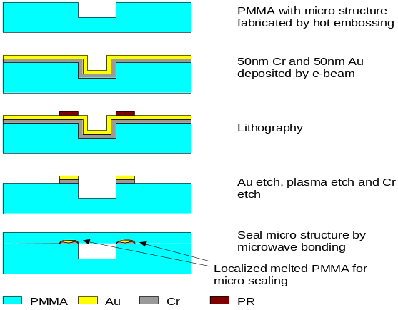
Figure 11. Fabrication process of closed micro structure.
References
[1] Nasser Budraa, H. W. Jackson, M. Barmatz, William T. Pike, and John D. Mai, “Low Pressure and Low Temperature Hermetic Wafer Bonding using Microwave Heating”, IEEE MEMS 1999, Orlando Florida, January 17-21, 1999.
[2] Keith Thompson, Yogesh Gianchandani, John Booske, and Reid Cooper, “Si-Si Bonding Using RF and Microwave Radiation”, Transducers 2001.
[3] Andrey Bayrashev, and Babak Ziaie, “Silicon Wafer Bonding with an Insulator Interlayer Using RF Dielectric Heating”, IEEE MEMS 2002, Las Vegas, NV, January 20-24, 2002.
[4] Jongbaeg Kim, Mu chiao, and Liwei Lin, “Ultrasonic Bonding of In/Au and Al/Al for Hermetic Sealing of MEMS Packaging”, IEEE MEMS 2002, Las Vegas, NV, January 20-24, 2002.
[5] Gwo-Bin Lee, Shu-Hui Chen, Guan-Ruey Huang, Wang-Chou Sung, and Yen-Heng Lin, “Microfabricated Plastic Chips by Hot Embossing Methods and Their Applications for DNA Separation and Detection”, Sensors and Actuators B 75, pp. 142-148, 2001.
[6] A. F. Harvey, Microwave Engineering, pp.247-252, academic Press, New York, 1963.
[7] Victor K. W. Li Chong, K. F. Lei, Wen J. Li, and Thomas Y. S. Lee, “Development of Mass-Manufacturable Micro/Nano Fluidic Devices Using Standard CD Fabrication Technology”, IMU2 2003, Taiwan, 2003.

