Dielectrophoretic Batch Fabrication of Encapsulated Carbon Nanotube Thermal Sensors

Carmen K. M. Fung and Wen J. Li*
Centre for Micro and Nano Systems
The Chinese University of Hong Kong, HKSAR
*Contact Author: wen@acae.cuhk.edu.hk

Abstract

This paper presents the batch fabrication technique of carbon nanotubes (CNTs) micro thermal sensors by utilizing AC electrophoretic CNTs manipulation and embedding CNTs in polymer thin films. By utilizing electrophoretic technology, bundled multi-wall carbon nanotubes (MWNTs) were successfully and repeatably manipulated across micro-fabricated electrodes. Besides, a surface micromachining fabrication process to embed bundled MWNTs inside parylene C polymer film layers was developed. This encapsulation process ensures that the MWNTs elements can be protected from moisture and contaminates in an operational environment, and thus, allow the sensors to be useful for potential application such as temperature measurement in water or as ultra-sensitive sensors in manufacturing plants. Preliminary results showed that encapsulated MWNTs-based micro sensors exhibited ultra low power consumption (~µW) and fast frequency response (>100 kHz) in constant current mode circuit operation. Our developed technology provides a basis and a cost-effective approach for MEMS research community to fabricate CNTs based sensor in batch mode efficiently.

Keywords: batch manipulation, carbon nanotubes, micro sensors

1 INTRODUCTION

CNTs have been extensively studied for their electrical and mechanical properties in the past decade [1][2]. In order to build a CNT based device, reliable batch assembling of CNT devices has to be developed. Currently, in order to manipulate a post-growth CNTs to a desired position of a substrate, atomic force microscopy (AFM) [3] can be employed. However, it suffers from relatively long operation time to create a functional CNTs device on a chip. On the other hand, it was shown by K. Yamamoto et al. that carbon nanotube can be manipulated by AC and DC electric field [4][5]. By using the similar technique, our group has applied electric-field assisted approach to manipulate bundles of CNTs [6] and offer a fast and efficient way to assemble functional nanodevices in a single-run fashion. Our current work is to develop a robust protection scheme to protect the CNT sensing elements to minimize the sensing variations in different fluidic media. With our experimental evidence, our embedded CNT sensors are capable of operating in µW range which is an ultra low power consumption level for applications like shear stress and thermal sensing (e.g., in the order of mW range for typically MEMS polysilicon devices [7]) and can be fabricated in batch mode efficiently by using the electric-filed assist technology. The fabrication process and experimental characterization, such as temperature sensitivities in air and fluidic media, I-V characteristics and frequency response of the parylene film embedded CNT sensor will be presented in this paper.

2 PARYLENE FILM EMBEDDED MWNT SENSORS

2.1 AC Electrophoretic Batch CNT Manipulation
We have demonstrated previously in [6] that MWNTs can be manipulated across micro-fabricated electrodes by using AC electrophoretic manipulation. Detailed theoretical and experimental aspects on AC electrophoretic CNT manipulation have been reported by our group [6]. In order to use the same technique to batch fabricate the CNT embedded sensors, an array of CNT sensors were designed and the detailed fabrication process of the CNT embedded sensors will be presented in the next section. To prove the validity of batch assembling by AC electrophoresis, we have implemented the experimental procedures mentioned in [8] and extended to an array of microelectrodes which are electrically connected together on a substrate (see Figure 1). By using the same experimental parameters presented in [8], we have successfully manipulated the CNT bundles on most of the gold (Au) microelectrodes by AC electrophoresis in a single-run fashion. In order to confirm the linkage of bundled CNTs across two microelectrodes, the room temperature resistance corresponding to each pair of microelectrodes was measured.
To validate the consistency of the batch assembly of CNT devices, repeated experiments for AC electrophoretic batch manipulation of CNTs between the arrays of Au microelectrodes were performed and plots of statistical data for different experiments were generated (see Figure 2). From the experimental results, we have observed that the range of the room temperature resistances is from several kΩ to several hundred kΩ. Besides, we have experimentally found that the successful rate for different sensor chips are consistent with overall successful rate to be equal or greater than 70%.
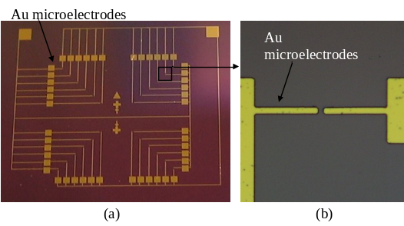
Figure 1. (a) Photograph of the fabricated array of Au microelectrodes on a substrate. (b) Optical image showing a pair of Au microelectrodes before CNT manipulation.
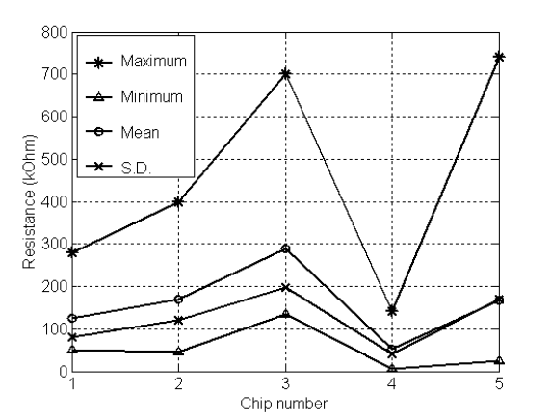
Figure 2. Plots of statistical data of measured resistances between the Au microelectrodes on different samples.

2.2 Fabrication Process
By using the technique to manipulate CNT bundles across the microelectrodes of the fabricated sensors and embed it inside polymer thin film, a surface micromachining fabrication process was developed to batch fabricate the polymer films embedded CNT sensors. As seen in Figure 3, in order to avoid conduction of the Au electrode with the substrate, SiO₂ was first deposited on the silicon substrate. Since the polymer film embedded CNT sensor can be potentially used for different sensing purposes, a trench under the sensor is fabricated for particular applications, such as mechanical and fluidic sensing. In order to provide a trench, a sacrificial layer was deposited on the substrate. Aluminum was used as a sacrificial layer of the sensor and was deposited by using thermal evaporation on the substrate. The bottom parylene C layer was then deposited on the substrate to isolate the MWNT bundles from the substrate. The Au and Chrome (Cr) microelectrodes with the distance between 3μm and 10μm were patterned on the substrate and Cr was used to improve the adhesion of Au to the substrate. Based on the technique for CNT manipulation presented in [8], the bundled MWNTs was manipulated and connected across the microelectrodes of each sensor (by observing the resistance change between the electrodes). Afterwards, the top parylene C layer was deposited to embed the MWNTs and protect them from contamination. Finally, the sacrificial layer was released to serve as mechanical micro bridges that suspend the MWNT sensors across the Au electrodes. The final structure of the CNT embedded sensor is shown in Figure 4.
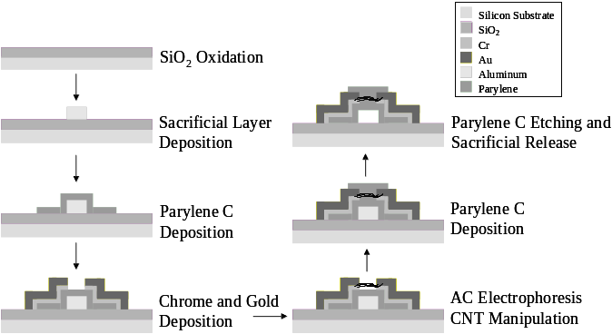
Figure 3. Fabrication process of polymer film embedded CNT sensors.
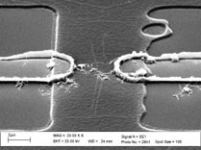
(a)
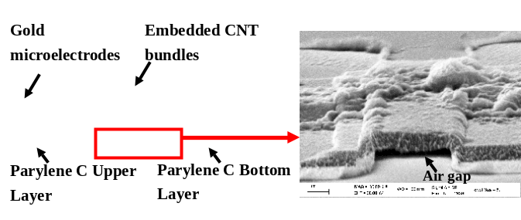
(b)
Figure 4. Scanning electron microscopic (SEM) images showing (a) bundles of MWNTs was resting on the lower parylene layer and bridging against the microelectrodes; (b) the final sensor structure and bundles of MWNTs was embedded inside the parylene C thin films.

3 EXPERIMENTAL CHARACTERIZATION

In order to utilize the polymer film embedded CNT sensor in different sensing applications, several important parameters such as frequency response and I-V characteristics have to be determined experimentally. By comparing to the results collected for the un-encapsulated MWNT devices reported in [8], the resistance for these embedded CNT sensors is more stable and consistent. We have also proved that these embedded based MEMS sensors have ultra low power consumption and high frequency response. Details of the experimental results are discussed in this section.
Similar to those CNT sensor without parylene C protection [8], the chip of array of fabricated polymer film embedded CNT sensors has been driven in constant current (CC) mode configuration (see Figure 5) and then placed inside an oven (L-C oven, Lab-Line® Instrument Inc.). A type-K thermocouple was attached on the PCB to monitor the temperature inside the oven and the readout was determined by a digital multi-meter (Fluke 16). The resistance change of the sensor was then measured by another digital multi-meter (Hioki 3804 Digital Hitester). The temperature range for the temperature coefficient of resistance (TCR) measurements was from 25ºC to 60ºC in each experimental run. The resistance changes of the polymer films embedded CNT sensor against temperature was shown in Figure 6. It showed that the resistance dropped with temperature and the curves were consistence in three repeated measurements. The range of the TCR for the MWNT sensors was found to be from -0.05 to -0.11 %/°C, which are closely matched with our previous experimental determination of TCR (-0.12%/oC to -0.15%/oC) on CNT sensors without parylene C protection [8].
Moreover, power consumption of the polymer film embedded CNT sensor was investigated and the I-V characteristic of the sensor was shown in Figure 7. It was found that the current required to heat up the sensor to non-linearity region (or Joule-heating) was in the range of µA at several volts as depicted from Figure 7. It implies that the power consumption of the polymer film embedded CNT sensor is in the order of µW, which is three orders of magnitude lower than conventional MEMS thermal sensors whose power consumption are in the order of mW [7].

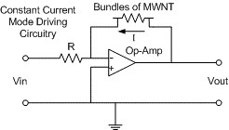
Figure 5. Constant current mode circuit.
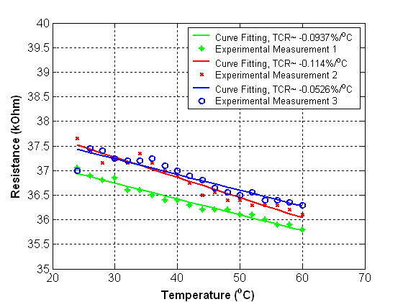
Figure 6. Three repeated measurements of thermal sensitivities of the polymer film embedded CNT sensor.
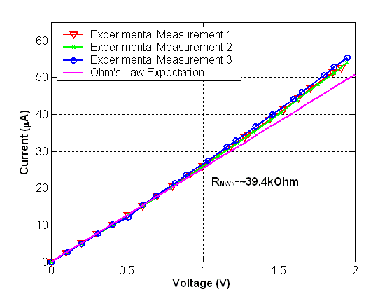
Figure 7. I-V characteristics of the polymer film embedded CNT sensor.

To test the frequency response of the polymer film embedded CNT sensor, the sensor was hybridly integrated into a constant current mode circuit (see Figure 5) and a input square wave (amplitude = 3V peak-peak; frequency = 19 kHz) was fed into the negative input terminal of the CC mode circuit by a signal generator and the output response was then determined from a oscilloscope (see Figure 8). From our experimental measurements, the estimated cutoff frequency of the device was about 148 kHz, which shows that the sensors exhibited very fast frequency response.
Owing to ultra low power consumption of polymer film embedded CNT sensors, CNT can sense the surrounding physical parameters (such as temperature or fluid motion) with minimal thermal disturbances to the environment as presented before. Therefore, CNT is very promising to sense the physical parameters in micro scale or even nano scale world where the true parameters are easily overwhelmed by thermal disturbances. In order to investigate the thermal sensing ability of the polymer film embedded CNT sensor insides a fluidic media, the sensor was put inside DI water and placed on a digital hot plate. By changing the temperature, the resistance change of the sensor was measured by a digital multi-meter. The resistance changes of the polymer film embedded CNT sensor against temperature were shown in Figure 9. The preliminary results showed that the fabricated CNT embedded sensor can sense the temperature activities of the fluid and at the same time, the CNT sensing elements will not be disturbed by the chemical species, as they have been protected by the pinhole-free Parylene C layers.

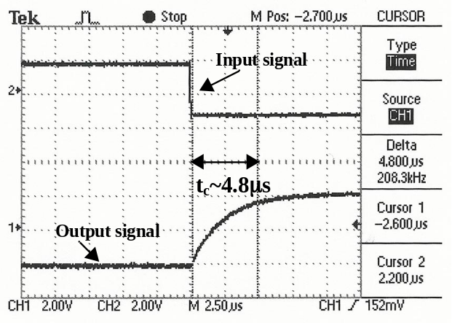
Figure 8. Frequency response of the polymer film embedded CNT sensor.
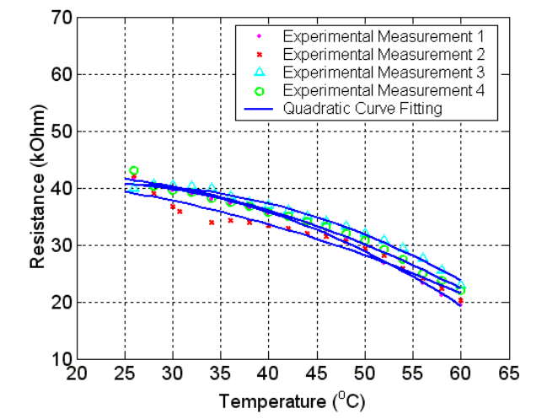
Figure 9. Thermal sensing of polymer film embedded CNT sensor inside fluidic media (DI water). Four repeated measurements have been performed on the sensor with reasonable repeatability.

4 CONCLUSION

A technique to batch fabricate polymer film embedded CNT sensor based on dielectrophoretic manipulation was presented. We have proven that the success rate for batch assembling the bundled CNT sensor is equal or greater than 70%, which demonstrated that dielectrophoretic manipulation is a feasibility technology to batch assemble CNT functional devices. Besides, the electrical characterizations of the polymer film embeeded CNT sensor such as TCR, frequency response, I-V characteristics were also investigated. The parylene C thin film does not affect the intrinsic thermal sensing properties of CNTs as determined experimentally. Our developed fabrication process provide a fast and efficient alternative for MEMS/NEMS research communities to fabricate good performance CNT-based thermal sensor for the areas of aero-dynamic and nano-biotechnology researches.

5 ACKNOWLEDGEMENTS

This project is funded by the Hong Kong Research Grants Council (Grant No. CUHK 4381/02). The authors would like to sincerely thank Mr. Victor T. S. Wong of Mechanical and Aerospace Engineering of UCLA, Dr. W.Y. Cheung of the Department of Electronic Engineering of CUHK, and Mr. King W. C. Lai of Centre for Micro and Nano Systems, CUHK for their contributions to this project.

REFERENCES

[1] S. Frank, P. Poncharal, Z.L. Wang, W.A. de Heer, “Carbon Nanotube Quantum Resistors”, Science, vol. 280, pp. 1744 – 1746, 1998.
[2] E.W. Wong, P.E. Sheehan, C.M. Lieber, “Nanobeam Mechanics: Elasticity, Strength, and Toughness of Nanorods and Nanotubes”, Science, vol. 277, pp.1971 – 1975, 1997.
[3] T. Shiokawa, K. Tsukagoshi, K. Ishibashi, Y. Aoyagi, “Nanostructure Construction in Single-walled Carbon Nanotubes by AFM Manipulation”, Proceedings of Microprocesses and Nanotechnology Conference 2001, pp. 164 – 165, 2001.
[4] K. Yamamoto, S. Akita, Y. Nakayama, “Orientation of Carbon Nanotubes Using Electrophoresis”, Japanese Journal of Applied Physics, vol.35, L917-L918, 1996.
[5] K. Yamamoto, S. Akita, Y. Nakayama, “Orientation and Purification of Carbon Nanotubes Using AC Electrophoresis”, Journal of Physics D: Applied Physics, vol. 31, L34-L36, 1998.
[6] Victor T. S. Wong and Wen J. Li, "Bulk carbon nanotubes as sensing element for temperature and anemometry micro sensing", IEEE MEMS 2003, pp.41 – 44, 2003.
[7] C. Liu, J.B. Huang, Z. Zhu, F. Jiang, S. Tung, Y.C. Tai, C.M. Ho, “A Micromachined Flow Shear-Stress Sensor based on Thermal Transfer Principle”, Journal of Microelectromechanical Systems, vol. 8, No. 1, pp. 90 – 99, 1999.
[8] Victor T. S. Wong and Wen J. Li, "Bundled carbon nanotubes as electronic circuit and sensing elements", IEEE ICRA 2003, vol. 3., pp.3648 –3653, 2003.

