Development of an AA Size Energy Transducer with Micro Resonators

Johnny M.H.Lee^{1,2}, Steve C.L.Yuen³, Wen J.Li^{1,2,}* and Philip H.W. Leong³
¹Center for Micro and Nano Systems
²Dept. of Automation and Computer-Aided Engineering
³Dept. of Computer Science and Engineering
The Chinese University of Hong Kong,
Shatin, N.T., Hong Kong SAR

ABSTRACT
This paper presents the preliminary design and experimental results of a standard AA size vibration-induced micro energy transducer which is integrated with a power-management circuit. The generator is a spring mass system which uses laser-micromachined copper springs to convert mechanical energy into electrical power by Faraday’s Law of Induction. A power-management circuit is used to step up the AC output and act as a reservoir to store the electrical energy generated. Our goal is for the generator to provide 3V DC output with low input mechanical frequencies, and will produce enough power for low-power wireless applications. Potential applications for this micro power generator such as serving as a power supply for infrared transmission and radio frequency transmission was proved to be possible.
Keywords: micro power generator, micro energy transducer, power-management circuit.
1. INTRODUCTION
Traditional alkaline battery has being used for almost a century, and has brought dramatic revolutions to human life. However, shelf life, replacement accessibility and potential hazards of chemical are some of the problems when chemical batteries are used. Our ongoing work is to develop a brand new power supply with unlimited shelf life and is environmentally safe. Three main advancements in engineering technology in the last 20 years allow possible applications for magnetic-induction based energy transducers: 1) increase in magnetic flux density if rare-earth-magnets; 2) continual reduction of power consumption of low-power circuits and sensor; 3) MEMS fabrication technology that allows precise and low cost production of spring-mass system. Thus far, we have successfully developed a vibration-induced power transducer with total volume of ~1 cm³ [1] and demonstrated it to be useful for IR and RF wireless transmissions. When input vibration frequencies ranging from 60 to 110Hz with ~200μm amplitude is provided, the generator is capable of producing up to 4.4V peak-to-peak, which have a maximum rms power of ~680μW with loading resistance of 1500Ω. We are now targeting to develop a micro power generator integrated with a power-management circuit with total dimension equal to an AA size battery. The development of this AA size micro power generator is presented in this paper.
*Contacting Author : wen@acae.cuhk.edu.hk; CMNS, The Chinese University of Hong Kong, MMW Bldg., Room 422 Shatin, NT, Hong Kong SAR; phone: +852 2609-8059; fax: +852 2603-6002.
This project is funded by a grant from the Hong Kong Innovation and Technology Commission (ITF/185/01)
Research on micro power generator has been done by scientists throughout the world. Williams and Yates has developed an electromagnetic micro generator to produce 0.3μW in 1997 [2], Amirtharajah & Chandra-Kasan has used a vibration-based power generator to drive a signal processing circuitry in 1998 [3]. Nevertheless, neither of them has fabricated a micro power generator which integrated with a power-management circuit that have enough power to drive an off-the-shelf circuit.
2. GENERATOR PRINCIPLE
AND DESIGN
The prototype micro power generator is consist of five main components: 1) inner and outer housing which is used to carry the resonating structure and the power generating system, respectively, 2) a laser-micromachined resonating spring with spring constant k, 3) a N45 grading rare earth permanent magnet of mass m and magnetic field strength B, 4) copper coil of length l, and 5) a power-management circuit for output voltage step up and energy storing purpose. The resonating spring is attached to the magnet and packed by the inner housing. The orientation of inner housing, magnet and the resonating spring is shown in Figure 1a, and the illustrative drawing of AA size’s micro power generator is shown in Figure 1b.
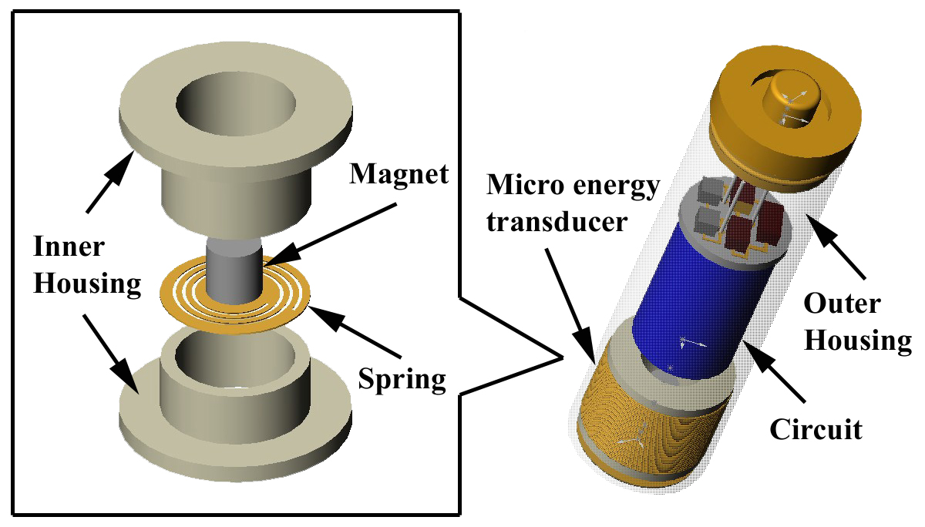
(a) | (b)
Figure 1. Illustrations of : (a) Inner structure of the micro power generator; (b) the AA size micro power generator which is integrated with a power-management circuit.
When the generator housing is vibrated with an amplitude of y(t) , the magnet will vibrate with a relative amplitude of z(t). This relative movement of the magnet results in the varying amount of magnetic flux density cutting through the coil. According to Faraday’s law of electromagnetic induction, a voltage is induced in the loop of coil. The average power output of the vibration-induced power generating system can be derived as [4]:
Eq.1
where ξ_{e} is the electrical damping factor, Y₀ is the input vibration amplitude, ω is the input vibration frequency (angular), ω_{n} is the resonance frequency of the spring-mass system and ξ is the sum of electrical damping factor and mechanical damping factor of the system. From the above equation, at resonance, the average power and voltage output is maximized:
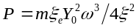 Eq.2
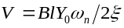 Eq.3
Based on the above equations, the power generator will have maximum power and voltage output when vibrating in resonance frequency with maximum amplitude and electrical damping factor. Using a spring constant k ~ 40 N/m, damping ratio ~0.01, magnet weight 140mg, magnetic field strength 3600 Guass and input vibration amplitude ~150μm, we performed Matlab simulations and compare with experimental results. The result was close to experimental measurement and the comparisons are shown in Table1.
Table 1: Comparison between experimental and simulation results.
 | Experimental results | Simulation results
V_{L}(R_{L} = 0Ω) | 4 V p-p | 4 V p-p
V_{L} (R_{L}=1000Ω) | 2.58 V p-p | 2.71 p-p
P (R_{L}=1000Ω) | 830 μW | 919 μW

3. DESIGN OF RESONATING STRUCTURE
The resonance frequency of the spring-mass system depends on the materials used for the resonating structure, and hence, the choice of spring material will affect the performance of power generator. Copper was chosen to be the material for the resonating structure because of its relatively low Young’s modulus and high yield stress where compared to Silicon (See [6]). Some other materials such as brass, titanium and 55-Ni-45-Ti can also be considered, depending on the operation environment. For instance, titanium should be used if the power generator is designed to vibrate in extremely large displacement, as its yield stress is higher than copper. We have experimentally verified that brass and 55-Ni-45-Ti resonating structures could obtain a lower resonance frequency than copper due to their lower Young’s modulus. The material properties of some potential metals which may be suitable to fabricate the resonating spring are compared in Table 2.
Table 2: Potential materials for the resonating spring [5].
 | Young’s modulus  (GPa) | Yield Stress  (MPa) | Ultimate Stress  (MPa) | Fatigue Limits  (MPa) | Fatigue Ratio
Aluminum | 70 | 270 | 310 | 21 | 0.30
Brass | 96 – 110 | 70 – 550 | 200 – 620 | 98 - 147 | 0.31
Copper | 130 | 55 – 760 | 230 – 830 | 63 | 0.29
Nickel | 200 | 100 – 620 | 310 – 760 | 109 | 0.35
Titanium | 120 | 760 – 1000 | 900 – 1200 | 364 | 0.59
55-Ni-45-Ti | 83 | 195 – 690 | 895 | --- | ---
Silicon | 160(ave) | --- | --- | --- | ---

Using ANSYS to simulate the resonating structures, it was found that springs with spiral geometry have lower spring constant and stress concentration than other designs, such that a larger displacement can be obtained [6]. We have used a Q-switch Nd:YAG (1.06μm wavelength) laser to micromachine the spiral resonating spring as shown in Figure 2a and b. A copper spring with diameter of 8mm and 0.1mm thickness will be used for the AA size micro power generator.
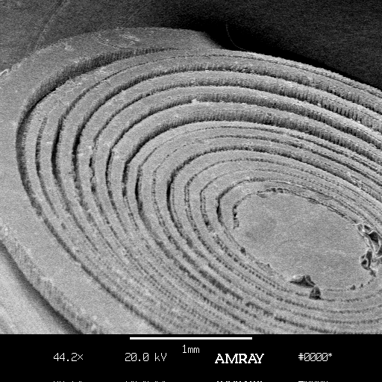 | 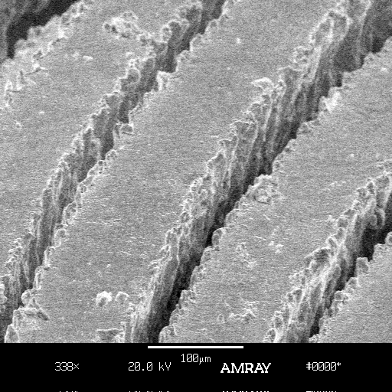
(a) | (b)
Figure 2. SEM pictures of : (a) a laser-micromachined copper spring with diameter of 5mm;. (b) close up of the copper spring; width of the spring is ~100μm.
The micro power generator was experimentally found to have different motion of resonance vibration in different frequencies. It gave relatively high voltage at higher frequencies even though the vibration amplitude was almost negligible in the vertical direction. The 3 different modes of vibration captured by a strobe light is shown in Figure 3a to 3c. It was observed that the spring was vibrated vertically in 1st mode, but appeared to cyclically rotate about an axis parallel to the plane of the coil in 2nd and 3rd mode.
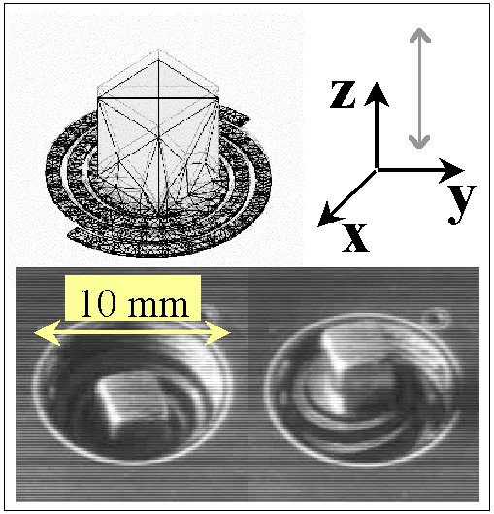 | 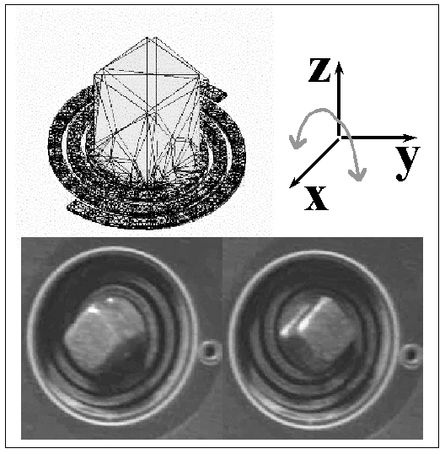
(a) | (b)
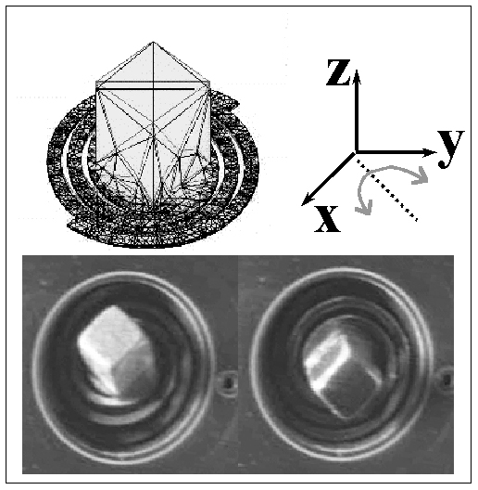 | 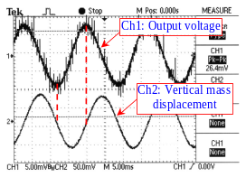
(c) | (d)
Figure 3. Simulation and experimental results for 3 different resonance vibration modes were matched: (a) 1st mode vibration (vertical); (b) 2nd mode vibration (rotation about x axis); (c) 3rd mode vibration (rotation about an axis between x and y axis); (d) The phase difference between the output voltage of the generator and vertical displacement of the magnet at the 3rd mode vibration.
Based on the experimental was designed to vibrate in a horizontal plane with rotation results, we believe if the a spring instead of vibrating vertically, the voltage output can be increased and the stress on the spring can be reduced. This can be explained by Faraday’s Law of induction which stated that the voltage output should be proportional to the rate of changing magnetic flux. Therefore the faster the translation and rotation of the mass, the greater current induction. As shown in Figure 3d, at 3rd mode resonant vibration, the faster the rate of change of vertical displacement (i.e., slope of Ch2, which represents the “angular velocity” of the magnet), greater is the voltage induced.
Using laser-micromachining to fabricate the copper spring is direct, fast, but the cutting resolution is not ideal (see Figure 2b). We are now developing another process which will involve high-aspect-ration electroplating of copper using lithographic techniques.

4. POWER – MANAGEMENT
CIRCUIT DESIGN
A quadrupler circuit was integrated with the micro power generator to step up and rectify the AC output to DC voltage. The schematic diagram of quadrupler, complete power-management circuit and the rectifying performance for quadrupler compared with tripler and doubler is shown in Figure 4. The prototype circuit was built using KEMET type T491 10μF, 10V capacitors and Toshiba 1SS374 Silicon Epitaxial Schottky Barrier Type diodes. The 1SS374 diode was chosen as it has relatively low forward voltage (0.23V) which allows an increase in efficiency of the quadrupler. A capacitor of 1.2mF is connected with the quadrupler and act as a reservoir to store the electrical energy generated by the micro power generator.
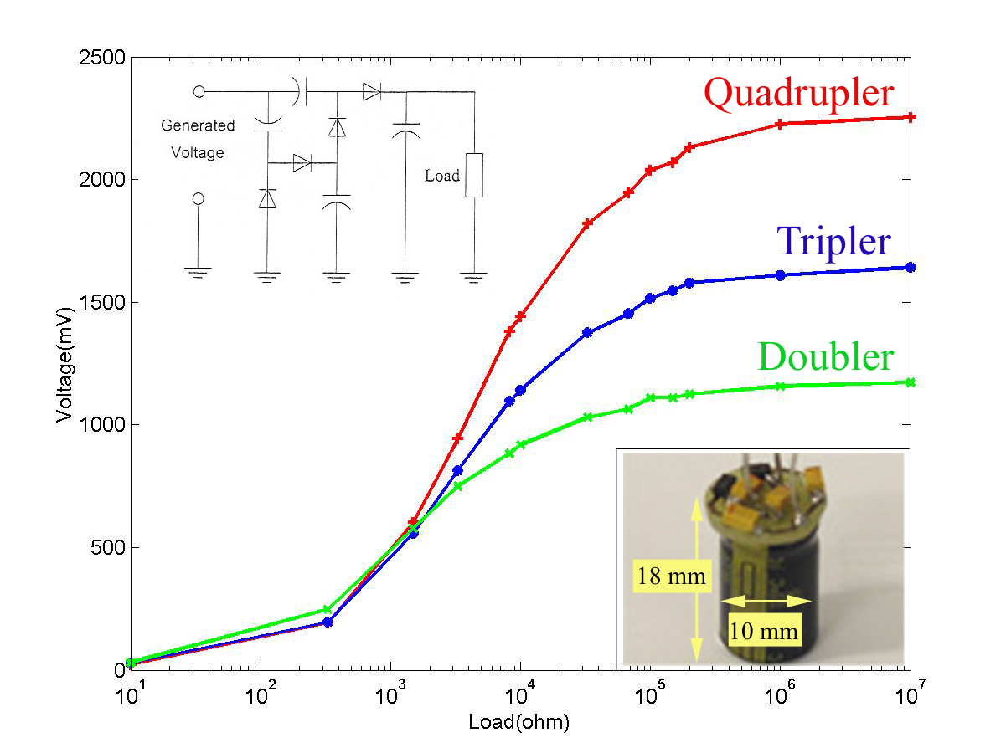
Figure 4. Schematic diagram, picture of quadrupler and comparison on performance for quadrupler, tripler and doubler.
5. APPLICATIONS
5.1 Infrared Transmission
An Infrared (IR) transmitter was built using a commercial SM5021 encoder chip. Experimental result shows that this circuit could operate properly with a voltage as low as 1.8V. An IR signal would be sent to a receiver every time a key was pressed. The signal was a 140.8ms long IR pulse train. For a 2.0V power supply, the current drawn during a key press was measured to be 1.5mA and, in standby mode, 2.4μA. We have used a ~1cm³ volume micro energy transducer to successfully drive the above IR transmitter (as reported in [1]). The schematic diagram for this system is shown in Figure 5.
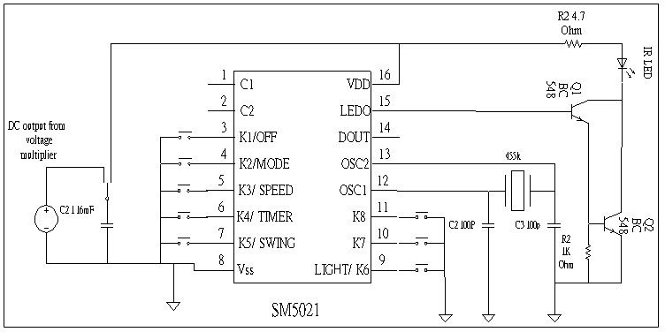
Figure 5. Diagram of the commercial SM5021 encoder chip
5.2 RF Temperature Transmission
We have also demonstrated that the ~1cm³ volume micro energy transducer is able to drive a 914.8MHz FM wireless temperature sensing system [7]. The schematic diagram of this system is shown in Figure 6. A microcontroller is used to instruct the temperature sensor to convert the ambient temperature to digital format and read the converted temperature through 3-wire communication protocol. The controller then sends the data serially to the TXD pin of the transmitter, which will modulate the digital temperature data into FM signal at 914.5MHz to be received by the receiver module at a distance of 25m. The transmitted data is readily available in digital form from RXD pin of the receiver.
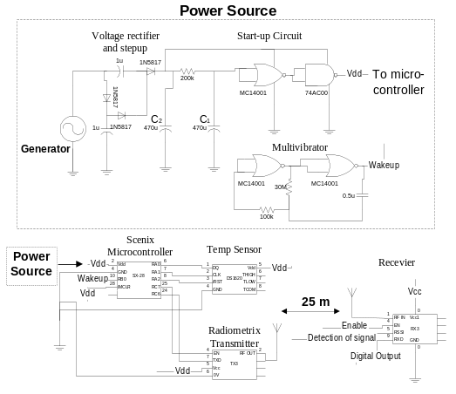
Figure 6. Schematic diagram of the wireless temperature sensing system.
5.3 RF Transmission to off-the-Shelf FM Radio
Another potential application for the micro power transducer is to use it to power a wireless temperature transmitter to transmit data to an off-the-shelf FM radio. This system contains a transmitter circuit and a receiver circuit. The transmitter side consists of a digital thermometer DS1620, a microcontroller SX28 and a FM transmitter. The circuit diagram of FM transmitter is shown in Figure 7.
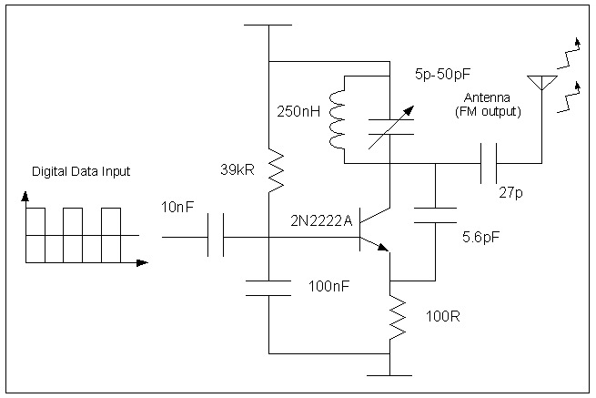
Figure 7. Circuit diagram for the FM transmitter.
The receiver side consists of a commercial FM radio receiver. When the transmitter powers on or gets reset, the microcontroller instructs the digital thermometer to convert the ambient temperature to digital format via a three-wire communication protocol. Once the temperature conversion is completed, the microcontroller packs the data into the frequency-shift-keying (FSK) format and sends it to the FM transmitter serially. The commercial radio on the receiver side then gets the data immediately. This circuit consumes 7.6mA at 3V in continuous mode and consumes 75uA at 1% duty cycle. We are currently building the AA size power source to generate sufficient power to drive the transmission system described above. The results will be reported at the conference.
6. CONCLUSION
We have designed a magnet-based AA size micro power transducer that converts mechanical energy into electrical power by Faraday’s Law of Induction. Potential applications using the micro power source for wireless (IR and RF) transmission systems were shown to be possible. We have also found that if the resonating spring is designed to vibrate horizontally with a vertical input vibration, significantly higher output voltage for the generator could be obtained.
Future work for this project include 1) using ANSYS modeling to aid the design of low frequency resonating springs and springs which give significant horizontal vibrations; 2) development of a MEMS-based process to fabricate the spring-mass and coil system; 3) integration of the generator system with low-power consumption devices. With the growing interests and the advantages of technologies to minimize power consumption of portable systems, we believe our micro power generator will find many applications in the future.
7. ACKNOWLEDGMENT
We would like to thank the Hong Kong Innovation and Technology Commission, Brilliant System Limited, DAKA Development Limited, and Varitronix International Limited for funding this project (ITF/185/01). We also deeply appreciate Magtech Industrial Company (Hong Kong) for donating the permanent magnets needed for this project. Special thanks are due to Thomas K. F. Lei and Gordon M. H. Chan for their contributions to this project.
8. REFERENCES
- Neil N. H. Ching, H. Y. Wong, Wen J. Li, Philip H. W. Leong, and Zhiyu Wen, "A laser-micromachined multi-modal resonating power transducer for wireless sensing systems", Sensors and Actuators, A: Physical, 2002, pp. 685-690.
- C. B. Williams, and R. B. Yates, “Analysis of a micro-electric generator for microsystems”, Sensors and Actuators, A 52, 1996, pp. 8-11.
- R. Amirtharajah, and A.P. Chandrakasan, “Self-powered signal processing using vibration-based power generator”, IEEE J. of Solid-State Circuits, vol. 33, May 1998, pp. 687-695.
- W. J. Li, Z. Y. Wen, P. K. Wong, G. M. H. Chan, and P. H. W. Leong, “A micromachined vibration-induced power generator for low power sensors of robotic systems”, Proc. Of the World Automation Congress, Hawaii, USA, June 11-14, 2000.
- F. Cardarelli, Materials Handbook : A Concise Desktop Reference, Springer-Verlag London Limited, 2000.
- W. J. Li, G. M. H. Chan, N. N. H. Ching, P. H. W. Leong, and H. Y. Wong, “Dynamical modeling and simulation of a laser-micromachined vibration-based micro power generator”, International Journal of Non-linear Sciences and Simulation, vol. 1, 2000, pp. 345-353.
- Neil N. H. Ching, Hiu Yung Wong, Wen J. Li, and Philip H. W. Leong, "A laser-micromachined vibrational to electrical power transducer for wireless sensing systems", 11th International Conference on Solid-State Sensors and Actuators, Munich, Germany, June 2001.

