Ultra-low-power Polymer Thin Film Encapsulated Carbon Nanotube Thermal Sensors
Carmen K. M. Fung and Wen J. Li*
Centre for Micro and Nano Systems, The Chinese University of Hong Kong, Hong Kong SAR
*wen@acae.cuhk.edu.hk

Abstract — A novel polymer thin film embedded carbon nanotube (PECNT) sensor was developed for ultra-low-power micro thermal sensing. The basic fabrication process of this sensor includes AC electrophoretic manipulation of multi-walled carbon nanotubes (MWNT) bundles on a silicon substrate and embedding them inside parylene C layers to provide a robust protection for the bundled MWNTs. This encapsulation process ensures that the MWNT elements can be protected from moisture and contaminates in an operational environment, and thus, allows the sensors to be useful for potential applications such as temperature measurement in water, sensing human touch and body temperature, or as ultra-sensitive sensors in manufacturing plants. The I-V measurements of the resulting devices revealed that their power consumption were in the μW range, which is 3 orders of magnitudes lowered than polysilicon sensors and can be operated at over 20V. Besides, the frequency response of the testing devices was generally over 100 kHz in constant current mode operation. Moreover, from the results of resistance stability measurement, our PECNT sensors remained stable for over at least 20 hours. Based on these experimental evidences, carbon nanotube is a promising material for fabricating ultra-low-power consumption and high frequency response micro sensors for future thermal sensing applications.

Index Terms — CNT, microsensors, nano sensors, nanotube, thermal sensors.

I. Introduction
Low power consumption physical sensing elements are highly sought in the area of aerodynamic and nano-biotechnology research since low power consumption will minimize the thermal disturbance conducted to the fluid medium during physical sensing. Carbon Nanotubes (CNTs), owing to their interesting electrical properties, high thermal conductance and fast frequency response, are suitable to act as good low power sensing elements. In order to utilize CNTs as sensing elements, a number of research groups have previously reported the usage of bundles of CNTs as sensing elements successfully [1]-[3]. Since CNTs have been proven to be sensitive to the presence of molecular species (e.g., NO₂, NH₃ [2] and O₂ [3]), and also some biological species with suitable chemical functionalization schemes [4]-[6], care must be taken to appropriately protect the sensing elements for specific applications. For instance, in order to avoid the influence of molecular species on the electrical conductivities of CNTs during physical thermal sensing, a robust protection scheme must be developed to protect the CNTs to minimize the sensing variations in different fluidic media.
In this paper, we present our latest successful development of a MEMS-compatible process to encapsulate MWNT bundles for reliable tests and measurements. To utilize the PECNT sensors for micro thermal sensing application, the thermal and electrical performance such as temperature coefficient of resistance (TCR), frequency response, I-V characteristics and stability (reliability) of a few sensors were investigated. Our preliminary results showed the resistance of these embedded CNT sensors is more stable and consistent compared with the results collected from the un-encapsulated MWNT devices reported by our group in 2003 [7].

II. Fabrication Process of Polymer Thin Film Embedded CNT Sensors
The fabrication process for the PECNT sensor is shown in Fig. 1. The novelty of this fabrication process involved the usage of AC electric filed to manipulate CNTs bundles across microelectrodes, and the use of parylene C polymer to protect the bundles against contaminates. Detailed theoretical and experimental aspects of dielectrophoretic manipulation of CNT were reported by our group previously in [7]. As seen in the fabrication process, around 1μm SiO₂ was first deposited on the silicon substrate to avoid conduction of the electrodes with the substrate. Then the chrome (Cr) and gold (Au) microelectrodes were patterned on the substrate (Cr was used to improve the adhesion of Au to the substrate). The gap distance between the electrodes of the PECNT sensors is between 3μm and 10μm. The bottom parylene C layer was then deposited on the substrate to isolate the MWNT bundles from the substrate. The advantage of using parylene C is that it can be deposited conformally at room temperature. Based on the technique for CNT batch manipulation that was presented in [7], the bulk MWNTs were then manipulated and connected across the microelectrodes. Finally, the top parylene C layer was deposited to embed the MWNTs and protect them from contamination. The SEM image of the final structure of a typical PECNT sensor is shown in Fig. 2.
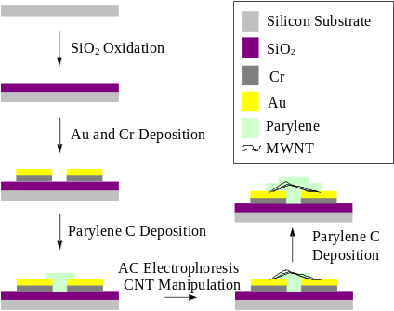
Fig. 1. Fabrication process flow of the PECNT sensor.
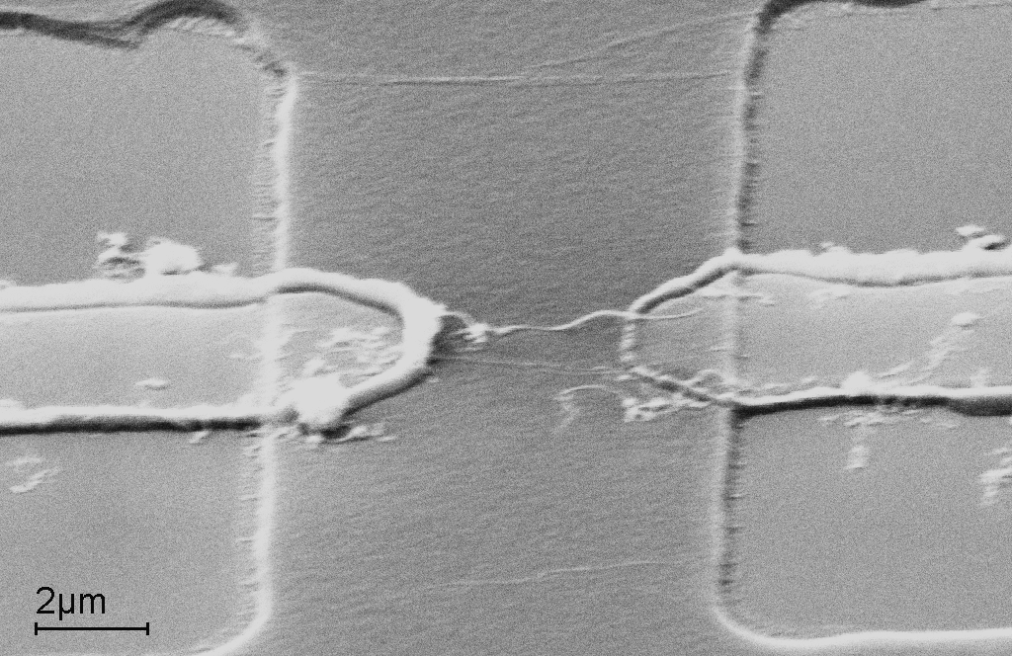
(a)
(b)
Fig. 2. SEM images showing (a) a bundle of MWNTs was resting on the lower parylene layer and bridging across the microelectrodes, and (b) the final PECNT sensor structure and the bundle of MWNTs was embedded inside the parylene C thin films.

III. Electrical Characterization of Polymer Thin Film Embedded CNT Sensors
A. Thermal Sensitivity
Similar to those CNT sensors without parylene C protection [7], thermal annealing cycles (from 25ºC to 80ºC) are required to stabilize the room temperature resistance of the PECNT sensor. Experimental determinations showed that the TCR of the PECNT sensor was around -0.15%/ºC to -0.18%/ºC (see Fig. 3) which closely matched our previous experimental determination of TCR (-0.12%/ºC to -0.15%/ºC) on CNT sensors without parylene C protection [7]. This implies the thin parylene C protection layers do not affect the intrinsic thermal sensing properties of CNTs due to the extremely high thermal conductivity of CNTs. On the other hand, in the experimental measurements of TCR on CNT sensors without parylene C protection, considerably room temperature resistances drifting were observed in repeated measurements during the thermal annealing cycles. However, we found that the PECNT sensor did not show prominent drifting in the room temperature resistances after the initial thermal annealing cycle (see Fig. 4). This suggests that the parylene C layers do provide a better fixation of CNTs with the microelectrodes when compared with those without parylene C protected CNT sensors.
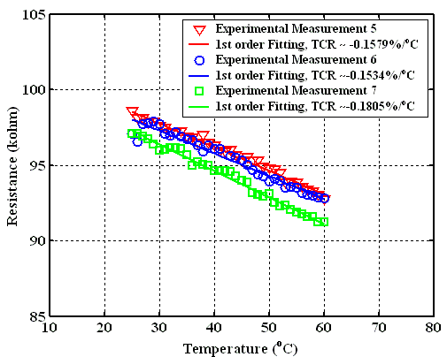
Fig. 3. Three repeated measurements of thermal sensitivities of the PECNT sensor.
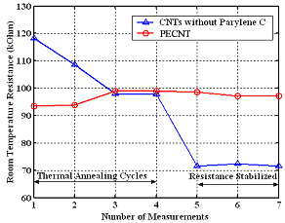
Fig. 4. A comparison in room temperature resistance drifting between the CNT sensors without parylene C protection and PECNT sensor during seven repeated thermal cycling.
B. Frequency Response
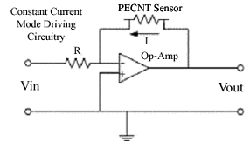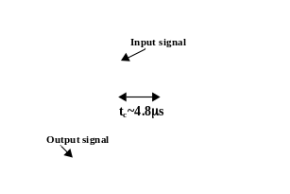
(a) (b)
Fig. 5. (a) Constant current mode circuit, (b) Frequency response of the PECNT sensor.
To test the frequency response of the PECNT sensor, the sensor was hybridly integrated into a constant current (CC) mode circuit (see Fig. 5a) and a square wave was fed into the circuit and the output response was then determined from an oscilloscope (see Fig. 5b). The estimated cutoff frequency of the PECNT sensor was about 148kHz, while typical frequency response of MEMS polysilicon sensors is around several hundred Hz to several kHz [8].
C. Power Consumption
To determine the power consumption of the PECNT sensors, I-V characteristics were determined experimentally (see Fig. 6a). The current required to heat up a typical PECNT sensor to the non-linearity region was in the range of µA. This power consumption is three orders of magnitudes lower than conventional MEMS thermal sensors whose power consumption are in the order of mW [8]. From the results of the I-V characteristic of another PECNT sensor shown in Fig. 6b, the allowable driving voltage to heat up a sensor is around 20V, which implies the sensor can operate at a very large power range (μW to mW).
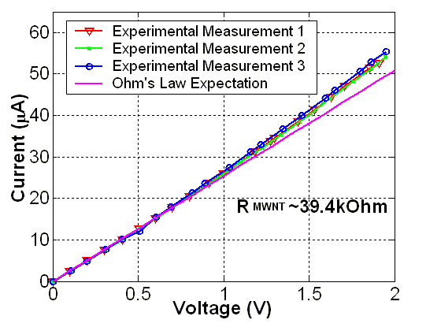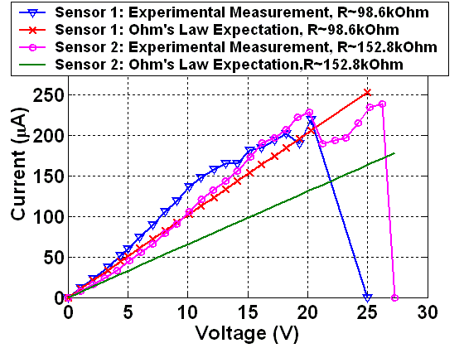
(a) (b)
Fig. 6. I-V characteristics of PECNT sensors.
D. Stability (Reliability)
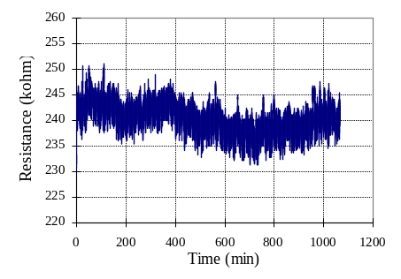
Fig. 7. Resistance stability of the PECNT sensor.
In order to investigate the long-term stability of the PECNT sensors, a room temperature resistance of a sensor was measured for ~20 hours. The sensor was integrated into a constant current mode circuit (see Fig. 5a) and was put in a heating chamber for resistance stability measurement. The stability of the two probe resistances of the sensor is shown in Fig. 7. The average resistance is about 240kΩ and varied within 2% in the 20 hours span. (Note that the time is limited by data storage medium). This suggests that the polymer film embedded sensor remains stable and reliable over time.
VII. Conclusion
The fabrication process and electrical characterizations of a novel PECNT sensor have been presented. The TCR, frequency response, I-V characteristics and resistance stability of the PECNT sensor were discussed. The parylene C thin film does not affect the intrinsic thermal sensing properties of CNTs as determined experimentally. Besides, the fast frequency response (>100 kHz) and low power consumption (~µW) of the PECNT sensor indicate that CNTs may eventually replace polysilicon as high performance micro/nano sensors. Our developed fabrication process will provide a fast and efficient alternative for MEMS/NEMS research communities to fabricate good performance CNTs-based thermal sensors for applications in aero-dynamic and nano-biotechnology researches.

Acknowledgement
The authors would like to sincerely thank Mr. Victor T. S. Wong of Mechanical and Aerospace Engineering of UCLA, Dr. W.Y. Cheung of the Department of Electronic Engineering of CUHK, and Mr. King W. C. Lai of Centre for Micro and Nano Systems, CUHK for their contributions to this project.

References
- H.T. Ng et al., “Flexible carbon nanotube membrane sensory system: a generic platform”, J. of Nanosci. and Nanotech., vol. 1, no. 4, pp. 375-379, 2001.
- J. Kong et al., “Nanotube molecular wires as chemical sensors”, Science, vol. 287, pp. 622-625, 2000.
- P.G. Collins et al., “Extreme oxygen sensitivity of electronic properties of carbon nanotubes”, Science, vol. 287, pp. 1801-1804, 2000.
- F. Balavoine et al., “Helical crystallizations of proteins on carbon naontubes: a first step towards the development of new biosensors”, Angew. Chem. Int. Ed., vol. 38, no. 13/14, pp. 1912-1915, 1999.
- B.F. Erlanger et al., “Binding of an anti-fullerence IgG monoclonal antibody to single wall carbon nanotubes”, Nano Lett., vol. 1, no. 9, pp. 465-467, 2001.
- N. Shim et al., “Functionalization of carbon nanotubes for biocompatibility and bimolecular recognition”, Nano Lett., vol. 2, no. 4, pp. 285-288, 2002.
- Carmen K. M. Fung et al., “Towards batch fabrication of bundled carbon nanotube thermal sensors”, IEEE-Nano 2003, vol. 2, pp. 866-869, 2003.
- C. Liu et al., “A micromachined flow shear-stress sensor based on thermal transfer principle”, J. MEMS, vol. 8, no. 1, pp. 90-99, 1999.

