Abstract — An automated Carbon Nanotubes (CNTs) microspotting system was developed for rapid and batch assembly of bulk multi-walled carbon nanotubes (MWNT) based Nanosensors. By combining dielectrophoretic (DEP) and microspotting technique, MWNT bundles were successfully and repeatably manipulated between arrays of micro-fabricated electrodes. Preliminary experimental results showed that two different spotting methods succeeded in forming CNTs between microelectrodes and the time required to form one CNT sensor was less than 1 second. This feasible batch manufacturable method will dramatically reduce production costs and production time of nano sensing devices and potentially enable fully automated assembly of CNT based devices.
A Systematic Approach to Fabricate CNT-Based Nano Devices: Combining DEP and Microspotting Technologies
King W. C. Lai¹, Carmen K. M. Fung¹ and Wen J. Li^{1,2,} ∗
¹Centre for Micro and Nano System
²Shun Hing Institute of Advanced Engineering
The Chinese University of Hong Kong, Hong Kong SAR
Index Terms — DEP manipulation, micro-robotic spotting, CNT sensors, nano manufacturing, nano batch fabrication.

Introduction
Carbon nanotubes (CNTs) have been widely studied for their electrical (e.g., see [1]), mechanical (e.g., see [2]), and chemical properties since its discovery in 1991 by Sumio Iijima [3]. Owing to their minute dimensions and their tendency to cling together in nature, the connecting, aligning and isolating process of CNTs have been difficult for engineers and scientists world-wide. To manipulate these nano-sized tubes, atomic force microscopy (AFM) is typically used to manipulate each of them one-by-one [4]. However, this is time-consuming and unrealistic when batch production is required. On the other hand, researchers have recently demonstrated different novel methods in carbon nanotube manipulation such as guided carbon nanotube growth [5][6], external forces [7][8], and polar molecular patterning [9]. Whereas the former technique grows organized carbon nanotube structures (guided/directed growth or assembly) by chemical-vapour deposition, the latter two methods are for pre-grown nanotubes. Currently, manipulation based on electric field generated force is becoming more promising, as it can be used to isolate, align and connect the metallic (electrically conductive) carbon nanotubes for nano-scale circuits or sensors congruently, while leaving the semi-conducting carbon nanotubes or impurities in a suspension [10]. K. Yamamoto et al. have pioneered the work in electric-field assist manipulation of CNT bundles [11][12]. Our group has pioneered the development of a systematic and time-efficient approach to engineer CNT based nanosensors [13][14].
In this paper, we will discuss our ongoing work to develop a more precise and efficient process for CNT batch manipulation by combining the dielectrophoretic (DEP) CNT manipulation and micro-robotic spotting technology. Preliminary experimental results have shown the validity of batch assembling of arrays of CNT sensors by using an automated CNT micro-spotting/injection system. The methodology of the manipulation process and architecture of the automated CNT micro-spotting/injection system will be described in this paper. Experimentally, the main problem in developing such a system is to reduce the spot size precisely, and the alignment of the probe tip to the sensor microelectrodes. The solutions to overcome these problems are also presented in this paper.

Automated CNT Microspotting system
A computer-controlled CNT microspotting system was developed for performing the dielectrophoretic CNT manipulation automatically. The theoretical background and basic results of non-automated DEP CNT manipulation was reported previously in our work [10]. This newly developed automated system allows the CNT/ethanol solution to be spotted to the microelectrodes precisely, and the volume of CNT/ethanol droplet could also be well controlled, resulting in a high yield and high precision method to batch assemble CNT devices. In short, in order to build the functional micro-robotic spotting system to assembly CNT sensors, we have developed four different technologies: 1) DEP CNT manipulation, 2) shaping of micro capillary probes to minimize CNT dilution droplet, 3) microspotting using our fabricated capillary micro probes, and 4) positioning of the probe tips to the sensor electrodes through a micro-robotic station.

DEP Manipulation of CNTs
As mentioned earlier, our group has already done significant studies on the DEP manipulation of CNTs. We will only briefly describe the process here. For details of the DEP manipulation process [10] can be referenced. Basically, the carbon nanotubes were dispersed inside a liquid medium (e.g., ethanol), and then drops of the liquid medium were placed between a pair of conduction electrodes with gaps ranging from 2 to 5 microns between them. Then an AC voltage at specified frequency and amplitude were applied between the electrodes, and CNT bundles would then form between the electrodes as the liquid medium evaporated. Dielectrophoresis refers to the force exerted on a polarized particle in a non-uniform electric field, and can be written as
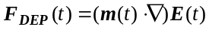 (1)
where E is the electric field, m is the induced dipole moment of a CNT.

Fabrication of Nanometric Probes
Tip profile of a probe directly affects the size of a micro liquid droplet spotted on the surface of a substrate. Smaller probe tip diameter allows smaller size droplets, and consequently, allows the CNT dilution and chemical liquid spot size to be smaller on a chip. By using our novel chemical etching process, which employed glass tubing as a sacrificial barrier, to control and sharpen the probe into different tip profiles as shown in Fig. 1. Details of the fabrication process developed by our group can be found in [15]. Capillary probes (originally from Polymicro Technologies) were fabricated and sharpen into different inner diameters ranging from 2 μm to 100 μm and different outer diameters ranging from 5 μm to 150 μm.
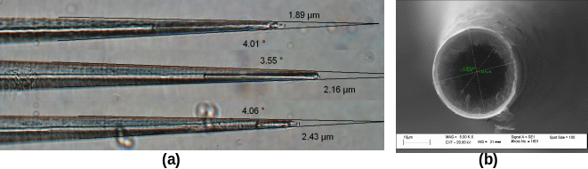
Fig. 1. (a) Microscopic image showing different capillary probe tips were sharpen by our chemical etching process. (b) SEM image showing a sharp tip with the inner diameter.

Micro-Robotic Spotting System
The micro-robotic station included three programmable systems: 1) a computer controllable X-Y-Z micromanipulator (MP285, Shutter Instrument Company) to manipulate the micro capillary probe tips to appropriate positions on a sensor chip, 2) a computer controllable hydraulic pump system (V6 syringe drive modules, Kloehn Limited) to inject CNT dilution through the capillary probes, and 3) a CCD video microscope system to allow operator to locate the initial microelectrodes. The spotting system was integrated as shown in Fig. 2. Essentially, a microchip with arrays of microelectrodes can be placed on the sample stage with its movement controlled by the X-Y stage. An AC voltage can then be applied between the microelectrodes to initiate the CNT DEP manipulation process as mentioned before as soon as a micro-droplet is placed between a pair of electrodes by the capillary probes. However, to spot the CNT/ethanol solution spots precisely to the microelectrodes is not a trivial task. We will discuss spotting of micro-size droplets by using fabricated probes in the following section.
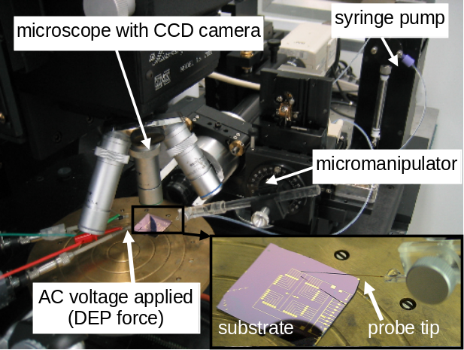
Fig. 2. Microspotting system with syringe pump and micromanipulator.
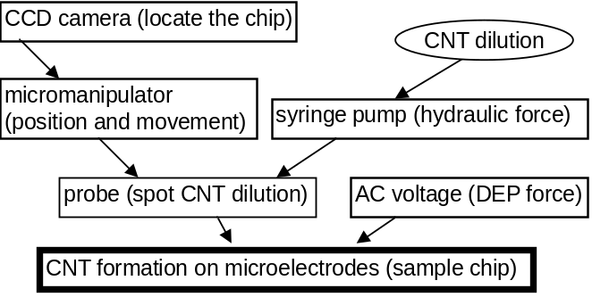
Fig. 3. Flow chart showing the architecture of the spotting system

Rapid CNT-based nano davices fabrication
CNT dilution spotting is challenging because of the difficulties of spotting very small CNT/ethanol solution to particular positions automatically and precisely. It is not only required to overcome the strong adhesion force (between probe tip and fluid), but to eject the CNT dilution spot size as small as possible, so that the droplet will only cover one pair of microelectrodes is also a problem. The following sections show our experimental result involving: 1) comparison of spot sizes by using different probes, 2) position control of X-Y-Z micromanipulator, and 3) the experimental result of batch CNT formation.

CNT/Ethanol Solution Spotting Experiment
Spotting experiments were conducted by comparing our fabricated probe (10 μm inner diameter) and commercially available Tygon tube (250 μm inner diameter). It was verified that the spot sizes could be much smaller when our fabricated micro probes were used as shown in Fig. 4. With the 250 μm tube, spot size is not easily controllable (>1 mm diameter), while the 10 μm I.D. probe gives ~50 μm spots.
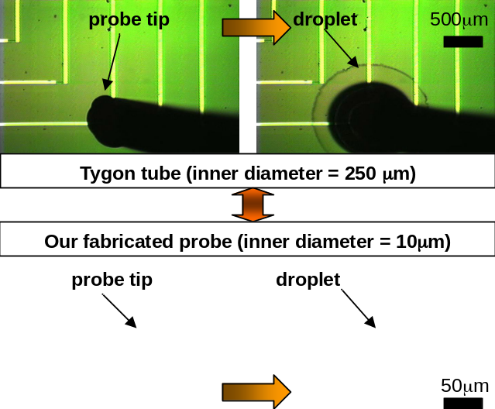
Fig. 4. Microscopic images [top view] showing the probe tip moved to a pair of microelectrodes, and a droplet was spotted from probe to the substrate successfully.

Position Control of Micromanipulator
Since the sensor chips with arrays of microelectrodes can be fabricated by a standard microlithographic technique, a CIF- mask computer file can be generated by appropriate commercial MEMS or IC design software packages. For our work, we used MEMSPro™ and added a custom “CNT layer” on the software to record different positions of microelectrode gaps onto a CIF-mask data file. This file is then imported to our automated CNT microspotting system to command the motions of the micro-robotic manipulator. For example, all positions of the center of the gaps between pairs of electrodes can be obtained and stored in array of X-Y coordinate system. Then, an arbitrary reference frame can be chosen to move the micro-manipulator. Currently, we choose the upper-left microelectrode as the initial reference position, the next position is obtained by finding the nearest neighbor from remaining microelectrode pairs (sorting principle) as shown in Fig. 5.
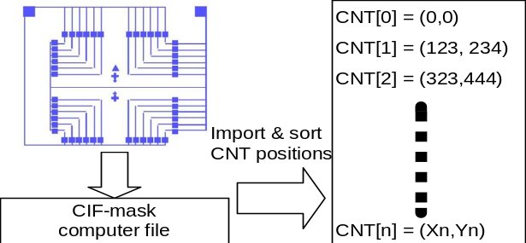
Fig. 5. Illustration of CNT position assignment.
After the system stored the position of microelectrodes, the probe tip is required to align to the initial (upper-left) microelectrode so that it and the electrode could be observed under the microscope as shown in Fig. 6. Our group is also working on automating this initial reference site finding currently.
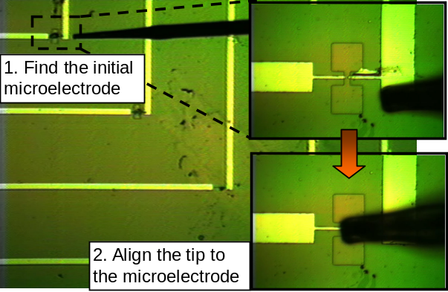
Fig. 6. Probe tip must align to the initial microelectrode.
After the initial position is determined, the spotting process begins. The probe tip is automatically moved to positions which is above each microelectrode, then it is moved downwards to the substrate, and then the CNT/ethanol solution from the probe to the substrate is spotted. Finally, the CNT/ethanol spots are dropped in between each pair of microelectrodes automatically.

Experimental Results
Experiments were conducted by using our fabricated probe with 100 μm I.D. and ~125 μm O.D. In the experiment, an AC voltage (16 Vpp, 1 MHz) was applied to the sensor chips (with array of 24 pairs of fabricated micro electrodes in each chip) to DEP manipulate CNTs across the micro electrodes. The probe was tilted in order to reduce damaging effects on the probe as it hits the substrate. Two different spotting methods were conducted to study the performance of the micro-robotic spotting system: 1) injection method -- spotting using a syringe pump to induce enough hydraulic pressure (24 drops), 2) droplet contact method - spotting by allowing a droplet to come in contact with substrate. However, for the contact method, two scenarios were tested: a) 24 drops were spotted on the sensor chip, and b) 4 drops were spotted on the sensor chip.
After applying the DEP voltage and spotting the CNT/ethanol solution on the defined positions of the chips by any of the three spotting scenarios mentioned before, it was observed that the ethanol is evaporated away very quickly, leaving the CNTs to reside between the gaps of the microelectrodes. We have found that the time required for manipulating CNTs to form between each sensor-electrode-pair by using this automated microspotting system is less than 1 second. The corresponding connections of bundled CNTs for a representative pair of microelectrodes using the three different spotting conditions are shown in Fig. 7. We have observed that the CNT formations by using three different spotting conditions are similar and the CNTs were successfully connected between the microelectrodes. In order to confirm the linkage of bundled CNTs across two microelectrodes, the room temperature resistance corresponding to each pair of microelectrodes was measured. The CNT connection process was deemed successful between two microelectrodes when the room temperature resistance measured became several kΩ to several thousand kΩ. The chips were also eventually checked using a scanning electron microscope (SEM) to validate the CNT connections between the electrodes. Since the conductivity of CNTs depend on their lattice geometries during their growth process, the conductivities of individual CNTs cannot be well controlled, which results in the variation of conductivities in individual CNTs. During the DEP process to form CNT bundles across microelectrodes, the CNTs were randomly connected between microelectrodes. Therefore, it is logical that different CNT samples exhibited different conductivities. The room temperature resistances of different sensors of the chips were measured and plots of statistical data for different spotting experiments were generated (see Error: Reference source not found), which shows the maximum, minimum, average and standard deviation (S. D.) among the measured resistances on each spotting experiment.
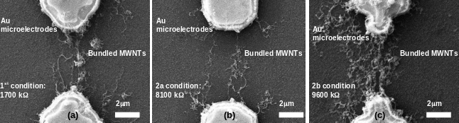
Fig. 7. SEM images showing the formations of MWNTs between different pairs of Au microelectrodes of different conditions. (a) Spotting using syringe pump (24 drops), (b) spotting using contact method (24 drops), and (c) spotting using contact method (4 drops).
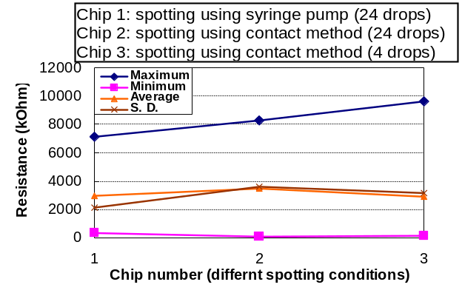
Fig. 8. Statistical data of measured resistances on different chips of three different spotting conditions.

Conclusion
An automated microspotting system to batch fabricate nanosensors with CNTs based on dielectrophoretic manipulation was presented. We have proven that the success rate for batch assembling bundled CNTs on arrays of microelectrodes and the time required to manipulate one CNT sensor is less than 1 second. This is a promising indication that DEP manipulation process combine with the automated microspotting system is a feasibility technology to batch assemble CNT functional devices in a fast and precise manner.
Acknowledgment
The authors would like to sincerely thank Dr. W.Y. Cheung of the Department of Electronic Engineering of CUHK and Mr. Victor T. S. Wong and Ms. Charlotte C. H. Kwong of UCLA for their help and discussion on this project.
References
- S. Frank, P. Poncharal, Z.L. Wang, and W.A. de Heer, “Carbon nanotube quantum resistors”, Science, vol. 280, pp. 1744 – 1746, 1998.
- E.W. Wong, P.E. Sheehan, and C.M. Lieber, “Nanobeam mechanics: elasticity, strength, and toughness of nanorods and nanotubes”, Science, vol. 277, pp.1971 – 1975, 1997.
- S. Iijima, “Helical microtubules of graphitic carbon”, Nature, vol. 354, pp. 56 – 58, 1991.
- T. Shiokawa, K. Tsukagoshi, K. Ishibashi, and Y. Aoyagi, “Nanostructure construction in single-walled carbon nanotubes by AFM manipulation”, in Proc. Microprocesses and Nanotech. Conf., Japan, pp. 164 –165, 2001.
- B. Q. Wei, R. Vajtai, Y. Jung, J. Ward, R. Zhang, G. Ramanath and P. M. Ajayan, “Organized assembly of carbon nanotubes”, Nature, vol. 416, pp. 495 –496, 2002.
- J. Hu, M. Ouyang, P. Yang and C. M. Lieber, “Controlled growth and electrical properties of heterojunctions of carbon nanotubes and silicon nanowires”, Nature, vol. 399, pp. 48 –51, 1999.
- J. E. Fischer, W. Zhou, J. Vavro, M. C. Llaguno, C. Guthy, R. Haggenmueller, M. J. Casavant, D. E. Walters and R. E. Smalley, “Magnetically aligned single wall carbon nanotube films: Preferred orientation and anisotropic transport properties”, J. Appl. Phys, vol. .93, pp. 2157 –2163, 2003.
- Y. Huang, X. Duan , Q. Wei and C. M. Lieber, “Directed assembly of one-dimensional nanostructures into functional networks”, Science, vol. 291, pp. 630 –-633, 2001.
- S. G. Rao, L. Huang, W. Setyawan and S. Hong, “Large-scale assembly of carbon nanotubes”, Nature, vol. 425, pp. 36 –37, 2003.
- C. K. M. Fung, V. T. S. Wong, R. H. M. Chan and W. J. Li, “Dielectrophoretic Batch Fabrication of Bundled Carbon Nanotube Thermal Sensors”, IEEE Tran. on Nanotechnology, vol. 3, no. 3, pp. 395 – 403, 2004
- K. Yamamoto, S. Akita, and Y. Nakayama, “Orientation of carbon nanotubes using electrophoresis”, Japanese J. Appl. Phys., vol .35, pp. L917 – 918, 1996.
- K. Yamamoto, S. Akita, and Y. Nakayama, “Orientation and purification of carbon nanotubes using AC electrophoresis”, J. Phys. D: Appl. Phys., vol. 31, pp. L34 – L36, 1998.
- V. T. S. Wong and W. J. Li, "Bulk Carbon Nanotubes as Sensing Element for Temperature and Anemometry Micro Sensing", IEEE MEMS 2003, Kyoto, Japan, Jan. 19-23, 2003.
- C. K. M. Fung, V. T. S. Wong, and W. J. Li, "Towards Batch Fabrication of Bundled Carbon Nanotube Thermal Sensors", IEEE Nano 2003, vol. 2, pp. 866 – 869, 2003.
- K. W. C. Lai and W. J. Li, “KL probes for robotic-based cellular nano surgery”, IEEE Nano 2003, vol. 1, pp. 152 – 155, 2003.
- C. H. Mastrangelo and C. H. Hsu, “Mechanical stability and adhesion of microstructures under capillary forces. I. Basic theory”, J. MEMS, vol 2, Issue: 1, March 1993, Pages:33 – 43, 1993.

