Determination of Bovine Insulin Solution Concentration Using Atomic Force Microscopy

Abstract— A novel method based on Atomic Force Microscopy (AFM) and digital light microscopy (DLM) to measure the concentration of bovine insulin solution is presented. To overcome the limited sensitivities of the conventional methods of protein trace detection (such as Lowry method, Ultraviolet Absorption Method, Coomassie Bright Blue Dye-binding Method), a new approach of determining insulin concentration by calculating the volume of insulin crystals on a mica substrate using the softwares of AFM and DLM is developed. In this approach, sulfuric sodium was used as a precipitant, and hydrochloric acid and sodium hydroxide were used to adjust the sample pH value to the insulin isoelectric point of ~5.35. Insulin crystals were formed by a simple evaporation method at the room temperature. The resultant crystal growth is observed and analyzed by the AFM and DLM. The up-to-date experimental results show that the combination of AFM and DLM is a feasible method to determine the concentration of insulin and other protein solutions, although the error margins must be improved in order for the method to become practical for clinical usage.
Zhikun Zhan^{1,3}, Steve Tung², T. J. Mitchell⁵, Zaili Dong¹ and Wen J. Li⁴
Keywords— insulin crystallization; Atomic Force Microscopy; concentration determination;

INTRODUCTION
Insulin, which is excreted from the secretory granules of pancreatic β-cells, is one of the important hormones with the specific function of controlling the amount of sugar in the blood, adjusting fat and protein metabolizability as well as advancing the synthesization of DNA, RNA and ATP. In clinical and animal studies of diabetes, insulin is the one of the most important direct detection targets for studying the pathogenesis of diabetes and evaluating the effect of new drugs. Presently, in the research of trace detection of protein, the applications of conventional methods such as the Lowry method, Ultraviolet Absorption Method, Coomassie Bright Blue Dye-binding Method are all restricted because of their limited sensitivities. Recently, bovine, human and porcine insulin crystal research based on AFM has been demonstrated [1-3]. The insulin crystallization process and crystal morphology are also observed and analyzed using AFM by Waizumi et al. [4]. However, a suitable method for measuring the concentrations of protein solutions (including insulin solution) based on AFM has yet to be developed.
In this work, a new method based on AFM and DLM for determining the concentration of bovine insulin solution using crystallized insulin is presented. The stock sample is prepared by adding Na₂SO₄ and HCl to the primary bovine insulin solution. The solution is then allowed to crystallize on a mica substrate and the crystallization process is observed and analyzed by the AFM and DLM. The experimental results show that the average size of the insulin crystals ranges from several nanometers to hundreds of microns (Fig. 1). Crystal growth is usually complete within a period of 3hours. Using a “coarse-subtle” search strategy, the total volume of the crystals on the mica substrate is determined. By combining this information with the density of insulin crystal, the concentration of the primary insulin solution is estimated and compared with the actual value.
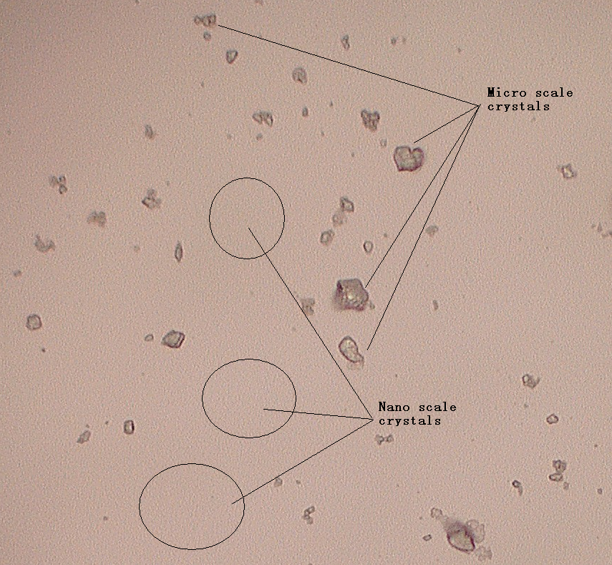
Fig. 1 DLM image of insulin crystals on a mica surface. Crystal size ranges from several nanometers (cannot be seen in this picture) to hundreds of microns.

MATERIALS AND METHODS
*Contact author: Steve Tung [chstung@uark.edu].

1State Key Laboratory of Robotics, Shenyang Institute of Automation, Chinese Academy of Sciences, Shenyang, China.
2Department of Mechanical Engineering University of Arkansas,
Fayetteville, AR, USA.
3 Graduate University of Chinese Academy of Sciences, Beijing, China
4 Centre for Micro and Nano Systems, The Chinese University of Hong Kong, Hong Kong, China
5 Department of Mechanical Engineering, John Brown University

A. Materials
The stock solution was prepared by mixing bovine insulin (Sigma I5500) with Na₂SO₄ (Analytical reagent). The pH value of the solution was then adjusted to about 5.35 with HCl and NaOH to allow the insulin to crystallize easily since its isoelectric point is 5.3~5.4. Impurities in the solution were removed by a filter needle (MILLEX®GP, Filter Unit 0.22μm).

B. Crystallization by evaporation
A straight-forward evaporation method was used to accomplish the crystallization process of bovine insulin. 1μL of the stock solution was placed on a freshly cleaved mica substrate with a very smooth surface (grain sizes <1nm). The sample was then left in air at a temperature of ~20℃ (it was previously reported that the optimal temperature range of protein crystallization is 4-22℃) until the solvent evaporates completely.

EXPERIMENTAL RESULT AND DISCUSSIONS

A. Crystal Detection and Growth
A comparison AFM experiment indicated that the mica surface with insulin crystals was quite different from those without. Fig. 2 demonstrates the AFM images of three different kinds of surfaces: naked mica slide, control slide (HCl and Na₂SO₄ with no insulin) and test slide (HCl and Na₂SO₄ with insulin). The test slide has a much wavier and rougher surface than the other two surfaces and their morphologies are also very different. It is very apparent that the nano-scale features in the third image are the insulin crystals that are too small to be visible in the DLM image shown in Fig. 1.

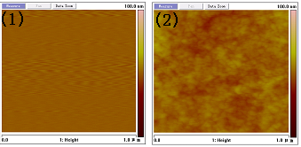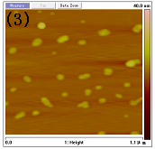
Fig. 2 AFM images of three different surface: (1) mica; (2) HCl and Na₂SO₄ with no insulin on mica; (3) HCl and Na₂SO₄ with insulin on mica.
The crystallization process of the stock solution on the mica substrate was observed by AFM over a period of three hours (Fig. 3). By analyzing the sizes of several feature crystals in the AFM images, it was determined that their sizes did not change significantly during the 3 hour period (TABLE 1).

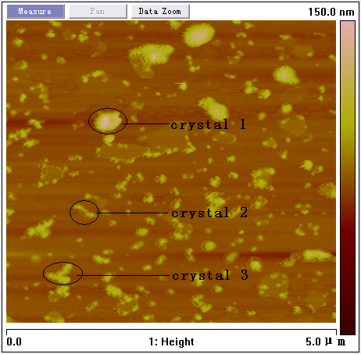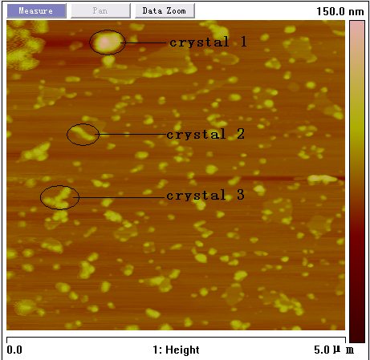
Fig. 3 Two scans of insulin crystals over a period of 3hours.

 | Size | Starting Time | 3hours later | Difference(nm) | % starting time
Crystals1 | Length(nm) | 372 | 401 | 29 | 7.8%
Crystals1 | Width(nm) | 294 | 284 | -10 | -3.4%
Crystals1 | Height(nm) | 91.045 | 78.942 | -12.103 | -13.3%
Crystals2 | Length(nm) | 333 | 324 | -9 | -2.7%
Crystals2 | Width(nm) | 33.701 | 27.65 | -6.051 | -18%
Crystals2 | Height(nm) | 205 | 205 | 0 | 0
Crystals3 | Length(nm) | 342 | 313 | -29 | -8.5%
Crystals3 | Width(nm) | 313 | 313 | 0 | 0
Crystals3 | Height(nm) | 31.484 | 35.29 | 3.806 | 12.1%
Sum | —— | —— | —— | -33.248 | -26%
Average | —— | —— | —— | -3.694 | -2.89%
TABLE 1 Size comparison of three characteristic crystals over a period of 3 hours

B. Insulin Concentration Measurement Based on “coarse-subtle” strategy
Since the size of the insulin crystals ranges from several nanometers to hundreds of microns, a “coarse-subtle” method was used to measure the total volume of all the crystals on the mica surface. Depending on the crystal size, DLM based micro-image analyzing and AFM based nano-imaging software were used to calculate the volume of micro- and nano-scale crystals respectively.

Determination of micro-crystal volume based on DLM
A 0.5μL drop of the control solution (HCl and Na₂SO₄ with no insulin) and a similar drop size of the test solution (HCl and Na₂SO₄ with insulin) were placed on two separate mica surfaces. After solvent evaporation, small clusters of crystals were formed on the surface. Since the solvent was allowed to evaporate slowly from the edge to the center (Fig. 4), crystal growth concentrates in the edge region (R1) rather than the inner area (R2) (Fig. 5). Characteristic regions that can represent R1 and R2 (the area is ~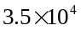μm²) were observed and analyzed to compute the total micro-crystals later.
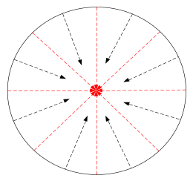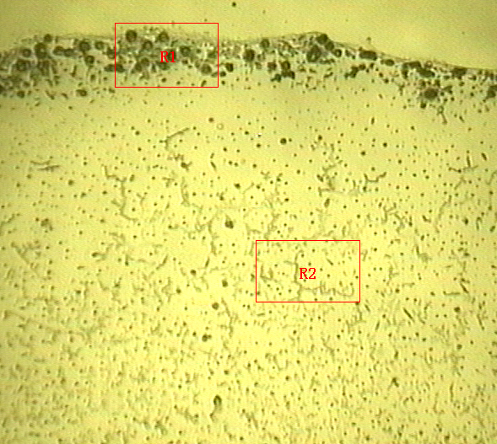
Fig. 5 DLM image of partial crystals (HCl and Na₂SO₄ with insulin) on the mica surface
Fig. 4 The sketch map of solvent evaporation path

A KH-7700 Digital Light Microscope (HiROX, Japan) was used to observe the micro-crystals and compute their volume. This DLM is equipped with a very useful function in the measurement software for area and volume computation. For traditional 3D image measurement, a newly synthesized picture of the objects could be performed before measuring all the parameters. For a special feature region of the micro-crystal image, a manual multi-focus method was used to perform 3D synthesis for focal planes of different heights. Here, we focused on 8~15 planes at different heights of the crystals surface with a step distance of 0.25μm between the bottom and top planes, then synthesis executed to form a 3D surface. The area and volume values of the protruding part above the lowest plane were dynamically computed and displayed in a box. Using the proportional relationship of the total diffused area and feature regions obtained previously, we can compute the total volume of all the micro-scale crystals. The measurement process of micro-scale crystals volume is described in Fig. 6.

Fig. 6 Flow chart of the measurement process for micro crystal volume.

Determination of nano-crystal volume based on AFM
The Veeco Dimension 3100 AFM was used to observe nano-scale insulin crystals and measure their volumes. In the Nanoscope (R) III (Version 5.30r3.sr3), there is a useful Bearing function to reveal how much of a surface lies above or below a given height, plot and analyze the distribution of surface height over a sample. Depending on the image cursor selection, values for up to eight terms including ‘bearing volume’ are listed in the measurement windows. Fig. 7 shows the parameters list of the test slide with a scanning area of 1×1μm².
Fig.7 The Bearing function Window multimode AFM (Nanoscope 5.30r3.sr3)
More than forty characteristic regions along eight different paths (Fig. 4, red arrowheads) with 45 degree phase difference from each other were chosen to represent the whole diffusion region. Using tapping mode AFM, all of the characteristic regions with a scan size of 1×1μm² were scanned.
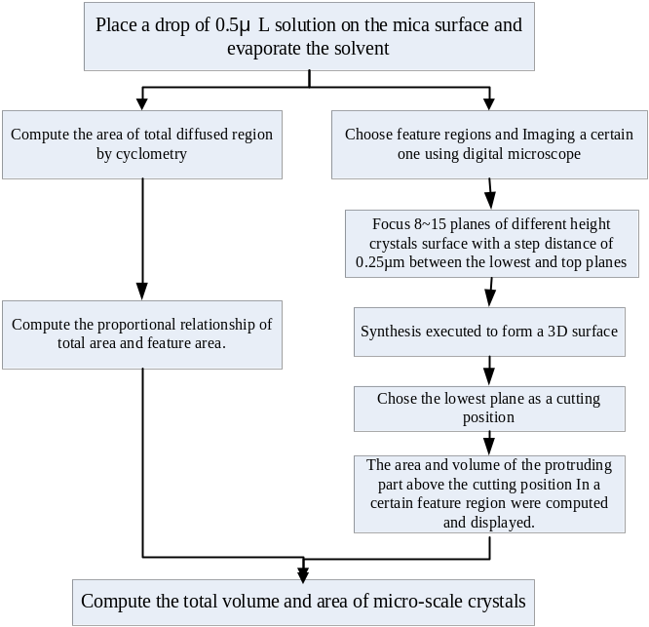Since both HCl and Na₂SO₄ in the insulin sample can also crystallize alongside the insulin, volume of the Na₂SO₄ crystal was subtracted from the mixture (insulin, HCl and Na₂SO₄) total volume. Using a similar AFM scanning method, the volume of HCl and Na₂SO₄ crystals are obtained from the control slide. By subtracting the volume of crystal on the control slide from the total volume of crystals on the test slide, the insulin crystal volume is obtained.
It was previously reported that the density of insulin crystal is about 1.24g/cm³[5]. By combining this value with the scanned insulin volume, the mass of insulin was obtained. Table II illustrates three experiment results with different insulin concentration. Here, a 0.5μL drop of each solution was placed on fresh cleaved mica surfaces, corresponding to 0.5μg, 50ng and, 5ng of insulin. The error factors are computed as the ratio of the real values and the AFM measurement results.
TABLE II Three experiment results with different concentration of insulin solutions.
Test NO. | Real concentration | Measurement results | Error factor
1 | 1mg/ml | 0.234mg/ml | 4.3
2 | 100μg/ml | -47.6μg/ml | -2.1
3 | 10μg/ml | 677.3μg/ml | 135.5

CONCLUSION
This paper describes a new method to determine the concentration of insulin solution based on AFM and DLM. Using the crystallization concept of protein, crystals in the size range of micro- and nano-scale are measured and the result is combined with a typical density value of insulin crystal to determine the amount of insulin in a 0.5μL sample drop with high accuracy. To date, preliminary experiments of the new method were performed and the results indicate that the method performs well with high insulin concentrations.
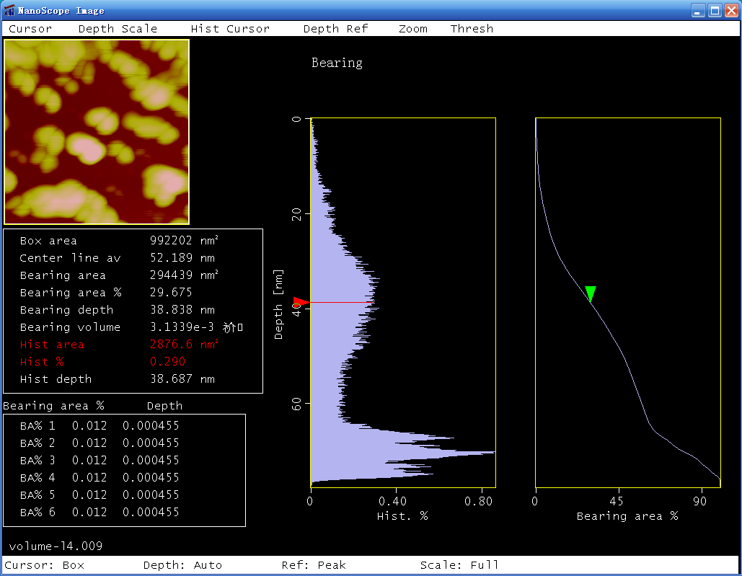
From private communications, clinical MDs have indicated to the authors that an insulin detection sensitivity of 2micro IU/ml (91pg/ml) is desirable. The present results do not meet this requirement. However, the approach described in this paper is proven to be a feasible and novel way to accomplish trace detection of proteins. Further work will be carried out with the goal of accomplishing the required detection sensitivity in the future.

ACKNOWLEDGEMENTS
This work was supported by the independent funding of State Key of Laboratory of Robotics, China. We also thank Mr. Yongliang Yang for his assistance in the AFM scanning process.
REFERENCE
[1] C. M. Yip, M.D. Ward, “Atomic force microscopy of insulin single crystals: direct visualization of molecules and crystal growth”, Biophys. J. 71 (1996) 1071.
[2] C. M. Yip, M. L. Brader, M. R. DeFelippis, M. D. Ward, “Atomic Force Microscopy of Crystalline Insulins: The Influence of Sequence Variation on Crystallization and Interfacial Structure”, Biophy. J. 74 (1998) 2199-2209.
[3] C. M. Yip, M. R. DeFelippis, B. H. Frank, M. L. Brader, M. D. Ward, “Structural and Morphological Characterization of Ultralente Insulin Crystals by Atomic Force Microscopy:Evidence of Hydrophobically Driven Assembly”, Biophy. J. 75 (1998) 1172.
[4] K. Waizumi, M. Plomp, W. van Enckevort, “Atomic force microscopy studies on growing surfaces of bovine insulin crystals, Colloids and Surfaces”, B: Biointerfaces 30 (2003) 73-86.
[5] S. J. Bao, D. Xie, J. P. Zhang, W. R. Chang, and D. C. Liang, “Crystal structure of desheptapeptide(B24–B30)insulin at 1.6 Å resolution: Implications for receptor binding”, Proc. Natl. Acad. Sci. USA Vol. 94, pp. 2975–2980, April 1997 Biochemistry.

