Abstract—Alcohol sensors, batch fabricated by forming bundles of chemically functionalized multi-walled carbon nanotubes (f-CNTs) across Au electrodes on SiO₂/Si substrates using an AC electrophoretic technique, were developed for alcohol vapor detection using an ultra-low input power of ~0.01-1 μW, which is lower than the power required for most commercially available alcohol sensors by more than 4 orders of magnitude. The multi-walled carbon nanotubes (MWCNTs) have been chemically functionalized with the COOH groups by oxidation. We found that the sensors are selective with respect to flow from air, water vapor, and alcohol vapor. The sensor response is linear for alcohol vapor concentrations from 1 to 21 ppm with a detection limit of 0.9 ppm. The transient response of these sensors is experimentally shown to be ~1 s and the variation of the responses at each concentration is within 10 % for all of the tested sensors. The sensors could also easily be reset to their initial states by annealing the f-CNTs sensing elements at a current of 100-200 μA within ~100-200 s. We demonstrated that the response of the sensors can be increased by 1 order of magnitude after adding the functional group COOH onto the nanotubes, i.e., from ~0.9 % of a bare MWCNTs sensor to ~9.6 % of an f-CNTs sensor with a dose of 21 ppm alcohol vapor.
Ultra-Low-Power Alcohol Vapor Sensors using Chemically Functionalized Multi-Walled Carbon Nanotubes
Mandy L. Y. Sin, Gary C. T. Chow, Gary M. K. Wong, Wen J. Li, Member, IEEE, Member, ASME, Philip H. W. Leong, Senior Member, IEEE, and Ka Wai Wong

Index Terms—Alcohol sensors, chemical sensors, CNT functionalization, CNT sensors, low-power-sensing

INTRODUCTION
MICRO sensors, based on physisorption or chemisorption, are now playing an important role in detecting chemical vapors for environmental protection and monitoring, process control, home-land security and personal safety [1]-[5]. Among various kinds of nanomaterials, carbon nanotubes (CNTs) have attracted substantial attention because of their unique structural, electronic, optical, thermal and mechanical properties [6]. These properties make them potential candidates for use as building blocks of active nanostructured materials in nanoelectronics, field emission devices, and gas sensors [7], [8]. The gas sensing property of the CNTs at room temperature is applicable to many kinds of applications [9] due to the fact that CNTs have nanosized morphology and high surface-to-volume ratio, resulting in high sensitivity and rapid gas adsorption. Interaction with gas molecules can change the electrical properties of CNTs, leading to fast response and good reversibility [10]. J. Kong et al. [11] have demonstrated chemical sensors based on individual single-walled carbon nanotubes (SWCNTs), where upon exposure to gaseous molecules such as NO₂ or NH₃, the electrical resistance of a semiconducting SWCNT is found to significantly increase or decrease. M. Penza and co-workers from Italy [12] have fabricated and characterized surface acoustic waves (SAWs) sensors coated by CNTs for chemical detection of volatile organic compounds (VOCs).
Ethanol vapor has been one of the most extensively studied gases for gas sensors due to the demand for small practical devices for breathalyzers or to identify leaks in industrial distribution lines. The sensing mechanisms include electrical, optical, and other signal transductions. For alcohol vapor detection, metal-oxide sensors are probably the most widely investigated type of sensors because of their high sensitivity. Tin oxide (SnO₂) is one of the most frequently used sensing materials [13], [14]. In particular, S. Mishra and co-workers have demonstrated the alcohol sensing ability of tin oxide thin film prepared by sol-gel process. Its conductance is sensitive towards vapors at ppm level but it requires a relatively high operating temperature (623 K) for best performance. This is undesirable in a practical device as heating leads to high power consumption [15]. Also, SWCNT-based devices in field-effect transistor (FET) geometry have been fabricated and their response to alcohol vapors was shown to be significant by T. Someya et al. in 2003 [16]. However, it is generally not easy to obtain semiconducting CNTs in as-grown samples as they typically contain mixtures of both semiconducting and metallic types of nanotubes [17]. This leads to low-yield, time-consuming and high-cost fabrication process. Besides employing the electrical property of CNTs, some groups have combined CNTs and optical detection technique for alcohol vapors. M. Penza et al. have implemented quartz crystal microbalance (QCM) and standard silica optical fiber (SOF) sensors coated by SWCNTs to study alcohol sensing properties [18]. In their work, detections of alcohol are based on changes in resonant frequency (mass) and light intensity reflected from the sensing interface (refractive index) for the QCM and SOF sensors, respectively. Also, H. K. Ye et al. have demonstrated the use of holographic interferometer to sense vapor-induced optical path length changes in polymer and other chemically sensitive films [19]. Although the devices are very sensitive, which can detect alcohol vapors at 1-2 ppb level, they require a relatively long exposure time (60 s). Moreover, the devices also require very complicated experimental setup so they may not be easily transformed into mobile and portable commercial products. A research group in Denmark has reported the development of alcohol vapor sensors using microcantilever probes [20]. In order to detect alcohol vapors, one side of the cantilever is coated with a polymer film. The cantilever response, i.e., the change in resistivity of the resistor on the cantilever, induced by the stress change in the film, is monitored as the output voltage from a Wheatstone bridge. Its detection limit is low, which is below 10ppm. But as the polymer coating is sensitive to water vapor, all experiments can only be done at very low humidity level (3%). Also, full reversibility can only be reached after ~1 hour, which hampers its practical applicability. In this paper, we will present the possibility of using chemically functionalized multi-walled carbon nanotubes (f-CNTs) as the sensing elements for detection of alcohol vapors with ultra-low power consumption (in μW range) and high reproducibility. The detections are based on the changes in resistance of the CNTs-based sensors. Their reversibility can be achieved easily within 1-2 mins with annealing current of 100-200 μA. The AC electrophoretic technique batch fabrication of the sensors is fast (within 3 mins), simple, and low-cost. Moreover, the sensors made are small in size (~several μm) and can be operated in room temperature. All these characteristics make the f-CNTs alcohol sensors very appealing for commercial applications.

Sensor Fabrication

Fabrication of the Sensing Element: f-CNTs
Commercially available multi-walled carbon nanotubes (MWCNTs) (by chemical vapor deposition method, from Shenzhen Nanotech Port Co. Ltd, China) with length of 1-2 μm and diameter of 10-20 nm were employed in our experiment. The MWCNTs were purified by heating in a box furnace at 400 °C for 2 hours at 1 atm. Then, purified MWCNTs were sonicated in 3:1 concentrated sulfuric acid and nitric acid for different time intervals. By this method, the MWCNTs can be oxidized and COOH groups will be grafted along the sidewall and the tube ends of the MWCNTs as shown in Fig. 1 [21]. We believe that the longer the time interval for the sonicating process, the larger the amount of COOH groups will be attached onto the MWCNTs. In this paper, the response of two types of f-CNTs, with sonicating times of 4 hours and 1 day respectively, are presented. After sonicating, the functionalized MWCNTs were collected by centrifuging and washed thoroughly with DI-water until the pH value was ~6-7. The resultant solid were then re-dispersed in propylene carbonate (PC) with density of 0.1 mg/ml for use. We believe that with polar COOH groups attached onto the nanotube surface, the sensors will give stronger response towards the alcohol vapors as their absorption efficiency with these volatile organic molecules will be increased due to the fact that there are dipole-dipole interactions (mainly hydrogen bonding) between the COOH groups on the MWCNTs and the polar organic molecules like ethanol. Fig. 2 shows a schematic diagram of how the ethanol molecules interact with the COOH groups through hydrogen bonds.

Batch Fabrication of the Sensor Chip
The Au microelectrodes were first fabricated on the Si-substrate by the lift-off process. The f-CNTs were then batch manipulated across the microelectrodes by AC electrophoresis with a 16 V peak-to-peak voltage and 1 MHz sine wave signal. The details of the fabrication process can be found in our previous paper [22]. The Si-based chip was then wire-bonded to a printed circuit board (PCB) for electrical connection to the measuring unit. A plastic cover was put on top of the sensor chip. Ten holes (diameter of 1.2 mm) were drilled on the PCB board, which were around our sensor chip and under the plastic cover, for the outlet of the vapors.

Experimental Setup
The experimental setup is shown in Fig. 3. Absolute ethanol (from Merck Ltd., 99.9 %) was used as the stock solution. We then prepared ethanol:water solutions of different concentrations by mixing different volume ratios of ethanol and DI-water (> 15MOhm-cm). The concentrations of alcohol solution mixed were from 5 to 100 ppth. We calculate the alcohol solution concentration as 1 ppth = 1 part in 10³ = 1 mL per L. 1 ppth = 0.2 mL ethanol solution per 200 mL as the total volume of solution used in our case was 200 mL. So, an ethanol solution of 10 ppth can be made by mixing 2 mL of absolute ethanol with 198 mL of DI-water. The alcohol vapor was generated by directing a well-controlled flow of compressed air into the mixed alcohol solution. According to Henry’s Law [23], the alcohol content in the air drawn off depends on the concentration of alcohol in the solution and the temperature at which the alcohol molecules are released from the liquid into the air [24]. The temperature dependence of the distribution coefficient K_{a/w}, which indicates the ratio of the alcohol concentration in the air relative to that in the water, can be expressed by the following equation [25]:
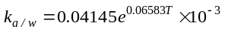
(1)

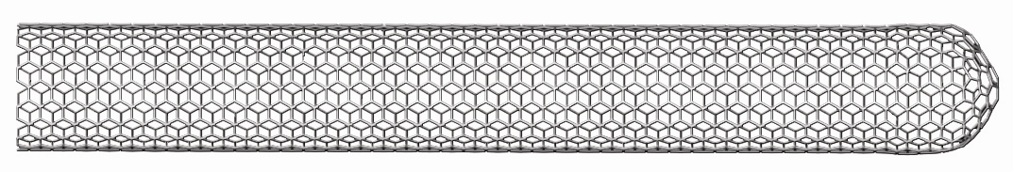
C
O
OH
C
O
OH
C
O
OH
C
O
OH
C
O
OH

Fig. 1. Schematic diagram of the chemically functionalized carbon nanotubes, which have COOH-group attached along the sidewall of the MWCNTs.

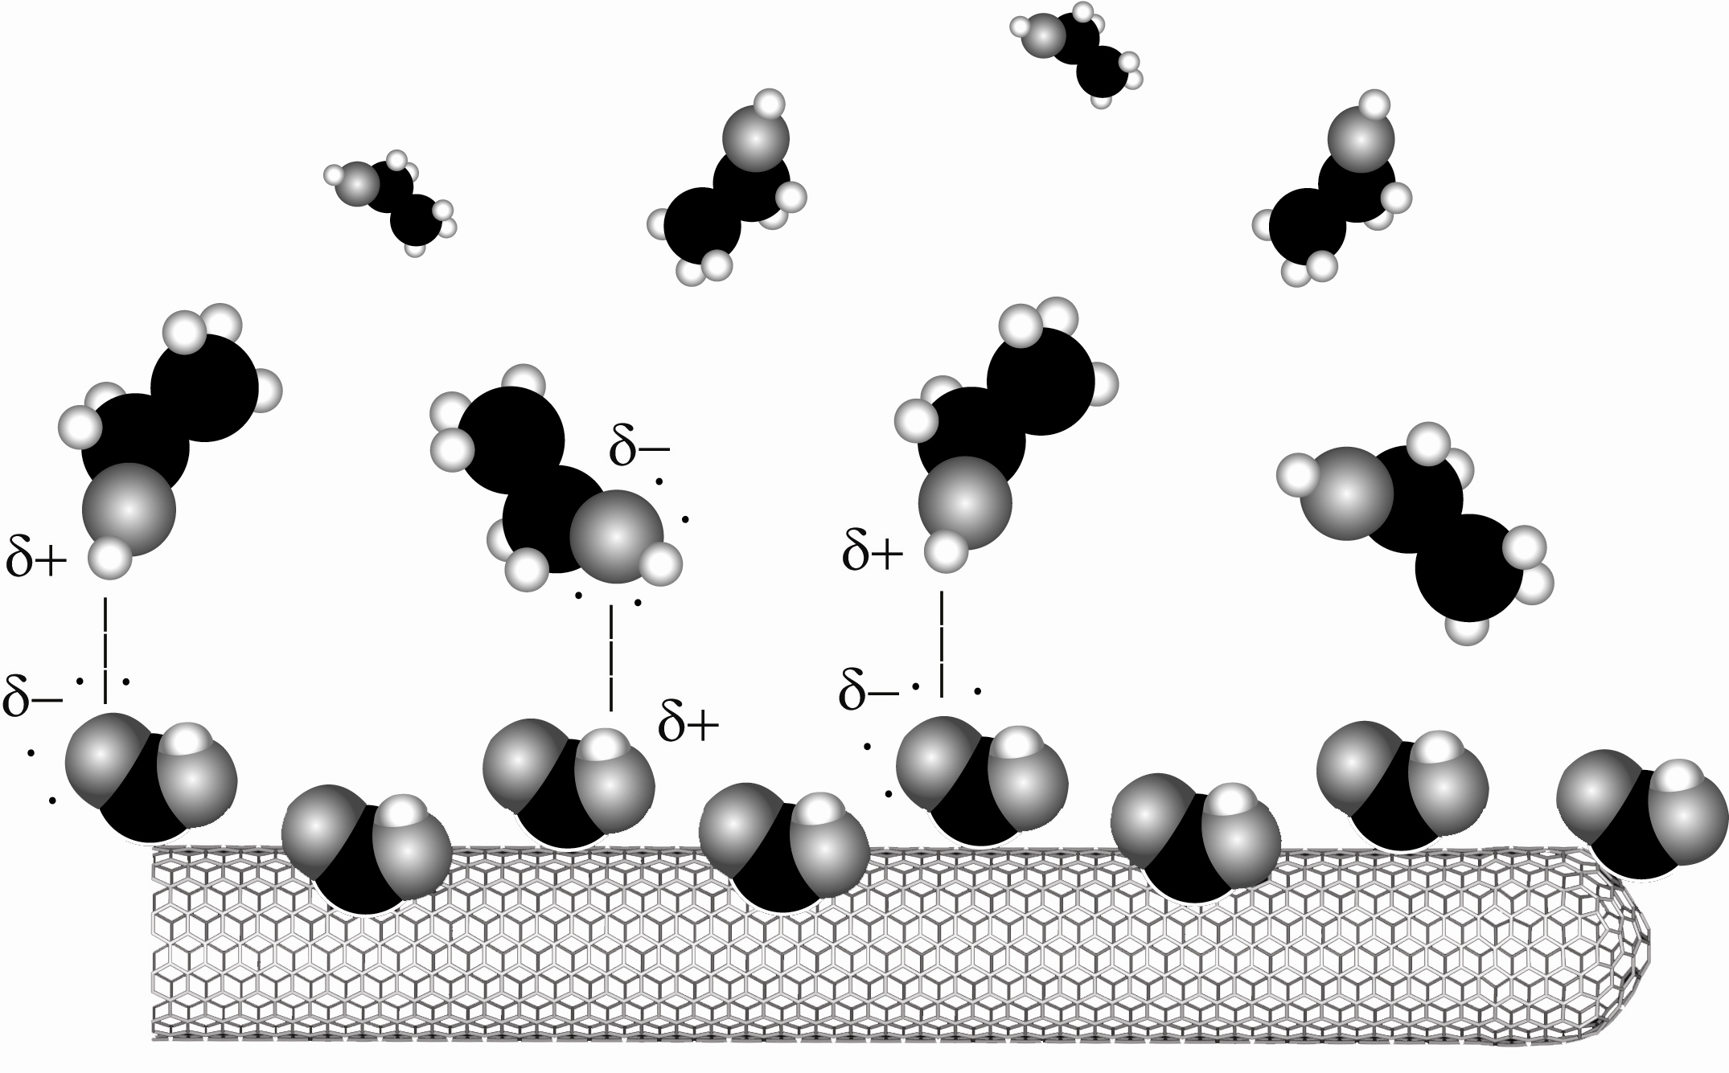
COOH group
Ethanol molecules
Hydrogen bonding
: Hydrogen
: Carbon
: Oxygen
MWCNTs

Fig. 2. The proposed mechanism for alcohol vapor detection using f-CNTs sensors. The COOH groups tend to form hydrogen bondings with the ethanol molecules at room temperature.

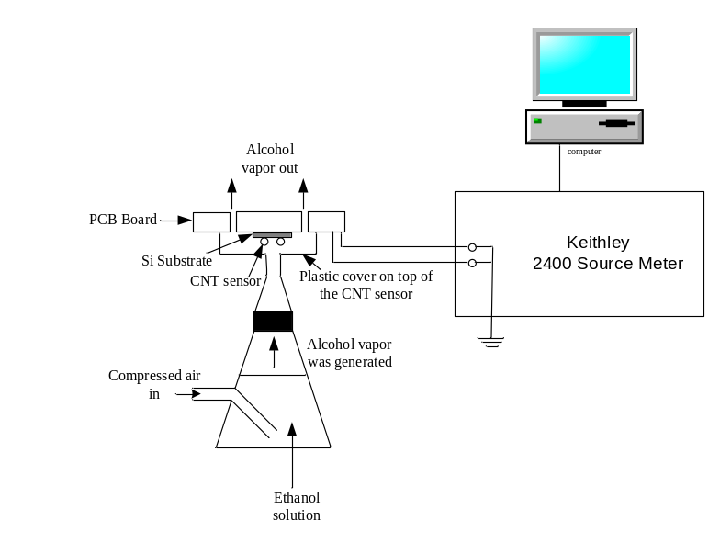
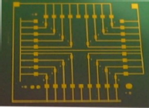
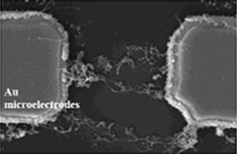
(A)
(B)
Au Microelectrodes
Alcohol solution

Fig. 3. Schematic diagram of the experimental setup for detecting alcohol vapor. Inset A and B show the array of Au microelectrodes on the SiO₂/Si substrate and a scanning electron microscopic (SEM) image of the f-CNTs formed between a pair of parallel Au microelectrodes respectively.
in which T is the temperature in °C. As all tests were performed at room temperature of ~25 °C, the alcohol vapor concentrations tested in our experiments correspond to 1-21 ppm as calculated by (1).
With the use of a Keithley 2400 SourceMeter, we studied the response of the sensors in a constant current configuration. We took the data every 0.7 s. We will define two currents here so as to make the explanation below clear. The first one is I, which is for the activation of the sensors. We use 1-10 μA as the activation current. The second one is I_{anneal}, which is for the annealing of the CNTs sensing elements so that they can be restored to their initial resistance. I_{anneal} is 100-200 μA.

Results

Power Consumption
Many research groups have investigated the electrical properties of individual CNTs in the last decade [26], [27] and shown their low power (microwatt) characteristics. Although bundles of MWCNTs are complex networks of individual CNTs, they also show a similar behavior according to our prior studies [22]. We have observed that the performance of CNTs bundles can have large variations in resistance, and hence we speculate that the chemically functionalized MWCNTs with COOH groups would also exhibit the same phenomenon. So, we first examine the I-V characteristics of two bundled f-CNTs sensors (4-hours and 1-day oxidized) using a constant current configuration. The results are shown in Fig. 4 and are similar to other previous reports. A self-heating effect started at 100 μA and 1V (35 μA and 1.1 V) for 4-hours (1-day) oxidized f-CNTs. This shows that we can treat the bundled f-CNTs as a resistive element with ultra-low power requirement. In all experiments, we activated the sensors at the linear region of 1 μA (below the overheat current) with the power consumption of only ~0.006-0.04 μW.

Typical Response
Fig. 5 shows the observed response of the sensor at 25 °C when an alcohol vapor of 21 ppm was blown onto the sensor. The transient response of the sensor is very fast. As we can see in Fig. 5, a sharp response can be observed within 1 s after we delivered alcohol vapor into the chamber. We filled the chamber with the alcohol vapor for 10 s. In the following discussion, the response of the sensors towards the ethanol vapor will be represented by the resistance change (ΔR).

Selectivity
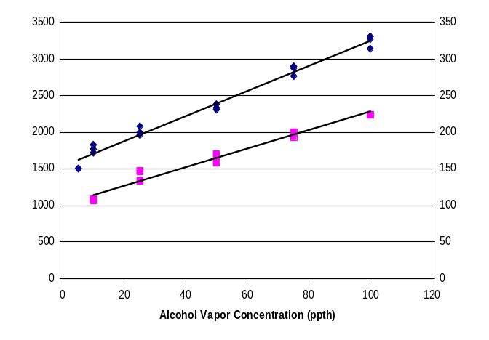
We also compared the response of the f-CNTs sensor to the flow of compressed air, DI-water vapor, and alcohol vapor. When we blow the alcohol vapor onto the f-CNTs sensors, 3 factors will affect the observed sensor resistance response (ΔR). The first factor is the air flow. From our previous findings [22], we know that MWCNTs are sensitive to the change of temperature and their resistance drops with increasing temperature, which indicates a negative temperature coefficient of resistance (TCR) of the CNTs. We have also tested the f-CNTs and they have similar characteristics. As the vapors flowing onto the sensors will convectively take away an amount of heat from them, it will enhance the response signals by a certain amount as well. The second factor is the DI-water used to mix with the absolute ethanol. As most of the concentrations of the alcohol vapors we tested are not very high, a very large volume ratio of the ethanol solution will be DI-water. Although the vapor pressure of water (3.2 kPa at 25 °C) is lower than that of absolute ethanol (7.9 kPa at 25 °C), the water molecules can also form hydrogen-bonds with the COOH functional groups. If the COOH group can form more extensive hydrogen-bond interaction with the water molecules, i.e., the f-CNTs are more sensitive towards the DI-water than the absolute ethanol, it will severely affect our results. The third factor is the absolute ethanol, which is what we want to measure. We compared the response of these three kinds of vapors by using the same experimental setup except that the ethanol solution was replaced with the compressed air and DI-water respectively. Hence, we could separately assess the contributions of these 3 kinds of vapors towards the observed response. As shown in Fig. 6, the signal of the alcohol vapor is easily distinguishable from those due to the flow of compressed air and water vapor, i.e., the response from the 1 ppm alcohol vapor was ~1.5 times larger than the other two kinds of vapors. So, this confirms that the f-CNTs are really detecting the ethanol molecules from the alcohol solution. This promising result encourages us to further investigate the response of the sensors towards other alcohol concentrations.
1 day oxidized f-CNTs: R₀~34.5kΩ, I = 1μA
The sensor was operated at 0.035μW

4 hours oxidized f-CNTs: R₀~5.7kΩ, I = 1μA
The sensor was operated at 0.006μW

Resistance Change ΔR (ohm)
Resistance Change ΔR (ohm)
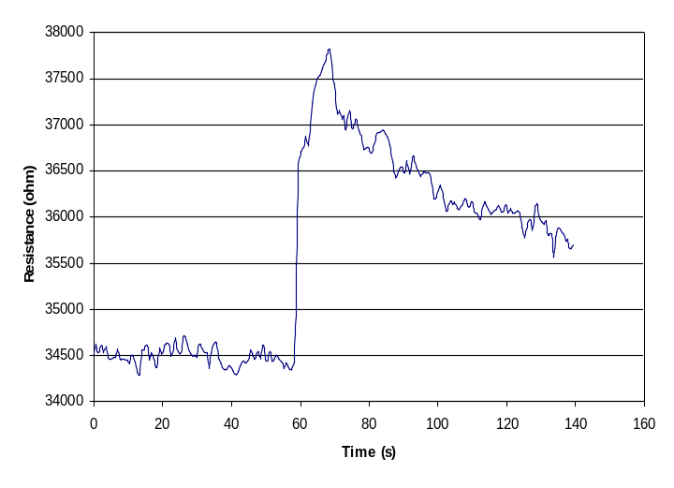
R₀~34.5kΩ, I = 1μA
The sensor was operated at 0.056μW.
Resistance change: ΔR
The moment when alcohol vapor was blown onto the f-CNTs sensor

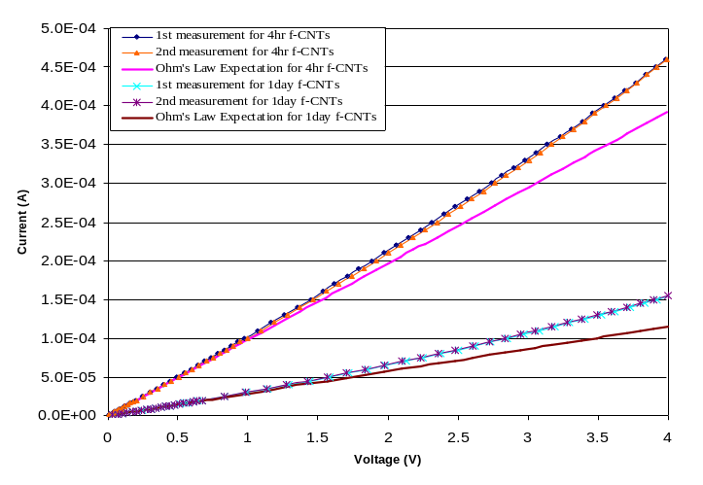

Fig. 4. I-V characteristics of the f-CNTs bundles. Two repeated measurements were performed for each sensor to validate the repeatability. The straight line is the theoretical expectation using Ohm’s law.

Alcohol Sensing Ability
Similar measurement like the one mentioned in Part B was carried out under the exposure of alcohol vapors from concentrations of 1-21 ppm. It shows a good linear dependency between the response and the alcohol vapor concentration as shown in Fig. 7. Both sensors have very good reproducibility for vapors of all concentrations. 3 cycles of data for two sensors (4-hours f-CNTs and 1-day f-CNTs) were collected at each concentration. The fluctuations of the data at all concentrations are within 10 % of the average values. In Fig. 8, the dependence of the relative resistance change of the sensors on the concentration level of alcohol vapors is also shown. We can clearly notice that the response of the 1-day f-CNTs sensor is 2 times stronger than the 4-hours f-CNTs. These results are reasonable as we expect that the longer the time interval for the oxidation process in acid, the larger the amount of COOH group will be attached to the MWCNTs, which results in more hydrogen-bond interaction and stronger response. We further compare these results with those using the bare MWCNTs. The response of the bare MWCNTs is 10 times and 4 times weaker than the 1-day and 4-hours f-CNTs, respectively, and it confirms that the COOH functional group is indeed more attractive towards the alcohol vapors.

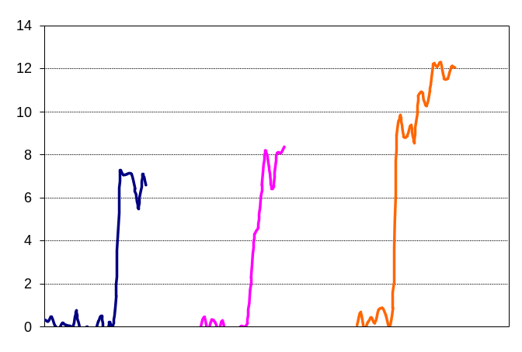
Fig. 5. Observed resistance change of the 1-day f-CNTs sensor with the introduction of 21 ppm concentration of alcohol vapor.
Air
I = 1 μA
DI-Water Vapor
1 ppm Alcohol Vapor
Relative Resistance Change (ΔR/R_{0×}100%)

Fig. 6. Comparison of the response of an f-CNTs sensor towards the flow of compressed air, water vapor, and alcohol vapor.

Reversibility
We found initially that even after the source of alcohol vapors was removed, the recovery time of the sensors was long, i.e., in the order of a few hours. The increase in resistance we have observed in all measurement must be due to the ethanol molecules being tightly adsorbed onto the nanotubes. So, we conjecture that the reversibility could be obtained and sped up by heating the sensor to a high enough temperature to “burn” away the alcohol molecules. But, there are two uncertainties. The first one is that the effective annealing temperature is unknown, i.e., what input power is required to “get rid of” the alcohol molecules. The second one is that not only the adsorbed alcohol vapors but also the COOH groups could be burned away if a sufficiently high annealing temperature is used, which thereby reduce the responsiveness of the sensors if they are used again. That is, the sensors may then lose part of their sensitivity towards the alcohol vapors even they can return back to their initial resistance after annealing. We propose that there are two kinds of bonding mechanisms in our system. One is the hydrogen bonding between the COOH functional group on the MWCNTs and the OH group of the ethanol molecule, which is ~21 kJmol⁻¹ [28]. Another one is the carbon-carbon single covalent bond between the COOH functional group and the MWCNTs, which is ~350 kJmol⁻¹ [28]. As the strength of the covalent bond is more than 10 times stronger than the hydrogen-bond, we expect that normal heating (< 100°C) can only remove the physisorbed ethanol molecules rather than the chemisorbed COOH functional groups. We proved this by the following experimental results. Two sets of data are shown in Fig. 9, which are the responses of an f-CNTs sensor after 21 ppm alcohol vapor is applied onto it. The sensor has been annealed with I_{anneal} of 100-200 μA for ~ 100-200 s. But, it is difficult to determine the exact annealing time required because the decrease in sensors’ resistance not only includes the alcohol molecules desorption, but also an intrinsic characteristic of the CNTs, which is the negative temperature coefficient of resistance (TCR) [22]. The result shows that the performance of the sensor did not vary much after different annealing processes. To further demonstrate the sensors’ repeatability, a second set of data with the same experimental setup 18 days after the first set was collected. The results are similar to the first set. Here, we illustrated that the reversibility of the f-CNTs sensors can easily be achieved if a high enough current is passed through them to accelerate the alcohol vapor desorption process. Also, due to the sensors’ reversibility, we conclude that the bonds between the COOH groups and the ethanol molecules must be non-covalent; while those between the COOH groups and MWCNTs must be covalent, and should be stable up to > 100 °C, as demonstrated similarly by G. Ovejero et al. using thermogravimetric analysis [21].
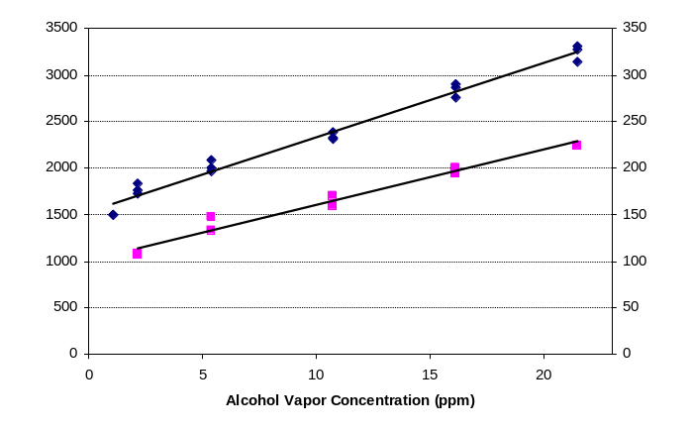
1 day oxidized f-CNTs: R₀~34.5kΩ, I = 1μA
The sensor was operated at 0.035μW

4 hours oxidized f-CNTs: R₀~5.7kΩ, I = 1μA
The sensor was operated at 0.006μW

Resistance Change ΔR (ohm)
Resistance Change ΔR (ohm)

Fig. 7. Responses of the f-CNTs sensors to 10-s dose of alcohol vapor with concentrations from 1-21 ppm. Three cycles of measurements for each sensor were performed.

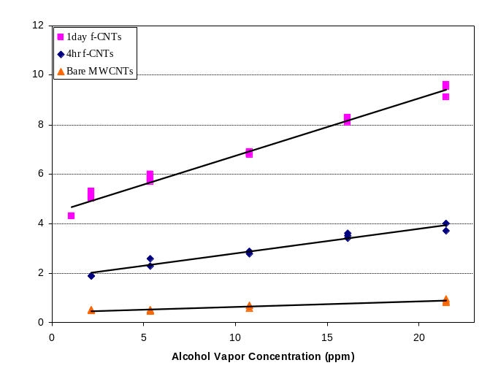
dx
Relative Resistance Change (ΔR/R_{0×}100%)
dy

Fig. 8. Measured relative percentage change of the resistance: ΔR/R₀×100%, of 3 different sensors: bare MWCNTs, 4-hours f-CNTs, and 1-day f-CNTs. The results of the f-CNTs sensors correspond to the results in Fig. 7.

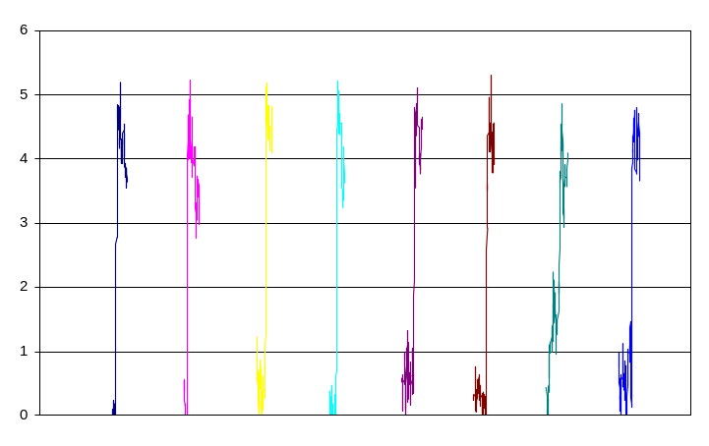
Relative Resistance Change (ΔR/R_{0×}100%)

1st set of data
2nd set of data
1st data
I_{anneal}:
100μA
I_{anneal}:
150μA
I_{anneal}:
200μA
I_{anneal}:
100μA
I_{anneal}:
150μA
I_{anneal}:
200μA
1st
data

Fig. 9. Measured relative percentage change of the resistance: ΔR/R₀×100%, of an f-CNTs sensor with an application of 21 ppm alcohol vapor after different annealing parameters. A: 1st response; B: 2nd response after annealing at 100 μA for ~100-200 s; C: 3rd response after annealing at 150 μA for ~100-200 s; D: 4th response after annealing at 200 μA for ~100-200 s.

Ultimate Sensitivity of the Sensors
In this paper, we define the sensitivity of alcohol sensors as the minimum input alcohol level that will create a detectable output change. It represents the minimum detectable alcohol level of the sensors, which is an important figure of merit of alcohol sensors. In this section, we will present a formal definition of sensitivity of the sensors, f ollowed by a discussion of the experiments we performed for the sensitivity analysis. At last, the result of the sensitivity for our sensors will be given. We define the sensitivity of the sensors as:

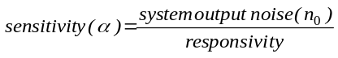 (2)

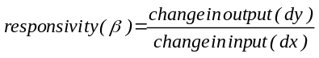 (3)

As the absolute resistance of the alcohol sensors is not well controlled and varies from sensor to sensor, it will be more suitable to compare the responsivity (β) using the percentage change of sensors’ resistance. Hence, (3) can be rewritten as:
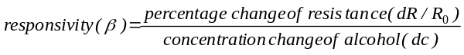
(4)

Using the experimental result of 1-day f-CNTs in Fig. 8, we found that the responsivity of our sensor is ~0.23 %/ppm. To find the system output noise (n₀), we used the same experimental setup as presented in section II and measured the resistance of the sensor without applying the alcohol vapor. The sensor was kept under constant environment (25 °C and 40 % relative humidity). Theoretically, the resistance of the sensor should not vary. However, in reality, the resistance of the sensor would fluctuate due to wideband noise. We took 1000 resistance samples for 700 s under this condition and computed the averaged output noise (n₀) using the following equation:

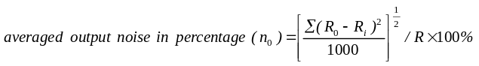(5)

where R₀ is the mean value of the sensor’s resistance and R_{i} is the individual measurement. It was found that the typical averaged output noise (n₀) of our sensor is 0.1-0.2 %. Hence, the sensitivity of our sensor base on this measuring methodology is 0.4-0.9 ppm. This means that the limit of detection for our 1-day f-CNTs sensor is 0.9 ppm at best.
It is possible that our measuring equipment and the environment may contribute to the system output noise. To further investigate the source of noise of the CNTs sensors, we repeated the same experiment but replaced the f-CNTs sensor with a carbon film resistor with similar resistance. We have found that the noise of this carbon film resistor is 0.01-0.02 %, which is an order lower than the f-CNTs noise. Hence, we can conclude that most of the noise in the f-CNTs sensor is inherent noise (noise that exists in the f-CNTs) rather than noise coming from measurement. Theoretically, resistors only have thermal noise which can be formulated by [29]:

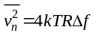 (6)

where Δf is the measuring bandwidth, T is the temperature, and k is the Boltzmann constant. The measuring bandwidth is defined by equivalent capacitance (C) connected parallel with the resistor, hence, thermal noise can be formulated as [29]:

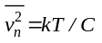 (7)

So, from (7), the thermal noise of resistors in the same circuit should be the same. Hence, we concluded that there exist other noise phenomena, besides thermal noise, that contribute to f-CNTs inherent noise. It is reported that 1/f noise (a noise that exists in many semi-conductor devices) is one of the inherent noise in CNTs [30]. We believed that unexpected excessive noise in our f-CNTs sensor may also be 1/f noise. Further research on CNTs noise sources is undergoing in our group now.

Conclusion
We demonstrated the potential of turning chemically functionalized MWCNTs based sensors into ultra-low-powered, selective, reproducible, highly sensitive, and reversible alcohol sensors. Based on our experimental results, we show that MWCNTs sensors, especially for those with proper functionalized groups, are sensitive to a wide range of alcohol vapors and potentially other volatile organic compounds, making them very attractive for commercialization due to their extreme low-power requirements for activation and simple and low-cost fabrication process.
Acknowledgment
The authors would like to earnestly thank Dr. W. Y. Cheung of the Department of Electronic Engineering of CUHK for his help on sensor fabrication. Also, we would like to express our appreciation to Amy Hiew of the Centre for Micro and Nano Systems, CUHK, for her help on preparing some figures in this paper. The work was partially supported by the RGC Research Grant Direct Allocation with a Project Code: 2060280.
References
[1] J. Li, Y. J. Lu, and M. Meyyappan, “Nano chemical sensors with polymer-coated carbon nanotubes”, IEEE Sensors Journal, vol. 6, pp. 1047, Oct. 2006.
[2] Y. J. Lu, J. Li, J. Han, H.-T. Ng, C. Binder, C. Partridge, and M. Meyyappan, “Room temperature methane detection using palladium loaded single-walled carbon nanotube sensors”, Chemical Physics Letters, vol. 391, pp. 344, Jun. 2004.
[3] A. Hierlemann, D. Lange, C. Hagleitner, N. Kerness, A. Koll, O. Brand, and H. Baltes, “Application-specific sensor systems based on CMOS chemical microsensors”, Sensors and Actuators B, vol. 70, pp. 2, Nov. 2000.
[4] J. Kong, Nathan R. Franklin, C. W. Zhou, Michael G. Chapline, S. Peng, K. J. Cho, and H. J. Dai, “Nanotube molecular wires as chemical sensors”, Science, vol. 287, pp. 622, Jan. 2000.
[5] R. A. McGill, V. K. Nguyen, R. Chung, R. E. Shaffer, D. DiLella, J. L. Stepnowski, T. E. Mlsna, D. L. Venezky, and D. Dominguez, “The “NRL-SAWRHINO”: a nose for toxic gases”, Sensors and Actuators B, vol. 65, pp. 10, Jun. 2000.
[6] Erik. T. Thostenson, Z. F. Ren, and T. W. Chou, “Advances in the science and technology of carbon nanotubes and their composites: a review”, Composites Science and Technology, vol. 61, pp. 1899, Oct. 2001.
[7] Y. Saito, K. Hamaguchi, S. Uemura, K. Uchida, Y. Tasaka, F. Ikazaki, M. Yumura, A. Kasuya, and Y. Nishina, “Field emission from multi-walled carbon nanotubes and its application to electron tubes”, Applied Physics A: Materials Science and Processing, vol. 67, pp. 95, Jul. 1998.
[8] L. Valentini, L. Lozzi, C. Cantalini, I. Armentano, J. M. Kenny, L. Ottaviano, and S. Santucci, “Effects of oxygen annealing on gas sensing properties of carbon nanotube thin films”, Thin Solid Films, vol. 436, pp. 95, Jul. 2003.
[9] E. S. Snow, F. K. Perkins, E. J. Houser, S. C. Badescu, and T. L. Reinecke, “Chemical detection with a single-walled carbon nanotube capacitor”, Science, vol. 307, pp.1942, Mar. 2005.
[10] A. C. Dillon, K. M. Jones, T. A. Bekkedahl, C. H. Kiang, D. S. Bethune, and M. J. Heben, “Storage of hydrogen in single-walled carbon nanotubes”, Nature, vol. 386, pp. 377, Mar. 1997.
[11] J. Kong, Nathan R. Franklin, C. W. Zhou, Michael G. Chapline, K. J. Cho, and H. J. Dai, “Nanotube molecular wires as chemical sensors”, Science, vol. 287, pp. 622, Jan. 2000
[12] M. Penza, F. Antolini, and M. Vittori Antisari, “Carbon nanotubes as SAW chemical sensors materials”, Sensors and Actuators B, vol. 100, pp. 47, Feb. 2004.
[13] S. Mishra, C. Ghanshyam, N. Ram, S. Singh, R. P. Bajpai, and R. K. Bedi, “Alcohol sensing of tin oxide thin film prepared by sol-gel process”, Bulletin of Materials Science, vol. 25, pp. 231, Jun. 2002.
[14] A. Burresi, A. Fort, S. Rocchi, M. Belen Serrano Santos, N. Ulivieri, and V. Vignoli, “Temperature profile investigation of SnO₂ Sensors for CO detection enhancement”, IEEE Transactions on Instrumentation and Measurement, vol. 54, pp. 79, Feb. 2005.
[15] Jose K. Abraham, Biju Philip, Ashwin Witchurch, Vijay K. Varadan, and C. Channaa Reddy, “A compact wireless gas sensor using a carbon nanotube/PMMA thin film chemiresistor”, Smart Materials and Structures, vol. 13, pp. 1045, Aug. 2004.

[16] T. Someya, J. Small, P. Kim, C. Nuckolls, and James T. Yardley, “Alcohol vapor sensors based on single-walled carbon nanotube field effect transistors”, Nano Letters, vol. 3, pp. 877, May. 2003.
[17] J. Li, Y. J. Lu, Q. Ye, M. Cinke, J. Han, and M. Meyyappan, “Carbon nanotube sensors for gas and organic vapor detection”, Nano Letters, vol. 3, pp. 929, Jun. 2003.
[18] M. Penza, G. Cassano, P. Aversa, F. Antolini, A. Cusano, A. Cutolo, M. Giordano, and L. Nicolais, “Alcohol detection using carbon nanotubes acoustic and optical sensors”, Applied Physics Letters, vol. 85, pp. 2379, Sep. 2004.

[19] H. K. Ye, O. Nilsen, Victor M. Bright, and Dana Z. Anderson, “Holographic chemical vapor sensor”, Optics Letters, vol. 30, pp. 1467, Jun. 2005.
[20] H. Jensenius, J. Thaysen, Anette A. Rasmussen, Lars H. Veje, O. Hansen, and A. Boisen, “A microcantilever-based alcohol vapor sensor-application and response model”, Applied Physics Letters, vol. 76, pp. 2615, May. 2000.
[21] G. Ovejero, J. L. Sotelo, M. D. Romero, A. Rodríguez, M. A. Ocaña, G. Rodríguez, and J. García, “Multiwalled carbon nanotubes for liquid-phase oxidation. functionalization, characterization, and catalytic activity”, Industrial and Engineering Chemistry Research, vol. 45, pp. 2206, Mar. 2006.
[22] Carmen K. M. Fung, Victor T. S. Wong, Rosa H. M. Chan, and Wen J. Li, “Dielectrophoretic batch fabrication of bundled carbon nanotube thermal sensors”, IEEE Transactions on Nanotechnology, vol. 3, pp. 395, Sep. 2004.
[23] Carl L. Yaws, Chemical properties handbook: physical, thermodynamic, environmental, transport, safety, and health related properties for organic and inorganic chemicals. New York: McGraw-Hill, 1999.
[24] R. N. Harger, B. B. Raney, E. G. Bridwell, and Mary F. Kitchel, “The partition ratio of alcohol between air and water, urine and blood; estimation and identification of alcohol in these liquids from analysis of air equilibrated with them”, Journal of Biological Chemistry, vol. 183, pp. 197, Mar. 1950.
[25] Dominick A. Labianca, “The flawed nature of the calibration factor in breath-alcohol analysis”, Journal of Chemical Education, vol. 79, pp. 1237, Oct. 2002.
[26] T. W. Ebbesen, H. J. Lezec, H. Hiura, J. W. Bennett, H. F. Ghaemi, and T. Thio, “Electrical conductivity of individual carbon nanotubes”, Nature, vol. 382, pp. 54, Jul. 1996.
[27] J. Y. Chung, K. H. Lee, J. H. Lee, D. Troya, and G. C. Schartz, “Multi-walled carbon nanotubes experiencing electrical breakdown as gas sensors”, Nanotechnology, vol. 15, pp. 1596, Oct. 2004.
[28] Peter R. S. Murray, Principles of organic chemistry, 2nd ed., London, U.K.: Heinemann Educational Books Ltd, 1977.
[29] B. Razavi, Design of analog CMOS integrated circuits. New York: McGraw-Hill, 2000.

[30] Philip G. Collins, M. S. Fuhrer, and A. Zettl, “1/f noise in carbon nanotubes”, Applied Physics Letters, vol. 76, pp. 894, Feb. 2000.


Mandy Lai Yi SIN received the B. Sc. degree in Physics from The University of Hong Kong in 2000 and M. Phil. degree in Physics from The Chinese University of Hong Kong in 2002. From 2003 to 2004, she worked in the Centre for Condensed Matter Sciences, National Taiwan University (NTU) and studied the growth kinetics and structure of molecular films on metal surfaces using ultrahigh vacuum scanning tunneling microscope (STM). She is currently working toward the Ph. D. degree in Mechanical and Automation Engineering of The Chinese University of Hong Kong. Her current research interest is the development of the micro/nano sensors for chemicals based on multi-walled carbon nanotube.

Gary Chun Tak CHOW received the B. Eng. degree in Computer Engineering from The Chinese University of Hong Kong in 2005. He is currently working toward the M. Phil. degree in Computer Science and Engineering in the same university. His research interests include reconfigurable computing, digital and analog integrated circuits. (E-mail: ctchow@cse.cuhk.edu.hk)

Gary Man Keung WONG received his B. Sc. degree in Materials Science and Engineering from The Chinese University of Hong Kong (CUHK) in 2005. In 2006, he worked as a Research Assistant in The Institute of Precision Engineering, CUHK. He is currently working toward the M. Phil. degree in Materials Science and Engineering in CUHK. His current research interest is the study of the electrical and electronic properties of the surface functionalized carbon nanotubes.


Wen Jung LI (S’97–A’97–M’00) is a Professor in the Department of Mechanical and Automation Engineering, and currently heads the Centre for Micro and Nano Systems at The Chinese University of Hong Kong (CUHK). He received B. S. and M. S. degrees in Aerospace Engineering from the University of Southern California and his Ph. D. degree specializing in MEMS from the University of California, Los Angeles. Before joining CUHK, he held R&D positions at the NASA/CalTech Jet Propulsion Laboratory (Pasadena, California), The Aerospace Corporation (El Segundo, California), and Silicon Microstructures Inc. (Fremont, California). His research group has won best paper awards from premier conferences of the IEEE Nanotechnology Council (IEEE-NANO) and the IEEE Robotics and Automation Society (IEEE-ICRA) in 2003 for its work on nano-sensors and micro cell-grippers. He has served/is serving as a guest editor for the IEEE Transactions on Automation Science and Engineering, the IEEE/ASME Trans. on Mechatronics, and the IEEE Sensors Journal on special topics related to nano-assembly and nano-sensors. He is currently the Editor-in-Chief of the IEEE Nanotechnology Magazine (1st issue in 2007), the General Chair of IEEE-NANO 2007, and a Distinguished Overseas Scholar of the Chinese Academy of Sciences.

Philip Heng Wai LEONG (M’84–SM’02) received the B. Sc., B. E. and Ph. D. degrees from the University of Sydney in 1986, 1988 and 1993 respectively. In 1989, he was a research engineer at AWA Research Laboratory, Sydney Australia. From 1990 to 1993, he was a postgraduate student and research assistant at the University of Sydney, where he worked on low power analogue VLSI circuits for arrhythmia classification. In 1993, he was a consultant to SGS Thomson Microelectronics in Milan, Italy. He was a lecturer at the Department of Electrical Engineering, University of Sydney from 1994-1996. He is currently a Professor in the Department of Computer Science and Engineering at the Chinese University of Hong Kong and the Director of the Custom Computing Laboratory. He is the author of more than 70 technical papers and 5 patents. His research interests include reconfigurable computing, digital systems, parallel computing, cryptography and signal processing. He is a senior member of the IEEE. (E-mail: phwl@cse.cuhk.edu.hk)


Ka Wai WONG received the B. Sc., M. Phil. and Ph. D. degrees in Chemistry from The Chinese University of Hong Kong (CUHK) in 1992, 1995 and 1999, respectively. After graduation, he joined the Advanced Surface and Materials Analysis Centre as Programme Executive and then joined the Department of Physics, CUHK as Postdoctoral Fellow with major research focus on organic/polymeric optoelectronics. From 2003-2005, he worked in Hong Kong DNA Chips Limited as a Project Manager leading a R & D team on developing novel silicon-based DNA chips for molecular diagnostics. He is currently a Research Assistant Professor in the Department of Physics at CUHK. His major research interests include nanotechnology, sensing technology, surface science and materials engineering.

 Manuscript received January 15, 2007. This work was funded by the Hong Kong Research Grants Council (4225/03), a grant from the Shun Hing Institute of Advanced Engineering of CUHK, and the RGC Research Grant (2060280). For sensor fabrication and characterization, contact Wen J. Li (wen@mae.cuhk.edu.hk); for CNT chemical functionalization, contact Ka Wai Wong (kwwong@cuhk.edu.hk). Mandy L. Y. Sin and Wen J. Li are with the Centre for Micro and Nano Systems, The Chinese University of Hong Kong, Shatin, New Territories, Hong Kong SAR. Gary C. T. Chow and Philip H. W. Leong are with the Department of Computer Science and Engineering, The Chinese University of Hong Kong, Shatin, New Territories, Hong Kong SAR. Gary M. K. Wong and Ka Wai Wong are with the Department of Physics, The Chinese University of Hong Kong, Shatin, New Territories, Hong Kong SAR. Copyright © 2007 IEEE. Personal use of this material is permitted. However, permission to use this material for any other purposes must be obtained from the IEEE by sending a request to pubs-permissions@ieee.org.

