Fabrication of High-Aspect-Ratio Probes for
Potential Applications in Biological Cellular Surgery

King W. C. Lai and Wen J. Li*
Centre for Micro and Nano Systems,
The Chinese University of Hong Kong,
Shatin, N.T., Hong Kong SAR
*Contact Author: wen@acae.cuhk.edu.hk

Abstract

This paper presents the fabrication process of novel high-aspect-ratio nanometric probes and their potential application in intracellular operation. The process is named as Kwong-Li’s (KL) Method which is a very fast and reliable single-step etching process to fabricate tiny-angled nanometric fiber probes and micropipettes from optical fibers and capillary tubings, respectively. Compared with other available multi-step sharp-tip (e.g., SNOM tips) fabrication processes, this novel process is less complex and can yield sharper tips. KL Method used a sacrificial boundary etching technique, which employed glass tubings as etching barriers, together with p-xylene as organic solvent and hydrofluoric (HF) acid as etchant, we succeeded in sharpening optical fibers into tiny probe tips with angles ranging from 2.7˚ – 9.7˚, and with nanoscale tip diameters of <1μm. Capillary tubes(with microchannels inside) were also sharpen into micropipettes with tip angle as small as 2.1˚ and with tip diameter of 5μm. (Both optical fibers and capillary tubes have initial diameter about 125μm). By controlling the initial etchant height in the sacrificial barrier, final tip profiles were demonstrated to be adjustable. Typical characteristics of fiber probes and micropipettes etched by KL Method, such as tip profile, tip diameter and tip angle, will be discussed in this paper. If the aspect-ratio (AR) of a probe is defined as the ratio between length of its tapered distance and the length of its base diameter, then the AR for a KL fiber probe can be as high as 15. For comparison, Turner’s probes typically have AR ~ 2, and AFM tips have AR ~ 1. Typical tip diameter of Turner’s fiber probes is about 1μm. However, tip diameter as small as 200nm can be obtained for a KL fiber probe. The KL fiber probes and micropipettes could potentially be used as surgical tools for cellular surgery and possibly for scanning probe microscopy applications. We have already shown that KL probes could penetrate through cell membranes with less mechanical resistance than conventional pipettes and probes made from Turner’s Method.

Keywords: Kwong-Li’s Probes, Kwong-Li’s Method, Micro/Nano Pipette, Micro/Nano Injection, Sacrificial Boundary Etching

1 INTRODUCTION

The fabrication of micro/nano scale probes/micropipettes has become essential in intracellular surgery. The size of micro probes is a major limitation for micro-cellular operation. For example, to investigate the DNA or small biological tissues in medical sciences, a probe with ultra-small tip diameter is needed. The micropipette has been used in the past but the applications were limited by its size. A summary of micropipette applications in neural sciences is given in [1]. Currently, the micropipette is being used in two major ways: 1) it acts as a microelectrode to obtain electrical signal; 2) to perform fluid/substance injection that allows fluid/substance to transfer from one end to the other end which contact with the cell. Thus, improved technologies for cell sensing, manipulation, or injection could be realized by minimizing the size of these probes and micropipettes.

On the other hand, Scanning Near-field Optical Microscopy (SNOM) was invented in 1984 to allow potential optical imaging in the nanometer scale. Its spatial resolution can go down to sub-100nm [2], which is far beyond the classical optical microscopy diffraction limit. This promising technique not only has a nanometric resolution, but also retains useful contrast mechanisms in traditional optical microscopy, e.g., polarization and fluorescence [3]. Like all other scanning probe microscopies, probe profile characterizes the resolution of SNOM. In general, the smaller the probe-tip diameter, the better the achievable spatial resolution. And, the sharper the tip, the smaller the tip angle [4]. Currently SNOM fiber probes are produced by mechanical pulling and chemical etching [3]. Among these, chemically etched probes have a higher optical transmission. Yet, there are limited mechanisms which can easily realize a large range of fabricated probe angles with such high optical transmission.

In this paper, we present a novel probe fabrication process named as Kwong-Li’s (KL) Method, in which a sacrificial boundary etching technique is combined with a well known and simple chemical etching process (Turner’s Method [5]). By controlling the initial etchant height in the sacrificial barrier, final tip profiles were demonstrated to be adjustable as shown in Figure 1. Typical characteristics of probes and micropipettes etched by KL Method, such as tip profile, tip diameter and tip angle, are discussed in this paper.
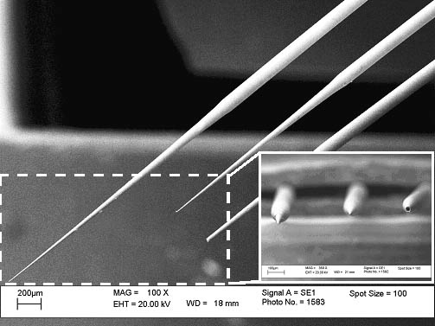
Figure 1. SEM pictures of fabricated KL micropipettes with different tip profiles.

2 PRINCIPLE OF THE KL METHOD

A simple chemical etching process was introduced by Turner using pure hydrofluoric (HF) acid and organic solvent to fabricate small probe tips from optical fibers [5]. Interfacial meniscus formed between an organic solvent layer and HF acid which was employed to etch the fibers. The stripped fiber was dipped into the etchant and the final probe tip was formed at the interfacial meniscus as shown in Figure 2. Such probe profile can be modeled by a solution of the Young-Laplace Equation [3], which reveals the relationship between the changes of interfacial meniscus to the final probe profile.

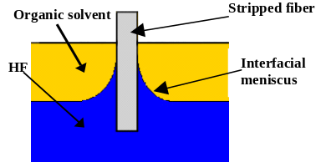
Figure 2. Illustration of Turner’s Method.

Inspired by this discovery, KL Method introduces a glass tubing as the sacrificial barrier to control the interfacial meniscus, so probe and pipette tip profile can be controlled. During the fabrication, the stripped fiber dipped into the etchant perpendicularly, both stripped fiber and glass tubing hold stationary as shown in Figure 3. It is important to align the stripped fiber to the center of the glass tubing in order to balance the interfacial meniscus surrounding the stripped fiber, resulting the fabricated probe tip is in circular shape. Since HF acid react with the stripped fiber and the inner wall of the glass tubing continuously, both stripped fiber and glass tubing would be etched away during the process, so that the interfacial meniscus keeps falling as shown in Figure 4. Finally, a probe can be formed with a very long taper and a sharp tip. To control the probe profile, we can simply adjust initial HF acid height in the glass tubing. The final tip profile is also highly depended on the exact finished etching time.
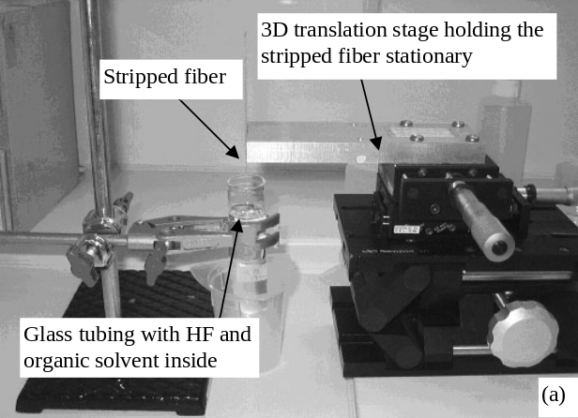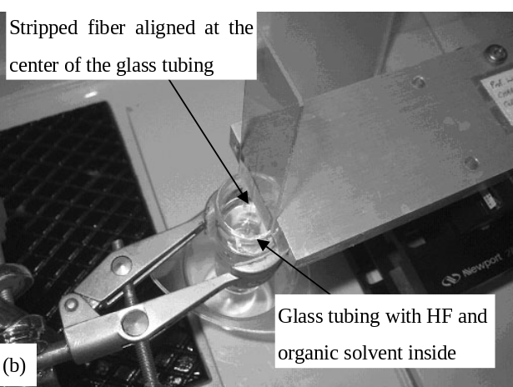
Figure 3. KL Method Experimental setup. (a) Stripped fiber is dipped perpendicular to the interfacial meniscus which formed by HF acid and organic solvent. 3D translation stage, glass tubing and stripped fiber keep stationary during the etching process. (b) Image shown the alignment of the stripped fiber.

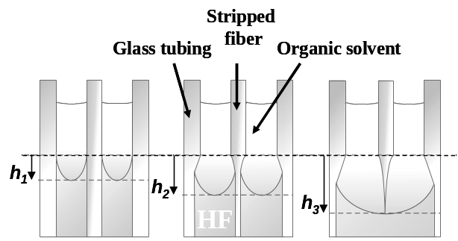
HF
Figure 4. Controlling the interfacial meniscus by sacrificial boundary etching.
3 FABRICATION RESULTS

A set of sacrificial boundary etching experiments was conducted with glass tubings of 21mm inner diameter. Fiber optics and fused silica capillary tubings were the samples used to test the KL method. Fiber probes were also fabricated by Turner’s Method as reference probes to KL probes. In all experiments, single mode fiber was used (F-SA with cladding diameter of 125μm, Newport Corporation) to fabricate KL probes; flexible fused silica capillary tubing was used (TSP002150 with inner diameter of 2μm and outer diameter of 126μm, Polymicro Technologies) to fabricate KL micropipette. The difference between probe and micropipette is that the micropipette contains a hollow microchannel which allows fluid to pass through it. Etchant and organic solvent in the experiments were pure HF acid (48%) and p-xylene, respectively. These experiments were carried out in 16.5˚C environment, where the typical time for the process was 55 minutes. A KL probe fabricated using the above process is compared with a Turner’s probe and an AFM tip as shown in Figure 5. The front view of a traditional pulled glass pipette, a KL probe and a Turner probe is shown in Figure 6. KL probes have much smaller tip angle and longer taper than the conventional Turner probes used for SNOM. Intuitively, this implies that KL probes can be used to probe or dissect biological cells with much less mechanical resistance on the cell membranes. KL micropipettes also allow biologists to conduct experiments such as fluid injection.
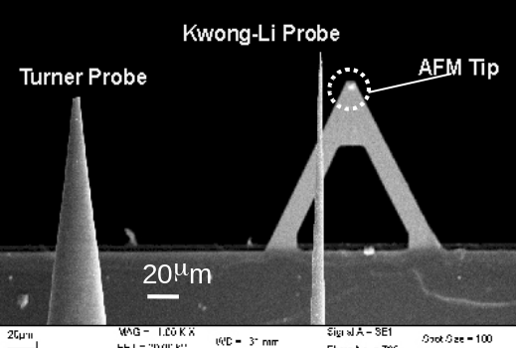
Figure 5. SEM picture of a Turner probe, a KL probe and an AFM Tip.
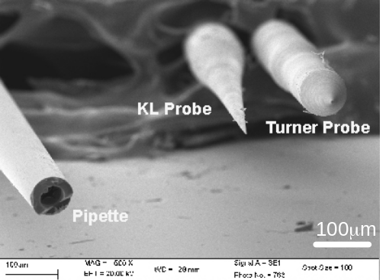
Figure 6. SEM picture of a KL Probe, a Turner Probe and a conventional pipette.
3.1 FIBER PROBE TIP PROFILE

Different lengths of the taper of probes were fabricated from etching optical fibers by controlling the initial height of HF acid in KL method, with the same experimental setup described above and etching time was 55mins. Examples of various probes are shown in Figure 7. The length of the taper can be as long as 2mm, which is much longer than a typical Turner’s probe. If the aspect-ratio (AR) of a probe is defined as the ratio between length of its tapered distance (L in Figure 7) and the length of its base (W in Figure 7), then, the AR for a KL probe can be as high as 15. For comparison, Turner’s probes typically have AR ~ 2, and AFM tips have AR ~ 1. The tip diameter is another difference between KL probes and Turner’s probes. Typical tip diameter of Turner’s fiber probes is about 1μm. However, tip diameter as small as 200nm can be obtained for a KL fiber probe as shown in Figure 8. Another great advantage of the KL Method is that the final fiber probe tip angle can be sharpened down to 2.7˚.
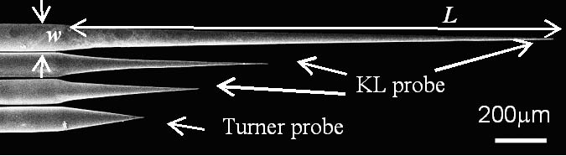
Figure 7. SEM picture of the length of taper of fiber probes can be controlled by using the KL Method.

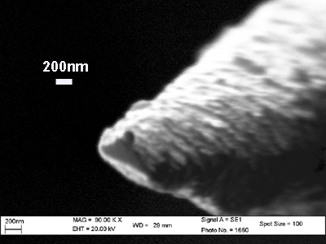
Figure 8. SEM picture of a KL fiber probe tip in nano-scale.

3.2 MICROPIPETTE TIP PROFILE

Similar etching process was applied to fabricate micropipettes from etching the capillary tubings. The experimental setup is the same as before but the optical fiber was replaced by capillary tubings. The length of taper of the fabricated KL micropipette is about 1.5mm. The fabricated KL micropipette tip angle can be sharpened down to 2.1˚. The cavity at the tip end is also enlarged due to the HF acid diffusing into the cavity during the fabrication process as shown in Figure 9a. However, this diffusion could be prevented by dipping the capillary tubing into p-xyene before the process, an improved micropipette tip is shown in Figure 9b. For typical KL micropipette as shown in Figure 10, the inner tip diameter is about 5.5μm and outer tip diameter is about 6.5μm. The tip diameter of KL micropipettes could not be as small as KL fiber probes because it is limited by the original inner diameter of the capillary tubings.
The resulting taper angles of KL micropipettes due to initial height of HF acid is shown in Figure 11. It implies that increasing the initial heights of HF acid can reduce the tip angle, resulting in sharper probe tip. The time of the etching experiment will also affect the probe tip angle as shown in Figure 11.

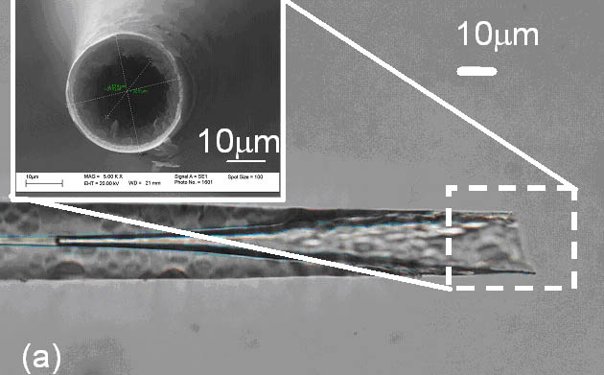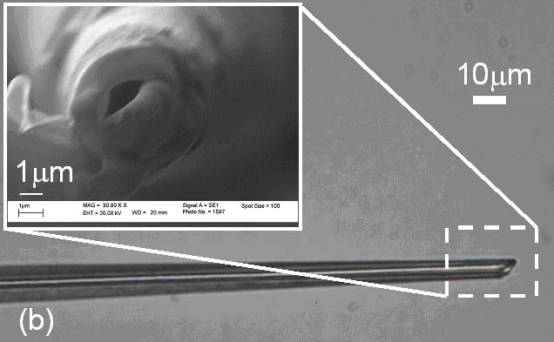
Figure 9. Microscope picture showing the inner microchannel profile of the KL micropipette: a) HF diffused into the capillary tubings; b) without HF diffusion. Inset SEM images show the detailed profile of the tip hole.

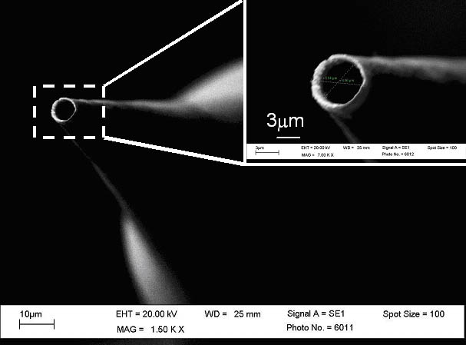
Figure 10. SEM picture of a KL micropipette showing the tip hole.
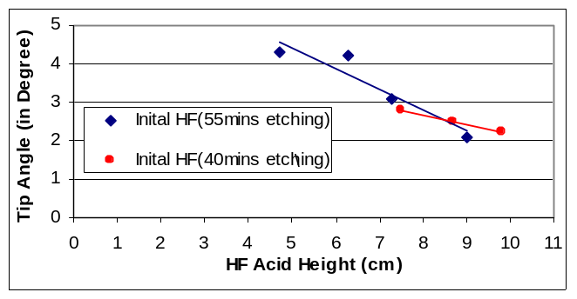
Figure 11. Relationship between KL pipette tip angle and HF acid height.

4 CELL PROBING EXPERIMENTS

With fabricated nanometric tips, the KL fiber probes could potentially be used as surgical tools for smaller cell. However, excessive force is one of the factors that kill the cells during the probe penetration of biological tissues. The comparison between the force of KL fiber probes and Turner probes when probing cell was conducted.

4.1 MICRO-NEWTON FORCE SENSING SYSTEM

A micromanipulation station with a micro-Newton force sensing system was developed in our prior work [6] to detect force during the micro probing/injection process. The sensing system consists of a PVDF sensor and adapters to a micromanipulator and a probe. We have previously shown that our PVDF sensor can resolve micro-Newton force within a proper frequency range (resonance frequency at ~50Hz and detectable frequency at a few mHz).

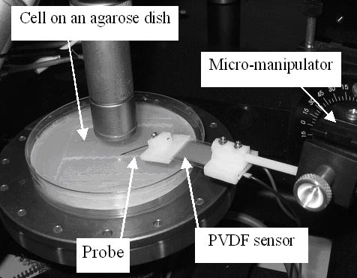
Figure 12. Experimental setup for the cell probing experiments.

In the experiment, we attached the Turner fiber probes and KL fiber probes to the sensing system to probe and penetrate cells under the control of a 3-axis micromanipulator as shown in Figure 12. Force signals acquired from penetrating these cells were collected and analyzed. Manipulation velocity of the probe may cause different impact force as well as inertia force on the sensing system. The relationship between the sensor output signal and the probing velocity is discussed as follows.

4.2 CELL PROBING SIGNALS

Unfertilized egg cells of Danio rerio (with diameter ranging from 500μm to 1mm) were employed in our cell probing experiments. The cells were placed on an agarose dish and observed under a microscope during the probing process. The probing speed of the micromanipulator was set to 1000μm/s and the travel distance was set to 500μm. Under the microscope, the tip of the probe was first manually aligned to point towards the center of the cell and initially 100μm away from the cell membrane. Then, the probe was commanded to move into the cell by a computer program. The key steps during the cell probing experiments are illustrated in Figure 13.
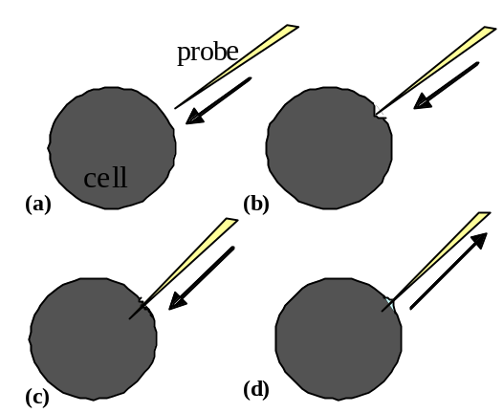
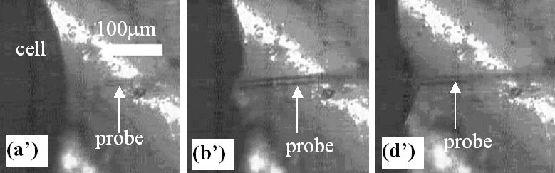
Figure 13. Illustrations showing various stages during a cell injection/probing/dissection process: (a) the probe moves towards the cell (corresponding microscope image is shown in (a’)); (b) the probe touches and deforms the cell membrane (corresponding microscope image is shown in (b’)); (c) the probe penetrates the cell membrane; (d) the probe is extracted from the cell (corresponding microscopic image is shown in (d’)).

A control experiment was performed by moving the sensing system with an attached probe, but not allowing the probe to touch the cell membrane. The result of the control experiment is shown in Figure 14. Two large-amplitude vibration signals were found due to the change in inertia force when the probe started to move and stopped from moving in the control experiment.
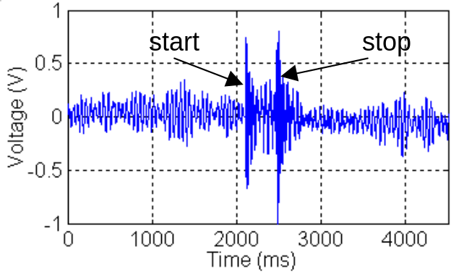
Figure 14. Voltage signal from the PVDF micro-sensing system which was measured from the control experiment to indicate the inertia force of the manipulation system without probing a cell.

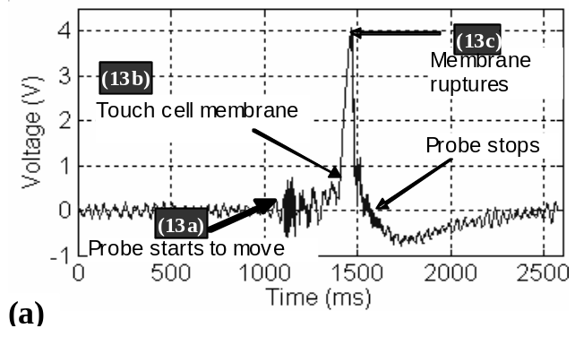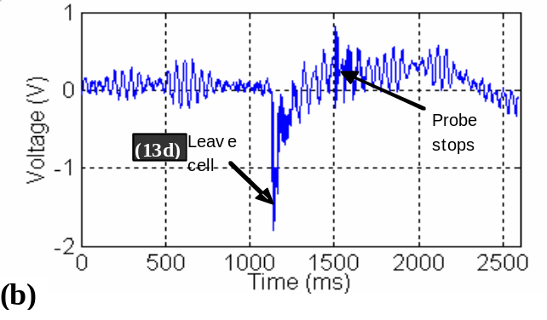
Figure 15. Voltage signal from the PVDF micro-sensing system which was used to measure the force of the probes as they impinge on the membrane of a cell. (a) A Turner Probe penetrated a cell membrane. The regions on the signal curve can be related to the steps illustrated in Figure 13a, 13b and 13c. (b) A Turner Probe was extracted from the cell.

Signals in the various stages of the probing process from Turner probe were recorded as shown in Figure 15a. When a Turner Probe touched the cell membrane (Figure 13b), the signal increased suddenly, which corresponded to the impact force on the membrane. Then, the signal dropped after the probe penetrated the cell membrane (Figure 13c) so that mechanical resistance on the probe was lowered on the probe from the membrane. These experiments clearly indicate that the PVDF sensing system is sensitive enough to pick up the cell probing signals. With the same configuration as the probing experiment, the probe was drawn out of the cell (Figure 13d) and the obtained signal is shown in Figure 15b. When the probe started to move, the signal dropped because the frictional force between the cell and the probe that moved the PVDF sensing element in the reverse direction of the probe withdrawing motion. After the probe moved to a certain distance, it left the cell membrane, and the force exerted on the probe decreased, then a consequent rise in the signal was observed.

Similar experiments were carried out using KL probes. Since KL probes are much “sharper” than Turner Probes, i.e., they have much smaller tip angle and much longer taper length than Turner Probes, so by intuition, KL probes should penetrate cells with less mechanical resistance. The signal obtained from our experiments validated this conjecture. As shown in Figure 16a and Figure 16b, both the penetration and extraction signals are much lower than when Turner Probes were used. Hence, KL probes will cause less damage to a cell during a cell probing/injection process.
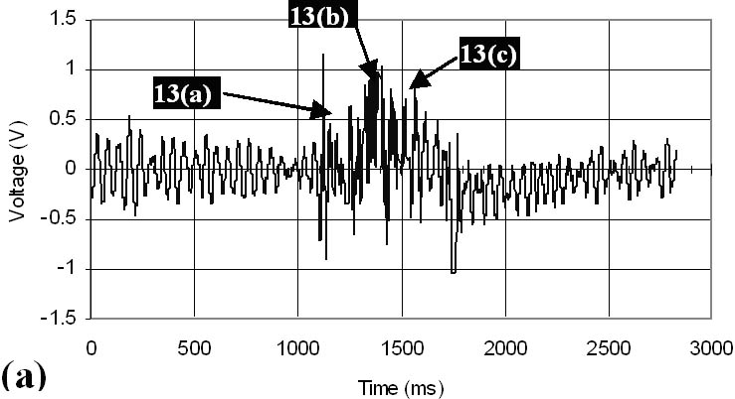
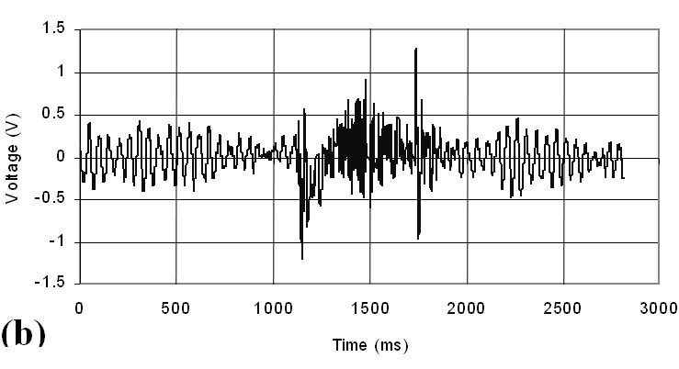
Figure 16. Voltage signal from the PVDF micro-sensing system which was used to measure the force of the probes as they impinge on the membrane of a cell. (a) A KL Probe penetrated a cell membrane. Much lower force signal was recorded, indicating much less resistance from the membrane on the probe. (b) A KL probe was extracted from a cell. Again, much lower signal was observed than using a Turner Probe.

4 CONCLUSION

A newly invented chemical probe-etching process with high reproducibility was developed which provides a simple, single-step method to fabricate probes with nanometric tips. With a suitable selection of organic solvent and correct etchant boundary conditions, it is likely to be a promising and quick process to fabricate probes for SNOM applications, cell probing and sensing tools, or even cell surgery purposes. In addition, initial experimental analyses were performed on the impact signal between cell membranes and probes made by Turner’s and Kwong-Li’s methods. The sensed signals clearly indicate that cell membranes will offer finite mechanical resistance even for the nanometric KL probes during the probing process.

5 ACKNOWLEDGEMENTS
This project is funded by the Hong Kong Research Grants Council (Grant No. CUHK 4381/02). The authors would like to sincerely thank Ms. Charlotte C. H. Kwong of Mechanical and Aerospace Engineering of UCLA for her contribution to this project.

REFERENCES

- K. T. Brown, D. G. Flaming, “Advanced Micropipette Techniques for Cell Physiology,” IBRO Handbook series: Method in the Neurosciences vol. 9, 1986, pp. 1-6.
- B. Hecht, B. Sick, U.P. Wild, V. Deckert, R. Zenobi, O.J.F. Martin and D.W. Pohl, “Scanning Near-field Optical Microscopy with Aperture Probes: Fundamentals and Applications,” Journal of Chemical Physics, 112, 18, 2000, pp. 7761-7774.
- P. K. Wong, T.-H. Wang, C.-M. Ho, “Optical Fiber Tip Fabricated by Surface Tension Controlled Etching,” Hilton Head 2002 Solid State Sensor, Actuator and Microsystems Workshop.
- A. Klini, T. David, E. Bourillot, S. Emonin, P. Papadopoulos, J.P. Goudonnet, G. Kotrotsios, “Reproducible Optical Fiber Tips for Photon Scanning Tunneling Microsopy with Very Small (<5˚) Cone Angle,” Journal of Lightwave Technology, 16, 7, 1998, pp. 1220-1227.
- D. R. Turner, US Patent No. 4,469,554.
- C. K. M. Fung, I. Elhajj, W. J. Li, and N. Xi, “A 2-D PVDF Force Sensing System for Micro-manipulation and Micro-assembly,” IEEE ICRA 2002, vol. 2, 2002, pp. 1489-1494.

