Low Temperature Polymer-Based Substrates Bonding Using PDMS for Microfluidic Applications

Winnie Wing Yin Chow¹, Kin Fong Lei¹, Guangyi Shi², Wen Jung Li^{1,*}, and Qiang Huang²
¹Centre for Micro and Nano Systems, The Chinese University of Hong Kong
Shatin, N. T., Hong Kong SAR
²Department of Mechatronic Engineering, Beijing Institute of Technology, Beijing, China
*Contact Author: wen@acae.cuhk.edu.hk

Abstract

A novel technique to bond polymer substrates using PDMS-interface bonding is presented in this paper. This novel bonding technique is promising to achieve precise, well-controlled, low temperature bonding of microfluidic devices. A thin (10-25μm) Poly (dimethylsiloxane) (PDMS) intermediate layer was used to bond two polymer (PMMA) substrates without distorting them. Micro patterns were compressed on a PMMA substrate by hot embossing technique first. Then, PDMS was spin-coated on another PMMA bare substrate and cured in two stages. The bonding was successfully achieved at a relatively low temperature (~90ºC). Tensile bonding tests showed that the bonding strength was about 0.015MPa. A vortex micropump connected with a microchannel was successfully fabricated using this novel bonding method. The design, fabrication processes, and testing results for the microfluidic devices are described in this paper.

Keywords: PDMS, PMMA, hot-embossing

1 INTRODUCTION

In recent years, polymer-based microfluidic devices have become increasing important in biological applications (e.g., see []). However, polymer substrates must be bonded to make functional microfluidic devices such as microchannels, microvalves and micropumps and the adhesion between the substrates is a problem of great practical concern. The development of polymer-based microfluidic systems requires specific biocompatible materials for bonding, packaging and assembling at low temperatures (<200ºC). Existing polymer-to-polymer substrate bonding methods include thermal-compression, ultrasonic, and gluing by application of either epoxy or methanol. Unfortunately, these techniques are not precise when compared to standard IC/MEMS bonding processes, i.e., they may induce global and localized geometric deformation of the substrates or leave an interfacial layer with significant thickness variation. For channels in the range from millimeter to a few hundred microns, these drawbacks are tolerable. However, it is implausible to construct micron and nanometer sized channels using these techniques since significant global and local material deformations may distort the micro/nano channel geometries. We have recently presented our work in using localized microwave heating to bond polymer (e.g., PMMA) substrate with a uniform interface layer about 1μm without causing any global deformations []. The operation of microwave bonding is convenient and well-controlled. However, microwave can only be applied to a relatively small surface area between two bonding substrates, e.g., 1cm×1cm.

To implement a microfluidic system, a reliable and repeatable bonding process, which does not alter the properties and performance of the components is required. Therefore, a low temperature bonding process is essential to ensure the integrity of the components during the bonding, packaging and assembling of these systems. Polymer is the most common adhesive bonding material for microfluidic devices because the bonding temperature is relatively low. Benzocylobutene (BCB) [] and Teflon-like amphorous fluorocarbon polymer [] are used as the adhesive layers to bond different materials such as silicon and glass. However, their required bonding temperature is still over 100ºC. SU-8 is another polymer that requires bonding temperature of ~95ºC []. For glass and silicon substrates bonding, bonding temperature over 100ºC is still acceptable; but for polymer substrates, this would greatly affect the bonding performance. For example, in this paper, we focus on the polymer substrate PMMA, which has the glass transition temperature of only 105ºC. Hence, bonding temperature that is over 100ºC cannot be applied to PMMA-to-PMMA bonding as it would melt the channel patterns on PMMA substrates.

PDMS, an elastomeric polymer, which is biocompatible, transparent, permeable to gases and low cost, is becoming more popular among the microfluidic device community. Replica molding technique is commonly used to fabricate PDMS microfluidic devices []. The preparation process of PDMS is also simple. In addition, its low curing temperature (<100ºC) makes it an excellent material for bonding polymer substrates since many polymer substrates cannot withstand a high bonding temperature (>200ºC). Currently, PDMS is widely used as the structural material for microfluidic devices because of its biocompatibility and low cost properties. 3-D microchannels can be made easily and rapidly by replica molding method. Typically 3-D channels are formed by exposing both PDMS layers to oxygen plasma and then bond them immediately after the plasma treatment [6]. PDMS can be irreversibly adhered to a number of materials such as glass, silicon and quartz []. However, PDMS cannot be adhered to PMMA by this method. Instead of using the oxygen plasma treatment, we have developed a novel bonding method, which used spin-coated PDMS as the interface to bond two PMMA substrates during the curing of PDMS. This method is effective, low cost, fast, and simple to fabricate microfluidic devices.

In this paper, we will present our recent progress in bonding PMMA substrates with large surface area (3.5cm×2.5cm) at low temperature (~90ºC) using a thin spin-coated PDMS layer (10-25μm) as the intermediate layer. We found that PDMS could be made to adhere well to PMMA during the curing process of PDMS and no global deformation was generated in the substrates. We have fabricated a microfluidic system with a vortex micropump and a closed microchannel using this method. In our experimental results, the flow rate of the system is 0.8ml/min, the bonding strength was 0.015MPa and no leakage occurred inside the channel.

2 DESIGN AND FABRICATION OF MICROFLUIDIC SYSTEM

2.1 Design of the Vortex Micropump

The vortex micropump uses the kinetic energy of an impeller and a circular pump chamber to move fluid []. The micro impeller is placed inside the pump chamber. When the fluid enters the micropump from the center of the impeller, the rotational motion of the impeller, driven by a DC motor, can induce fluid pressure with continuous flow. The vortex micropump was fabricated by the micro molding replication technique.

2.2 Fabrication of Microfluidic System
- Micro Impeller Fabrication Process
The rotating impeller can induce pressure and generate the fluid flow. The fabrication process is shown in Figure 1. A layer of 200μm thick SU-8 negative photoresist was spun on a nickel substrate and was exposed under UV light with the mask of impeller pattern. After developing the SU-8, a 100μm thick nickel layer was electroplated on the substrate. The micro impeller was fabricated after removing the nickel and SU-8 substrate. The pattern and fringe profile is illustrated in Figure 2.

Ni
SU-8
Spin coat and expose
200um PR
Develop SU-8 PR
Electroplate 100um
Nickel
Remove SU-8 PR
Figure 1. Fabrication of Nickel micro impeller.

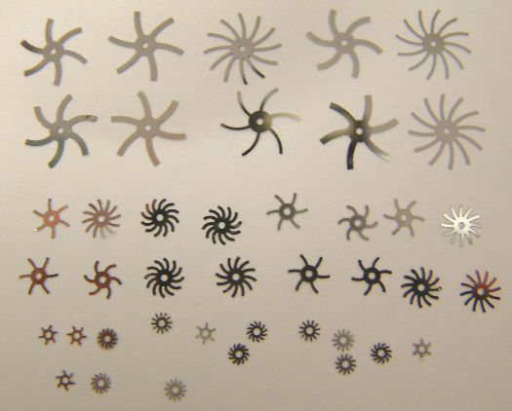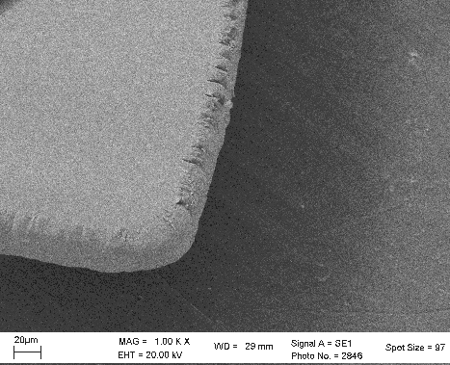
8mm
4mm
2mm
20um
Figure 2. (Left) Photograph of nickel micro impellers and (Right) SEM image of one fringe of the impeller.

B) Micro Pattering of PMMA by Hot Embossing Technique
Micropump and microchannel on PMMA were created by using the hot embossing technique similar to the one reported in []. The fabrication process used in our group is illustrated in Figure 3. A layer of 200μm thick SU-8 negative photoresist was pattern on a nickel substrate by photolithography. Then, a 3000Å thick silver conductive layer was sputtered on the substrate. The 300μm thick nickel mold was fabricated on the silver layer by electroplating. The mold pattern is shown in Figure 3(b). Nickel was used as the material of the metal mold because it is much harder than PMMA (Young’s modulus = 200GPa). The metal mold was then released and inserted into the hot embossing machine. The hot embossing machine used in our lab and its components are shown in Figure 4. The PMMA substrate was first heated to 120ºC, which was slightly above the glass transition temperature of PMMA (T_{g} = 105ºC). Then a pressure of 7MPa was applied by a hydraulic press to compress the mold towards the PMMA substrate, which allowed the channel pattern on the metal mold to be transferred to the PMMA substrate. The substrate and the mold were then cooled and separated.

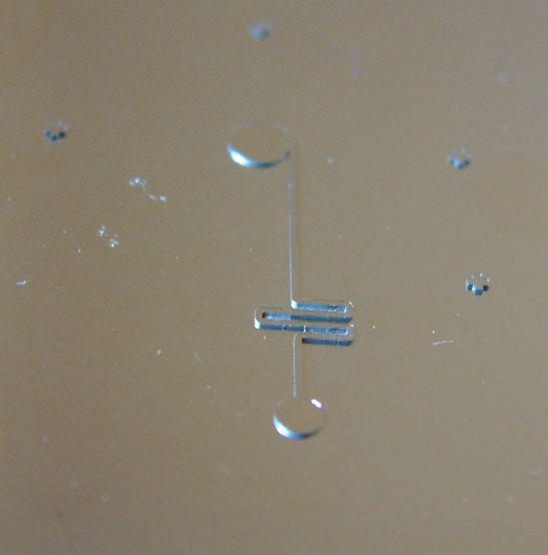
Spin coat and expose
200um SU-8 PR
Develop SU-8 PR
Sputter 3000A silver
as conductive layer
Electroplate 300um
nickel
Remove silver and
SU-8 PR
SU-8
Ni
Ag
Mold Pattern
(a)
(b)

Figure 3. (a) Nickel micro mold fabrication process and (b) photograph of nickel micro mold pattern.

C) Assembly of Micropump by PDMS Bonding Process
After creating the micropump and the microchannel patterns by hot embossing technique, machining tools were used to deepen the chamber. An impeller and a DC motor were assembled on the top and the bottom of the chamber respectively. The inlet and outlet of the micropump were produced by drilling holes through another bare PMMA substrate.

The bonding of the embossed PMMA substrate and the bare PMMA substrate was achieved by spinning a layer of PDMS on the bare PMMA substrate. The assembly process of the vortex micropump is illustrated in Figure 5. PDMS prepolymer (SYLGARD 184 Silicone Elastomer Kit, Dow Corning) was mixed with its curing agent in the volume ratio of 10:1. Then, the prepolymer mixture was degassed in a desiccator with a vacuum pump at 50 torr for half an hour to remove any bubbles created during mixing. A 10-50μm PDMS prepolymer mixture was spun on the bare PMMA surface. The size of the PMMA substrates was 2.5cm wide, 3.5cm long and 0.3cm thick. After spinning on the PDMS, the substrate was pre-cured at room temperature first for about 20 hours to evaporate most of the solvents. The thickness of PDMS was controlled by the spinning rate as shown in Figure 6. The two substrates were not bonded immediately because air could be trapped and bubbles could appear in PDMS layer. However, the PDMS layer was only partially cured after 20 hours. 24 hours is needed to fully cure PDMS at room temperature. This partially cured PDMS was very viscous and sticky, and was suitable for bonding. The bonded substrates were heated at 90ºC for 3 hours under a pressure 50kPa. PDMS was thus completely cured and the channel was sealed. The bonded vortex micropump and the microchannel are shown in Figure 7.

(a)
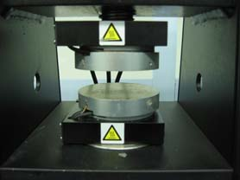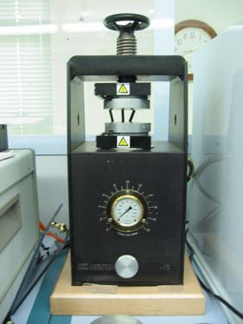
Hotplate

(b)
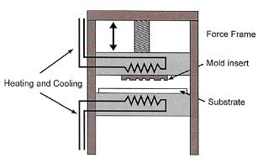
Hotplate
Hotplate
Figure 4. Hot embossing machine for compressing micro patterns on PMMA. (a) Photograph of the machine. (b) Schematic diagram of the machine.

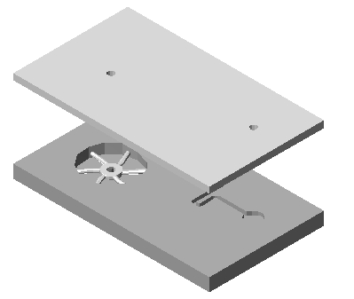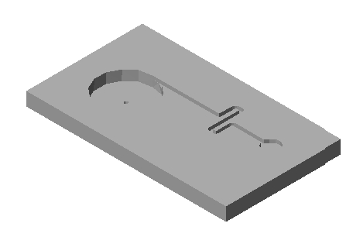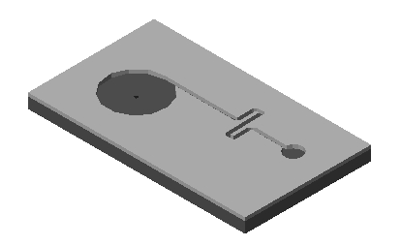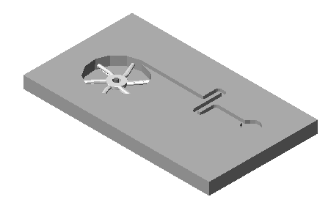
PMMA
Nickel Micro
Mold
Heating
Pressure
Pump
Chamber
Milling Tools
DC Motor
Micro Impeller
PDMS
Bare PMMA
Embossed
PMMA
Inlet
Outlet
Pressure
1. Replicate the pump chamber and channel
2. Modify the pump chamber and machining tools
3.
Assembly the micro impeller and DC motor on
the embossed PMMA
4.
(a) Spin on PDMS to another bare PMMA and
(b) bond two substrates together
(a)
(b)
Figure 5. Replication and Assembly Processes of the vortex micropump.
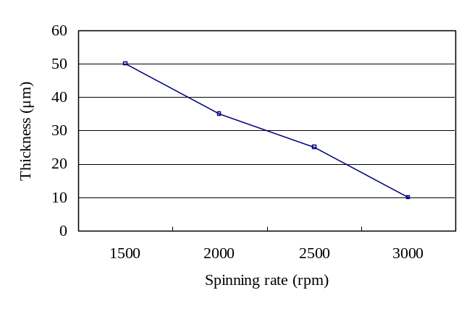

Figure 6. Thickness of spin-coated PDMS versus spinning rate.

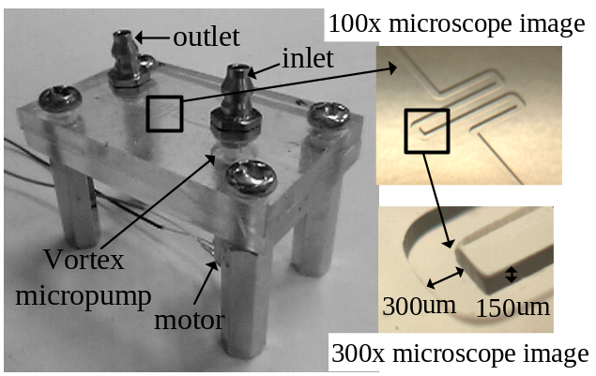

Figure 7. Photograph of a vortex micropump and its channel structure.

3 EXPERIMENTAL RESULTS

3.1 Tensile Bonding Test

The bonding test was performed by using the QTest™ tensile strength tester from MTS Systems Corporation. The test set up is shown in Figure 8(a). In order to fit the sample to the gripper of the machine, a piece of PMMA attachment substrate was adhered to both the top and bottom surfaces of the sample as shown in Figure 8(b). Chloroform was used to attach this attachment substrate to the samples. The evaluation results with various parameters are listed in Table 1. The bonding strength was about 0.015MPa. The results show that the thickness of the interfacial layer does not greatly affect the bonding strength. However, it does affect the bonding quality. Fewer bubbles formed with a thinner PDMS layer. Besides the thickness of PDMS layer, the pre-curing time of PDMS at room temperature also has a significant influence on the bonding quality. Sufficient pre-curing time (~20 hours) is needed to reduce bubble formation and achieves a larger bonded area. A larger bonded area leads to a stronger bonding strength.

3.2 Leakage Test

The most common concern about microfluidic system is the leakage problem. Many existing polymer-to-polymer substrate bonding methods such as gluing by epoxy or methanol suffered from uneven bonding and leakage near the edge of the device. Therefore, our fabricated device was tested for leakage. Since both PMMA and PDMS are transparent, it is difficult to examine the bonding quality by human eyes. Color dye was pumped into the channel, and no leakage occurred in the channels as shown in Figure 9. The channel dimensions in Figure 9 are w=300μm, h=100μm, l=1.6cm.

Table 1. Evaluation results of the bonding tests.
Sample No. | PDMS thickness  (μm) | Curing time at room temperature  (hr) | Bonding temperature  (°C) | Bonding time  (hr) | Bonding strength  (MPa) | Bonded area  (%) | Bubbles formed
1 | 10 | 20 | 90 | 3 | 0.015689 | 100 | No
2 | 25 | 20 | 90 | 3 | 0.015389 | 95 | Yes
3 | 35 | 20 | 90 | 3 | 0.014711 | 95 | Yes
4 | 10 | 6 | 90 | 1.5 | 0.011922 | 90 | Yes
5 | 25 | 6 | 90 | 1.5 | 0.009900 | 85 | Yes

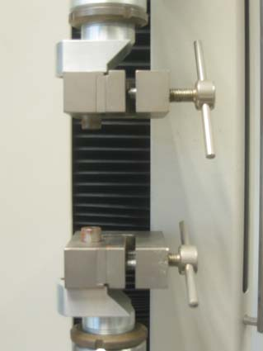
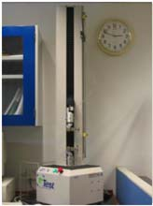

(a)
Grippers

PMMA attached
to substrates for
the grippers
Bonded
Substrates
(b)

Figure 8. Experimental setup of the tensile bonding test. (a) Photograph of the QTest™ tensile testing machine. (b) Two PMMAs were mounted to the top and bottom surfaces of the bonded substrates to fit the grippers of the machine.

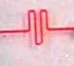

1mm

Figure 9. Color dye was pumped into the microchannel showing that no leakage occurred.

4 CONCLUSIONS

A low temperature bonding technique for polymer-based substrates to achieve a precise and well-controlled bonding interfacial layer has been presented. A vortex micropump was successfully fabricated by this technique. The bonding technique, using spin-coated PDMS, shows a low bonding temperature (~90ºC) and bonding strength of 0.015MPa in PMMA-PDMS-PMMA interface. The PMMA substrates were bonded without any global geometric deformation. The bonded substrates were tested with tensile bonding and leakage test. Results of tensile bonding test showed that thickness of the interfacial layer and pre-curing time of PDMS at room temperature were critical for realizing good bonding quality. Color dyes were pumped into a closed microfluidic system to show that no leakage occurred. We have demonstrated an effective, low cost, fast and simple way to fabricate polymer microfluidic system at relatively low temperatures.

ACKNOWLEDGEMENT

This project is funded by a grant from the Hong Kong Research Grants Council (Grant No. CUHK4206100E) and by a grant from the Chinese National High Technology Research and Development Plan (863 Plan; Project Ref. No.: 2001AA422320).

REFERENCES

[] G. B. Lee, S. H. Chen, G. R. Huang, W. C. Sung, and Y. H. Lin, “Microfabricated Plastic Chips by Hot Embossing Methods and Their Applications for DNA Separation and Detection”, Sensors and Actuators B 75, pp. 142-148, 2001.
[] K. F. Lei, W. J. Li, N. Budraa, and J. D. Mai, “Microwave Bonding of Polymer-Based Substrates for Micro/Nano Fluidic Applications”, The 12th International Conference on Solid-State Sensors, Actuators, and Microsystems (Transducers 03’) Boston, USA, June 8-11, pp. 100-107, 2001.
[] F. Niklaus, P. Enoksson, E. Kälvesten, and G. Stemme, “Low-temperature Full Wafer Adhesive Bonding”, Journal of Micromechanics and Microengineering 11, pp. 100-107, 2001.
[] K. W. Oh, A. Han, S. Bhansali, and C. H. Ahn, “A Low-temperature Bonding Technique using Spin-on Fluorocarbon Polymers to Assemble Microsystems”, Journal of Micromechanics and Microengineering 12, pp. 187-191, 2002.
[] S. Li, C. B. Freidhoff, R. M. Young, and R. Ghodssi, “Fabrication of Micronozzles using Low-temperature Wafer-level Bonding with SU-8”, Journal of Micromechanics and Microengineering 13, pp. 732-738, 2003.
[] B. H. Jo, L. M. Van Lerberghe, K. M. Motsegood, and D. J. Beebe, “Three-Dimensional Micro-Channel Fabrication in Polydimethylsiloxane (PDMS) Elastomer”, Journal of Microelectromechanical Systems, Vol 9, No. 1, pp.76-81, March 2000.
[] J. C. McDonald, D. C. Duffy, J. R. Anderson, D. T. Chiu, H. Wu, O. J. A. Schueller, and G. M. Whitesides, “Fabrication of Microfluidic Systems in Poly(dimethylsiloxane)”, Electrophoresis, 21, pp.27-40, 2000.
[] K. F. Lei, R. H. W. Lam, J. H. M. Lam, and W. J. Li, “Polymer Based Vortex Micropump Fabricated by Micro Molding Replication Technique”, submitted to 2004 IEEE/RSJ International Conference on Intelligent Robots and Systems.

